

**PLAGIARISM DECLARATION FORM (T-DF)**

|  |
| --- |
| **Instructions**  **Please complete and attach this Plagiarism Declaration Form to each Assignment that you**  **submit into the Online Assignment Submission (OAS) system for marking.** |
| I declare that the attached work is entirely my own (or when submitted to meet the  requirements of an approved group assignment is the work of the group), except where  materials cited, quoted or paraphrased are acknowledged in the text. I also declare that this  work / assignment has not been submitted for assessment in any other course or university  without due acknowledgement.  I understand that plagiarism, collusion, and copying are grave and serious offences.  I understand that disciplinary action (which may include deduction of marks in the Assignment) will  be taken against me if I am found to be an offender of Assignment plagiarism.  **Full name and IC No: KONG WAI KIT 880709-08-5223 Date: 18 March 2022** |

|  |  |
| --- | --- |
| **Assignment Declaration Form** | |
|  | |
| Semester/Year | **Jan 2022** |
| Student’s Name | **KONG WAI KIT** |
| Student’s ID No: | **051160090** |
| Course Code | **TSN309/10** |
| Course Title | **CSN Project** |
| Class Code | **5P-CSN2-Y** |
| Assignment No: | **3** |
| No. of pages of this Assignment  *(including this page)* | 188 |
| Project Supervisor | **Mr. HO HSIAO FOONG @ HO HSIEH HSIUNG** |
| Course Lead | **Mr. CHANDARASAGERAN NATARAJAN** |

***T-DF*** *Assignment Declaration Form (1/2020 version #003)*

**Network Infrastructure Planning for Norris Shai Wealth Management and Advisory**

**KONG WAI KIT**

**051160090**

**Final Year Project**



**SCHOOL OF SCIENCE AND TECHNOLOGY**

**JANUARY 2022**

2

# COPYRIGHT DECLARATION

Wawasan Open University

Session: **Jan 2022**

I, **KONG WAI KIT** declare that this report shall be the property of Wawasan Open University and I allow copies of it to be made for academic purposes.

kit

(Signature)

Date: 18 March 2022

# ORIGINAL DECLARATION

I declare that this report titled “*Project Title*” is my own work except where cited in the references. The report has not been accepted, and is not being submitted in candidature, for any degree or other award elsewhere.

kit

KONG WAI KIT

(Name in full as your NRIC)

Date: 18 March 2022

# ACKNOWLEDGEMENTS

I would like to thanks to Mr. HO HSIAO FOONG @ HO HSIEH HSIUNG for supporting me throughout the entire project by showing different method and possibility of information gathering. Besides, he also helping me by giving the right ways and advices in assisting me towards completing the project.

Besides, I would like to thank to Mr. CHANDARASAGERAN NATARAJAN as the Course Coordinator of this subject has helped to manage matters related as well as provided related resources for this project.

Last but not least, I would like to apologize and thanks all other unnamed and participants who helped me a lot in various ways as well as contributed valuable feedback throughout the process of completing for this project.

# Table of Content

Contents

COPYRIGHT DECLARATION 1

ORIGINAL DECLARATION 2

ACKNOWLEDGEMENTS 3

Table of Content 4

CHAPTER 1 1

PROJECT BACKGROUND 1

1.1 Company Background 1

1.2 Problem background 2

Figure 1.0 Current Network Structure of Norris Shai Wealth Management and Advisory 3

1.3 Project objectives and scope 4

Figure 1.1 6

CHAPTER 2 7

LITERATURE RIVIEW 7

2.1 Introduction 7

2.2 Overview of ethernet cables for new setup 7

Figure 2.0 8

2.3 Wired vs Wireless Network 9

2.4 IP Planning 10

2.5 DHCP 13

What is DHCP? 13

2.6 Domain Name Server (DNS) 14

2.7 Network Security 18

2.8 Demilitarized Zone (DMZ) 19

2.9 Virtual Private Network (VPN) 20

What is VPN? 20

2.10 What is VLAN? 24

2.11 Wireless Network and Security 26

2.12 Router 29

2.13 Firewall 30

2.14 Overview of File Server 31

2.15 Network Simulator 35

Figure 2.1 37

2.17 Methodology for the project 39

CHAPTER 3 42

METHODOLOGY AND PROJECT PLAN 42

3.1 Methodology 42

Figure 3.0 Comprehensive Network Design 44

3.2 Final Project Plan 46

3.3 Development Tools 49

CHAPTER 4 51

RESULT AND REVIEW 51

4.1 Research and Result Development 51

4.2 New Network Architecture 52

Figure 4.0 Network Architecture Design of Norris Shai Wealth Management and Advisory 52

Table 4.0 VLAN Group 53

Table 4.1 Department ID 53

Figure 4.1 Customer3 Connect to Wireless Network 54

Figure 4.2 Agent1 Connect to Wireless Network 55

Figure 4.3 VLAN Ping Test 56

Figure 4.4 VLAN Ping Test 57

Figure 4.5 VLAN Ping Test 58

Figure 4.6 VLAN Ping Test 59

Figure 4.7 Ping Test Result 60

Figure 4.8 Speed Test 61

Figure 4.9 SoftEther VPN Server 62

Figure 4.10 SoftEther VPN Server Connected 63

Figure 4.11 SoftEther VPN Client 64

Figure 4.12 Specification of Server (NRSSVR) 65

Figure 4.13 Shared Folder for Each Department 66

Figure 4.14 Shared Folder for Each Department 67

Figure 4.15 Domain User for Each Department 68

Figure 4.16 Shared Folder Access for IT Department 69

Figure 4.17 Shared Folder Access for Customer Service Department 70

Figure 4.18 Google Drive Directory for Dedicated Agents & Customers in NRSSVR 71

Figure 4.19 File Server Directory for Dedicated Agents & Customers in NRSSVR 72

Figure 4.20 File Server Directory for Dedicated Agents & Customers in NRSSVR 73

Figure 4.21 Google Drive Directory Access for Dedicated Agents & Customers for Internal Staff 73

Figure 4.22 Google Drive Folder for Dedicated Agents & Customers 74

Figure 4.23 Google Drive Folder for Dedicated Agents & Customers 74

Figure 4.24 Google Drive Folder for Dedicated Agents & Customers 75

Figure 4.25 Starting TinyWall 76

Figure 4.26 TinyWall Application Exception 77

Figure 4.27 TinyWall Allow Internet Access 78

Figure 4.28 TinyWall Allow Internet Access 79

Figure 4.29 TinyWall Application Exception 80

Figure 4.30 TinyWall Not Allow Internet Access 81

Figure 4.31 TinyWall Not Allow Internet Access 82

4.3 User Testing 83

Figure 4.32 Domain Access of User IT1 83

Figure 4.33 Access of Shared Folder of IT1 83

Figure 4.34 Domain Access of User CUSTOMERSERVICE1 84

Figure 4.35 Access of Shared Folder of CUSTOMERSERVICE1 84

Figure 4.36 File Sharing to Dedicated Agents 85

Figure 4.37 File Sharing to Dedicated Agents 85

Figure 4.38 File Sharing to Dedicated Customers 86

Figure 4.39 File Sharing to Dedicated Customers 86

Figure 4.40 Connection to VPN Server 87

Figure 4.41 Access Network Folder In NRSSVR 88

Figure 4.42 Access the document in the Network Folder 88

Figure 4.43 Scanning for GENERAL2 89

Figure 4.44 Show Print, Copy and Scan Record 89

4.4 User Reviews 90

CHAPTER 5 91

CONCLUSION AND RECOMMENDATION 91

5.1 Conclusion 91

5.2 Recommendation 91

References 92

Appendix 96

Youtube Presentation Link 177

Github File Link 178

# CHAPTER 1

# PROJECT BACKGROUND

# 1.1 Company Background

Norris Shai Wealth Management and Advisory is one of the dedicated company or agencies of Great Eastern Life Assurance that providing professional financial and insurance planning services to their clients for past 40 years. This company is located at Ipoh, Perak. Basically, their working routine would be preparing and submit document like increase premium, change nominee, mobile number, address, proceed medical claim and surrender policy. In this state, there are only four staffs to handling the task for the agency. However, there is no proper department for the staff. This means that there is no proper way to distribute the job for each of the staff and leads to all the staff is multitasking. The office consists of five computers in the office and a Canon photostat machine. Three of the computers are used by staff to access Great Eastern online portal, access account software and access to the printer whereas another two are used by agents to only access to Great Eastern online portal and access to the printer.

For future expansion, Norris Shai Wealth Management and Advisory are looking forward to hiring ten staff to extend their business operation and start off a whole new business operation manner. Besides, Norris Shai Wealth Management and Advisory is also looking for enhance the network connection speed in order to increase the efficiency as well as the productivity to perform the daily task and file processing. Other than that, the company want to segregate all the staff into department like Human Resource Department, Information Technology Department, Customer Service Department, General Department, and Life Department. They are required to have proper way to managing each of the user account. All the staff must be set in different role for different level of staff for P & C purpose when access to company’s data.

Besides, the company are seeking for privacy and security in order to protect the data against unauthorized. In fact, there are many private and confidential documents as well as customer’s particulars that cannot be disclose to other within Norris Shai Wealth Management and Advisory. Therefore, that it has to be protect and safeguard to avoid that fall into unauthorized peoples or criminal’s hand that seek for pecuniary interest.

Other than that, Norris Shai Wealth Management and Advisory looking to have a centralize storage that enable all the staff to access the resources of the company at anytime and anywhere.

# 1.2 Problem background

In order to full understanding the problem that laisse within Norris Shai Wealth Management and Advisory, I have organized a visit toward the company. During the visit, I found out that they are basically using five computer which all of it is Window OS, all the five computers consist of Window 7 and Window 10 and all of them are connect via wired LAN. The Canon printer is connected via wired LAN to all the computer, and it is control by dedicated ID and password when perform printing or copying. Besides, the agents will bring their iPad and using the agency’s Wi-Fi to access to Great Eastern Portal as well as submit new cases, claims or customer enquiries. Other than that, the Wi-Fi is also used to connect staff’s handphone to perform interaction with the boss as well as sending customer’s information like documents and photo.

The problem within this company is they still using traditional way to keep customer information. In fact, all the submission of the document will be having a copy to be filing in the form of hardcopy. Therefore, it will cause to an expense of the equipment to store the document like hard ring file, file rack and file cupboard. This makes a lot of trouble and waste a lot of time when want to search back the history of the existing customer. The subsequence problem of storing hardcopy would be the company have to extend the space if the office not enough space to store it anymore. Other than that, there is no way to find customer’s information anymore if the file is lost.

Besides, slow performance of the internet. In fact, all the task that carry out and complete is through Great Eastern Life and Great Eastern General website. Therefore, if the company facing network connectivity slow down, all the job cannot be proceeding and lead to productivity of the task slow down.

Other than that, although there is some document is store in softcopy, but there are no proper ways or any centralize storage that enable the employees to access on it. It makes most of the time when employee A must ask another colleague in order to acquire that information. Since there is no proper well of storing, it also happen whereby that employee can’t even remember where the document does he/she storing to and couldn’t found it.

Since FMCO (Full Movement Control Order) has been announce by government, Norris Shai Wealth Management and Advisory has to closed down and cause all the routine stuff has to be work from home. This makes even harder for searching customer’s information and any other document that needed to perform daily routine because all of it are storing in company’s pc. Even though the staff can bring back the pc, however the hardcopy document is nearly impossible to bring back to home as there is a bunch of it. This also cause to close contact to the customer is become very hard to do so.

Other than that, the exposure of company private and confidential data and information. In fact, Norris Shai Wealth Management and Advisory do not have any system security or protection to protect the privacy and confidential data against the unauthorize access or malicious attack. Hence, it will lead to easily targeted by hacker and seek for the payment.

**Existing Network Structure of Norris Shai Wealth Management and Advisory** 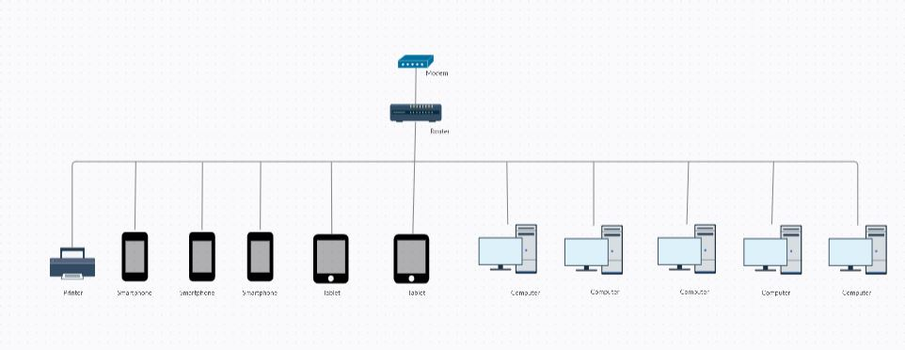

## Figure 1.0 Current Network Structure of Norris Shai Wealth Management and Advisory

Figure above shows that the current network structure of Norris Shai Wealth management and Advisory which is just very simple (wired and wireless) connection that distribute by the modem and the router to all the device that showing by the picture above.

# 1.3 Project objectives and scope

Due to the problem that stated above, I would like to propose the project objectives and scope in order to solve the issue for Norris Shai Wealth Management and Advisory and meet their company goals as well as the business need.

Besides, I would like to expand the IT infrastructure. In fact, Norris Shai Wealth Management and Advisory wish to recruit more agent and business partner to increase revenue of their business and hence more staff could be hire too to handle the increase the workload. Therefore, I would focus on the design of the IT infrastructure based on the company requirement and needed for their expansion.

Other than that, develop a centralize access of the data for Norris Shai Wealth Management and Advisory. This is because this company did not have proper storage location to keeping all the data and information. Besides, since there is FMCO, all the staff are work from home, the staff cannot bring back all the hardcopy to home. Therefore, the scope would be focus on how to implement a centralize access of the data in order to benefit for Norris Shai Wealth Management and Advisory.

Nevertheless, it is very common that an employee can’t stay long in insurance industry. Therefore, user account management is a need for Norris Shai Wealth Management and Advisory to managing the employee that quit from the company as well as new coming employee to the company.

I would also strengthen the security and protection for Norris Shai Wealth Management and Advisory. In fact, the company does not have any protection to protect of the privacy and confidential data and information against unauthorized access or malicious attack. The scope would be how to find a better software or tool to develop the protection to protect the company’s privacy, data, and information.

Besides, what there really want is that two among the ten staff that hired will be segregate and distribute into each department respectively. The purpose of it is because is to classify different role for each of the department. For example, Human Resource Department able to access, view and edit the file of Customer Service Department, General Department and Life Department while others department can only view the file of other department and view and edit the files of their own department and even not allow do view due to the permission of the department is lower. (Kindly refer to 1.1 Company Background paragraph 2)

Other than that, the privacy and security they are seeking for is that strictly no outsider that allow to join in the network unless giving permission to do so. In fact, the network is only allowing dedicated agents, staffs or any other company’s members to access the company’s network and data. For example, there are new agents that join into our company, or the agent has bought new device that required to join into the network. Then I add them to the network and giving them permission to access within the network. (Kindly refer to 1.1 Company Background paragraph 3)

Nevertheless, the centralize storage that they are looking for is that a network location that used to store all the confidential data of the company that only allow agents, staffs and any others company’s member to access as well as perform editing. Besides, this network location enables and allows the users to access the data anytime and anywhere even not at office or in oversea. (Kindly refer to 1.1 Company Background paragraph 4)

Due to the capacity of Norris Shai Wealth Management and Advisory has increase and the slow performance of the connectivity, existing network equipment and internet package can no longer support the network size of the company. Therefore, the network equipment as well as the internet package of Norris Shai Wealth Management and Advisory are required to upgrade.

Therefore, the project scope shall focus on:

* The network design must meet the need of Norris Shai Wealth Management and Advisory which is the combination of both wired and wireless networks.
* The configuration of the network design must alongside with the security for the wired as well as well as the wireless networks to protect the company’s data.
* Design of new network to allow for segregation of network and better security.
* Configure file server for centralized login and centralized storage for internal staff.
* Configure the VPN that allow internal staff to access the data and information from home.
* Configure the wireless network and only allow dedicated agents and customers to access the data and information.
* Configure the network simulator that used to identify and resolve the problem of the network architecture design.

**Network Architecture Design**

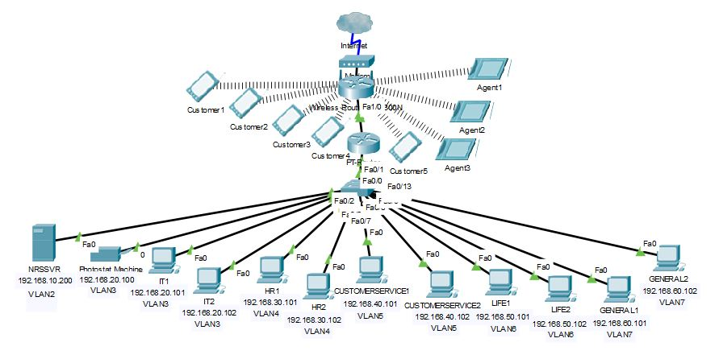

# Figure 1.1

Kindly refer to CHAPTER 4 RESULT AND REVIEW for the full result and description of the network design.

# CHAPTER 2

# LITERATURE RIVIEW

# 2.1 Introduction

The purpose of literature review is to discuss about the elements or components that needed of the network design in order to fulfil the expectation of Norris Shai Wealth Management and Advisory that help them to meet the business goal.

# 2.2 Overview of ethernet cables for new setup

**Cat5e vs Cat6**

**Bandwidth**

Both CAT5e and CAT6 cables are able to handle the rates up to 1000 megabits per second (Mbps) or a Gigabit per second. This speed should be enough for most of the internet connections. It is possible that a current internet connection won't be able to reach 500 Mbps. (Black Box Network Services, 2021)   
  
The primary distinction between CAT5e and CAT6 cable is the bandwidth with which the connection able to allow data transport. CAT6 cable able to handle working frequencies of up to 250 MHz whereas CAT5e is only able handle up to 100 Mhz. This could mean that CAT6 cable able handle much more data than CAT5e cable connection at the same time. Just think about it, the different between 2 lanes and 4 lanes highway, peoples able to drive the same speed on both highways, but 4 lanes highway able to handle much more traffic than 2 lanes highway at the same time. (Black Box Network Services, 2021)

**Speed**

CAT6 cables provides speed of up to 250 MHz which is more than double of the speed of CAT5e lines (100 Mhz). Therefore, CAT6 cables able to handle 10GBASE-T or 10-Gigabit Ethernet rates when compared to CAT5e cables is only support 1GBASE-T or 1-Gigabit Ethernet speeds. (Black Box Network Services, 2021)

**Crosstalk**

Both CAT5e and CAT6 are twisted pair cables with four twisted pairs (8 wires) per cable with copper wires. Previously, the 250 MHz performance of CAT6 cables was always achieved by employing nylon spline in the wire, which segregated each of the four twisted pairs and made the cable tough. Because of the adoption of different technologies to minimize the noise, CAT6 cables are now more flexible. (Black Box Network Services, 2021)

**Visual Differences**

Cable categories are mostly written on cable itself. In fact, users are not able to identify the cable type based on the color of the RJ45 connection. On the other hand, CAT6 cables are able to be immediately distinguishable as they always employ thicker copper wires than CAT5e cables. (Black Box Network Services, 2021)

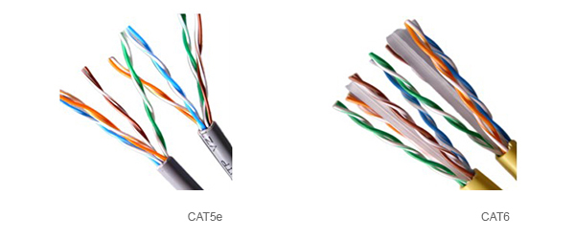

# Figure 2.0

**(source:** [**https://www.blackbox.co.uk/gb-gb/page/43869/Resources/Technical-Resources/Black-Box-Explains/Copper-Cable/Category-5e-And-6**](https://www.blackbox.co.uk/gb-gb/page/43869/Resources/Technical-Resources/Black-Box-Explains/Copper-Cable/Category-5e-And-6)**)**

**Cost**

There is a plethora of factors which may affect to the cost of the Ethernet cables, the most important factor may include copper content, length, manufacturer as well as quality. In average, CAT6 cables are around 10% - 20% more expensive than CAT5e cables. (Black Box Network Services, 2021)

**Ethernet Cable of Choice**

Based on our study, Norris Shai Wealth Management and Advisory has decided to use Cat6 ethernet cable rather than Cat5e for this project. In fact, it is more appropriate for the company's network structure. Although the price is a little higher and more expensive, but the performance is always worth it.

# 2.3 Wired vs Wireless Network

**Mobility**

A wired LAN (Local Area Network) connects all the desktop computers through Ethernet connections via switch, hub or router in order to make the internet connection. Compare to Wi-Fi adapters that require more power, cable connections are always less expensive and able to minimize the battery drain on desktop computers, laptops as well as to mobile devices. (Wong, 2017)

Users of the wireless network are free to move their laptops, smartphones, tablets, and other devices that can connect to the wireless internet connection anywhere within the wireless network's coverage area. As of the growing popularity of smart phones and tablets, the demand of Wi-Fi has also grown as well. Most of the gadgets are no longer connect to the wired networks and only relied on wireless signals to access the to the Internet. (Wong, 2017)

**Reliability**

Ethernet or cable networks are invariably more dependable than wireless networks. Ethernet connections are, in reality, the backbone of any network. The most prevalent issue with wired networks, though, is usually weak cable connections. In reality, you'll have to run a lot of cables through the walls, which can lead to tangled wires, which can cause damage and performance impairment. The best approach to keep the cords out of the way and tangle-free is to use Zip-Ties. (Wong, 2017)

Wireless technology is more dependable than wired networks for the most part. Many gadgets, such as smartphones, tablets, and laptops, rely on wireless networks rather than conventional networks. However, there are also worries regarding domestic appliances such as microwaves and cordless phones interfering with the signal. This problem might be rectified because most wireless routers include numerous channels that can readily alleviate this issue. (Wong, 2017)

**Security**

The firewall is always the most important factor in ensuring the security of a home-based Ethernet network. In reality, most broadband routers come with built-in firewalls as well as software firewalls that can be installed on individual computers. Unlike wireless networks, which broadcast all data over the air, all data packets in a wired network will be sent safely across Ethernet cables. Your connected home network will be safe as long as the router is protected against infiltration using a firewall. (Wong, 2017)

The firewall is always the most important factor in ensuring the security of a home-based Ethernet network. In reality, most broadband routers come with built-in firewalls as well as software firewalls that can be installed on individual computers. Unlike wireless networks, which broadcast all data over the air, all data packets in a wired network will be sent safely across Ethernet cables. Your connected home network will be safe as long as the router is protected against infiltration using a firewall. (Wong, 2017)

**Wired and Wireless Network**

Internal networks that perform well are always a mix of wireless and wired networks. "Wired or Ethernet connections are ideal for high-speed data transfer on desktops or other non-mobile devices. The smart phone, laptop, or tablet, on the other hand, will profit from a wireless network that has been correctly designed to assure the security of the surfing experience. Whether you choose a wired or wireless network, or a combination of the two, you'll need to design it properly and install a firewall to secure the network's privacy and integrity while taking use of the benefits offered by both technologies." (Wong, 2017)

**Networking type of choice**

For this project, combination of both wired and wireless network is suitable to the organization structure of Norris Shai Wealth Management and Advisory. In fact, they are not only using wired LAN to connect the desktop computers but also using wireless LAN to connect to staff’s and agent’s devices such as tablets, smartphones.

# 2.4 IP Planning

Every computer and device connected to a wired or wireless network is assigned a collection of numbers called an Internet Protocol (IP) address. Consider a company's wireless network, which hosts a variety of devices such as wireless printers, smartphones, tablets, and laptops. Each device has its own IP address, which functions similarly to a company or home's street address. When you print an invoice from a computer or laptop, the network will use its IP address to transport the data from the computer or laptop to the printer. There are two major forms for IP addresses: four decimal numbers separated by dots, each up to three digits long, or eight hexadecimal (base-16) integers separated by colons. The IP address might be "2601:1730:7250:fc10:93:af4c:801e:6983" or "2601:1730:7250:fc10:93:af4c:801e:6983." (Kaspersky, 2021)

Managing IP addresses isn't always straightforward. In reality, keeping a manual spreadsheet of all the operational addresses for a big network with a lengthy number of addresses may be time intensive, especially if the network is constantly expanding to accommodate new devices and users. (SolarWinds, 2021)

IP planning's primary goal is to assist you in making your IP settings as efficient as possible, all from a single control centre. IP administration entails assigning new units to an empty address, ensuring that your assignments do not exceed your IP capacity, and resolving any address setup inefficiencies. (SolarWinds, 2021)

IP planning entails subnet development and maintenance in addition to IP address assignment, allowing your network and operations to run more efficiently and effectively. IP addresses with the same routing prefix may connect with one other over shorter distances and in less time. A subnet is a collection of IP addresses that all start with the same prefix; this is something that should be considered in any IP planning if you want to improve the efficiency of traffic flow. (SolarWinds, 2021)

A comprehensive monitoring approach for your DNS servers, DHCP servers, and dynamic IP addresses that vary based on capacity is also required for successful IP planning. (SolarWinds, 2021)

**2.4.1 IPv4 vs IPv6**

**What is IPv4?**

IPv4 is an IP version that widely used to identify the devices on a network using an addressing system. In fact, It was the first version of IP which deployed for production in the ARPANET during 1983. It uses a 32-bit address scheme in order to store 2^32 addresses which is more than 4 billion addresses. It is considered as the primary Internet Protocol (IP) and carries about 94% of Internet traffic. (Williams, 2022)

**What is IPv6?**

IPv6 is the latest version of the Internet Protocol. This new IP address version is being implemented in order to meet the need for additional Internet addresses. It was meant to resolve the issues that are related with IPv4. With 128-bit address space, it allows 340 undecillion unique address space. IPv6 is also called IPng (Internet Protocol next generation). (Williams, 2022)

**Features of IPv4**

Following are the features of IPv4: (Williams, 2022)

* Connectionless Protocol (Williams, 2022)
* Allow creating a simple virtual communication layer over diversified devices (Williams, 2022)
* Requires less memory, and ease of remembering addresses (Williams, 2022)
* Already supported protocol by millions of devices (Williams, 2022)
* Offers video libraries and conferences (Williams, 2022)

**Features of IPv6**

Here are the features of IPv6: (Williams, 2022)

* Hierarchical addressing and routing infrastructure (Williams, 2022)
* Stateful and Stateless configuration (Williams, 2022)
* Stateful and Stateless configuration (QoS) (Williams, 2022)
* An ideal protocol for neighboring node interaction (Williams, 2022)

**Internet Protocol (IP) of choice**

For this project, I am applying IPv4 for the network design for Norris Shai Wealth Management and Advisory. In fact, it is still common in use by the website and traffic also easy to read and understand by the people.

**Pros of IPv4 vs IPv6**

Despite IPv6 being the newer, updated IP, there are still plenty advantages of IPv4. (IPv4.GLOBAL, 2020)

* Existing infrastructure – Most of the websites are using IPv4, although that also support IPv6. This makes version four a more seamless experience. That is, until most of the Internet switches to version six. (IPv4.GLOBAL, 2020)
* Simplicity – IPv4’s 32-bit dotted decimal is much simpler and smaller than IPv6’s hexadecimal numbers. This is more easier for people to read. (IPv4.GLOBAL, 2020)
* Support – Because most of the traffic is still using IPv4, Network operators find IPv4 familiar. They might wait until more traffic is IPv6 before making any decisions about their own infrastructure—especially if they have enough IPv4 addresses for the near future. (IPv4.GLOBAL, 2020)

# 2.5 DHCP

# What is DHCP?

Dynamic host configuration protocol (DHCP) is a mechanism that used to configure computer's network settings. It is a network protocol that used on IP networking in which a DHCP server distributes or assign an IP address and other information randomly to each device such as tablets, smartphones, or laptops on the same network so that they can connect with other as well as to access the internet more quickly and effectively. (Kerravala, 2018)

Besides, DHCP is also assigns the DNS address, subnet mask, default gateway address, and other setup information in addition to the IP address. DHCP was defined as an Internet Engineering Task Force (IETF)-specified standard based on the BOOTP protocol in Request for Comments (RFC) 2132 and 2131. (Kerravala, 2018)

**2.5.1 Benefit of DHCP**

**DHCP simplifies IP address management**

The primary reason for DHCP's existence is to make the administration of IP addresses on networks easier. In reality, having more than one host with the same IP address and manually setting them will almost always result in issues. Manually assigning an IP address, even on small networks, can be challenging, especially for mobile devices such as smart phones and tablets that require IP addresses on a temporary basis. Aside from that, the majority of people lack the technical knowledge required to give an IP address to a laptop or computer. As a result, DHCP automation simplifies this procedure and makes life easier for both users and network administrators. (Kerravala, 2018)

# 2.6 Domain Name Server (DNS)

**What is DNS?**

The Internet's phonebook is the Domain Name System (DNS). Domain names such as times.com and yahoo.com provide humans with internet information. Internet Protocol (IP) addresses are the means through which web browsers communicate. DNS's job is to convert domain names to IP addresses, allowing browsers to access Internet resources. (Cloudflare, 2021)

Each Internet-connected device has a unique IP address that other machines may use to discover and locate it. The DNS servers are designed to minimize the need for people and users to memorize IP addresses like 192.168.1.12 (in IPv4), or more complicated modern alphanumeric IP addresses like 2420:cb01:2058:1::c759:e7b2 (in IPv6) (in IPv6). (Cloudflare, 2021)

**2.6.1 Uses of DNS**

* Resolving the names of websites on the World Wide Web (WWW) (NS1, 2021)
* Messages are forwarded to email servers and webmail providers (NS1, 2021)
* Within a web application, connecting databases, app servers, and middleware (NS1, 2021)
* Virtual Private Networks (VPN) (NS1, 2021)
* Peer-to-peer sharing programs (NS1, 2021)
* Multiplayer games (NS1, 2021)
* Instant messaging and online meeting services (NS1, 2021)
* Communication between the IoT devices, servers, and gateways (NS1, 2021)

If you utilize any of the services listed above, you will almost certainly communicate with them over DNS. (NS1, 2021)

If you own or manage any of the above - for example, if you run a website or provide VPN access to your company's network - you'll need to set up a DNS to allow people to access your service. (NS1, 2021)

**2.6.2 How DNS Work?**

The DNS resolution procedure entails translating a hostname (such as www.example.com) into a computer-friendly IP address (like 192.168.1.50). As an IP address is assigned to each device on the Internet, it is the address that is required to locate the proper Internet device - similar to how a street address is needed to locate a specific residence. Whenever a user requests a web page, a translation takes place between the content that the user puts into the web browser (abc.com) and the machine-friendly address that is necessary to locate the abc.com webpage. (Cloudflare, 2021)

It's necessary to understand the different hardware components of a DNS query that must transit through in order to understand the mechanism of DNS resolution. Apart from the first request, web browsers do DNS lookups "behind the scenes," requiring no involvement from the user's machine. (Cloudflare, 2021)

**2.6.3 Free DNS Server**

**Google Public DNS**

**Google's Public DNS is fast**

To grasp the mechanics of DNS resolution, you must first comprehend the many hardware components that a DNS query must pass through. Apart from the first request, web browsers do DNS lookups "in the background," needing no interaction from the user's computer. (Caudle, 2015)

In addition, Google has made a number of initiatives to improve DNS query latency, including some novel approaches for resolving cache misses throughout their infrastructure. (Caudle, 2015)

**Using Google's Public DNS provides increased security**

One of the most serious issues with publicly available resolvers is the possibility that they might be utilised in DoS and then Amplification attacks by issuing a modest query and receiving a huge response. Regarding this issue, Google has taken a number of steps to assist guard against some of the most prevalent assaults, as well as closely monitoring their resolvers to guarantee that bad actors are unable to take advantage of their service. Furthermore, in addition to monitoring their servers for criminal actors, Google Public Resolvers fully support DNSSEC, which allows them to ensure that the replies they provide are genuine and from reliable sources. (Caudle, 2015)

One of the most common reasons we advise clients to utilize Google's resolvers is that their network is set up to use incorrectly configured resolvers. One of the main advantages of Google Public DNS is that it offers accurate results. It prioritizes providing the correct response to a query. When users inquire for a non-existent or mistyped domain name, they receive an NXDOMAIN answer, which means there is no known response. (Caudle, 2015)

**How to use Google Public DNS**

Now that we know why you would want to utilize Google's Public DNS, we can go on to the next step. Let's look at what you'll need to do in order to use it. Depending on the sort of device and operating system you're using, you'll have to adjust your settings differently. To alter the settings, you'll need administrative access to your device, although you should be able to edit the DNS settings for your system anywhere you'd like to adjust other network settings. You should use the following addresses as your DNS servers, or simply only the IPv4 addresses. (Caudle, 2015)

Google's Public DNS IP addresses (IPv4) are: (Caudle, 2015)

* 8.8.8.8 (Caudle, 2015)
* 8.8.4.4 (Caudle, 2015)

Google's Public DNS IPv6 addresses are: (Caudle, 2015)

* 2001:4860:4860::8888 (Caudle, 2015)
* 2001:4860:4860::8844 (Caudle, 2015)

**2.6.5 Cloudflare DNS**

Its top-rated content delivery network (CDN) has now been expanded to include a new public DNS service, the catchily called 1.1.1.1. (William, 2021)

Cloudflare has placed a greater emphasis on the foundations. This is because independent testing from sites such as DNSPerf (DNS Performance) demonstrates that Cloudflare delivers the quickest public DNS service available. (William, 2021)

Cloudflare's privacy would be another significant benefit. In reality, it not only guarantees that your surfing data will not be used to display adverts, but it also guarantees that the querying of your IP address will never be written to disc. Within 24 hours, any logs that exist will be destroyed. And these assurances aren't simply words on a webpage. Cloudflare has hired KPMG to conduct an annual audit of its processes and issue a public report to ensure that the business is following through on its pledges. (William, 2021)

Simple instructions for Mac, Android, Linux, Windows, iOS, Linux, and routers may be found on the 1.1.1.1 website. All of them are broad – you can receive instructions for all Windows versions, for example – but there are certain advantages (IPv6 and IPv4 information) and you should be able to figure it out. Mobile users can also utilize WARP, which encrypts all internet traffic on the phone. (William, 2021)

Cloudflare DNS does not include any ad-blocking features or attempt to track what you can and cannot access. With their 1.1.1.3/1.0.0.3 and 1.1.1.2/1.0.0.2 services, Cloudflare DNS has also implemented content filtering for adult material blocking and virus blocking, however this is a choice for the user rather than a requirement. (William, 2021)

If you have any problems, Cloudflare DNS provides a community forum where you can ask questions and see what other people are doing, which is a great feature that we hope other providers would emulate. (William, 2021)

**Domain Name Server (DNS) of choice**

I decide to use Cloudflare DNS for Norris Shai Wealth Management and Advisory rather than Google Public DNS for this project.

**Advantages of 1.1.1.1 over 8.8.8.8**

For security and performance, DNS 1.1.1.1 is most typically utilized. When you use any ISP to make an internet request, you utilize that digital phone book to hunt for a website. Your ISP's DNS servers respond to that request. All of the requests are documented. They have you now, and they are free to do anything they want with your information. This means that your data can be sold for marketing purposes by any ISP you use. They can also exploit it to make you a target. Another worst-case scenario is if your ISP throttles your internet speed based on the website you're viewing. (Geekboots, 2019)

The best thing about Cloudflare DNS 1.1.1.1 is that it doesn't keep or sell your browsing information. You'll gain a speed boost as well, depending on your location. (Geekboots, 2019)

Your computer, smartphone, or tablet will begin resolving domain names in 14.8 milliseconds if you use the Cloudflare 1.1.1.1 DNS service, which is more than 28% faster than OpenDNS (20.6ms) and Google (20.6ms) (34.7ms). (Geekboots, 2019)

The fastest DNS server in the world is currently 1. 1. 1. 1. You may put 1.1.1.1 into your web browser to see a DNS server website with a detailed description of what it is and how to set it up. (Geekboots, 2019)

The most common DNS servers are Google's 8.8.8.8 and Level Three's 4.2.2.2. It takes a bit longer to load than Cloudflare. (Geekboots, 2019)

Another big advantage of using 1.1.1.1 is that because the Cloudflare DNS resolver is tied to Cloudflare Services, Cloudflare-enabled websites have no DNS time to live expiration. (Geekboots, 2019)

With over 149 data centers, Cloudflare also offers an extremely resilient network. Many large gateway sites already use their CDN, so it's pretty much everywhere (Content Delivery Network). (Geekboots, 2019)

Cloudflare ensures that the data will never be utilized for marketing or other purposes if you use their service. It's also working with KPMG auditors to look into its systems and make sure no personal information is being collected. (Geekboots, 2019)

Cloudflare says that their 1.1.1.1 DNS resolver provides encrypted DNS and DNS over HTTPS, as well as 24-hour data erasure. User data and IP addresses are not stored. (Geekboots, 2019)

# 2.7 Network Security

Network security is a method or a tool that is created and executed to secure and safeguard a network and its contents. It mostly consists of hardware, software, and cloud-based solutions. Effective network security technologies will aid in the prevention of a wide range of assaults as well as attacks that propagate throughout the network in the event of a data breach. (Strickland, 2021)

In today's cyber climate, practically every firm will deploy network security solutions and policies to ensure that its online resources remain available. All network security solutions are implemented in accordance with network security's key principles. (Strickland, 2021)

Network security is critical for safeguarding consumer data and information, securing shared data, guaranteeing dependable access and network performance, and defending against cyber-attacks. A well-designed network security solution may save overhead costs while also protecting businesses from severe losses caused by data breaches or other security incidents. Assuring lawful access to data, systems, and apps that allow corporate operations and product and service delivery to customers. (Check Point, 2021)

# 2.8 Demilitarized Zone (DMZ)

A demilitarized zone (DMZ) is a perimeter network that prevents illegal traffic from entering an organization's internal local area network (LAN). A "common DMZ" is a subnetwork that connects the public internet to private networks. It exposes untrusted networks to external-facing services and adds an extra layer of security to secure sensitive and important data on internal networks, as well as filtering traffic across firewalls. The purpose of a DMZ is to allow an organization to access untrusted networks such as the internet while still preserving the security of its local area network (LAN) or private network. In the DMZ, organizations often store external-facing services and resources, such as DNS, mail, FTP, VoIP, web servers, and proxy servers. These servers and resources are segregated and have limited access to the local area network (LAN) to guarantee that they can be accessed via the internet but not by the internal LAN. As a result, a DMZ strategy makes it extremely difficult for hackers to acquire direct internet access to the organization's data and internal systems. (Fortinet, 2021)

The fundamental benefit of a DMZ is that it adds an extra layer of protection to an internal network by restricting access to critical data and services. A DMZ allows website users to access some services while also acting as a barrier between them and the company's private network. As a result, the DMZ provides additional security advantages, including: (Fortinet, 2021)

1. Enabling access control: Businesses can utilize the public internet to give consumers with access to services outside of their network's boundaries. The DMZ allows access to these services while also implementing network segmentation to make access to the private network far more difficult for unauthorized users. A proxy server is also included in a DMZ, which is utilized to consolidate internal traffic flow as well as simplify traffic monitoring and recording. (Fortinet, 2021)
2. Preventing network reconnaissance: A DMZ inhibits attackers from conducting reconnaissance work in order to find possible targets by establishing a barrier between the internet and the private network. Servers in the DMZ are accessible to the public, but a firewall provides an additional degree of protection by preventing an attacker from accessing the internal network. Even if a DMZ system is compromised, the internal firewall will keep the private network isolated from the DMZ, keeping it safe and complicating external espionage. (Fortinet, 2021)
3. Blocking Internet Protocol (IP) spoofing: Attackers can acquire access to systems by faking an IP address, impersonating a trusted device, and then signing into a network. A DMZ can detect and thwart such spoofing efforts while another service confirms the IP address's validity. Network segmentation is also provided by the DMZ, which creates an area for traffic to be structured and public services to be accessible outside of the internal private network. (Fortinet, 2021)

# 2.9 Virtual Private Network (VPN)

# What is VPN?

A Virtual Private Network (VPN) is one of the most significant technologies for protecting businesses against data breaches. Everyone should use a VPN, as Francis Dinha teaches in the Business VPN Series, but there are unique reasons why enterprises should utilize an enterprise VPN. (OpenVPN, 2021)

**2.9.1 Why VPN?**

**Remote Access**

Consider having a network at your office. You may use this network to access printers, connect to IT services, transfer data, and so much more. It's safe and secure, and it keeps your team safe from potentially harmful websites. But what if you start recruiting people who work from home? Everyone who works on site has easy access to the office network; however, distant workers are unable to log in, necessitating the use of a remote access VPN. In reality, employing a VPN allows your remote employees to connect to your office network from anywhere they have internet connection. As a result, they will be able to access the resources they require, such as staying at work to complete their tasks, while also protecting your company's data. (OpenVPN, 2021)

**Access Control**

Simply expressed, access control is the management of who has access to what. Without adequate access control, the right user will most likely not have enough authorization to access the resources to complete the task...or the wrong users will have much too much authority. By analyzing their needed credentials — verifying the person or the application is who or what it claims to be and allowing the proper access levels and permissions associated with the login or IP address, access control systems (like a VPN) provide authenticate and authorize to users. Access Server, our VPN, may be customized to give this level of control. (OpenVPN, 2021)

**Cybersecurity**

A virtual private network (VPN) is a fantastic way to protect your company's data. You may make your networks far safer and more robust by using a VPN across them. A VPN may be used to join a private network from any Internet-connected device. The devices can range from common consumer electronics such as PCs and cameras to specialist industrial sensors and other operational equipment. By using a VPN as your cybersecurity solution, you may construct your own private network that can be used to conduct and establish secure connections, allowing you to avoid assaults aimed at altering or stealing vital business data. (OpenVPN, 2021)

**2.9.2 How to choose a right VPN?**

**Security**

This is self-evident. Because the primary goal of a VPN is to increase online security, the level of security that the VPN service or solution can give is the most significant need or element to consider. Sending or receiving business files online while away from the office (on a public network) or while on business vacation overseas, for example, might be problematic for a variety of reasons. Furthermore, you are most likely at danger of data breach if you use a smartphone linked to public Wi-Fi to access sensitive data. Many technologies, as well as online security solutions, exist today that allow remote data access. Many businesses, for example, are already migrating to secure cloud storage. However, we must still find out what we must do and how we must do it in order to connect to and use the cloud more securely. (PLCGurus.NET, 2021)

Any device which access to an isolated network through a VPN may presents a risk of bringing malware into that network environment -- except there is a requirement in the VPN connection process to assess the state of the connecting device. Without inspection to verify whether the connecting devices fulfills to the organization's security policies or not, the attackers with stolen credentials can easily access to the network and stealing the organization’s resources. (Gillis, 2022)

For a secure VPN remote access connection, “VPNs able to provide the remote staffs and employees with [access to software applications hosted on proprietary networks](https://www.techtarget.com/searchnetworking/tip/How-client-VPN-technologies-will-evolve-with-AI-and-automation). In order to gaining access to the restricted resources via VPN, the user must be authorized or permission to using the virtual private network (VPN) and provide one or more [authentication factors](https://www.techtarget.com/searchsecurity/feature/5-common-authentication-factors-to-know). This can be security tokens, biometric data or passwords.” (Gillis, 2022)

**Reliability and Privacy**

Another crucial consideration. Most individuals who use the internet over public connections such as LAN, Wi-Fi, and phone tethering are unaware that doing so is extremely risky, and that doing so might expose you to data breach and theft. This is due to the fact that instructions on how to hack into public Wi-Fi networks can simply be found by conducting a Google search. As a result, a VPN for business must be able to consistently provide a new layer of privacy and security that is independent of basic encryption, firewalls, and other security measures. The job of VPNs in this situation is to secure the security of online activity without drastically slowing down internet speed (as stated above), as well as to conduct effective encryption and provide a private connection. If a data thief or hacker manages to break the connection, they will only be confronted with useless, encrypted data. (PLCGurus.NET, 2021)

**2.9.3 Comparison between popular free VPN**

**OpenVPN Access Server**

OpenVPN Access Server is a suite of installation and setup tools that makes it easier to implement a VPN remote access solution quickly. It is built on the popular OpenVPN open source software project and retains compatibility with it, making the deployed VPN immediately usable with OpenVPN client software on a variety of systems and devices. It also includes a set of installer files for OpenVPN Connect Client, the client software that connects Windows and macOS machines to an OpenVPN Access Server, which are preconfigured and ready to use right away. Clients for Android and iOS are also available, and these clients provide a built-in ability to import essential settings from an Access Server, making deployment on a client device a breeze. (openvpn, 2022)

You can start with an existing connection when using a remote access VPN. The public internet is the most logical and trendiest manner of sending information, thus a VPN transports data there. However, everything you send over the internet that isn't encrypted may be read by anybody else on the same network. Anyone on your wifi network might listen in on your conversations. Is there any way to avoid it? (openvpn, 2022)

Encryption. (openvpn, 2022)

Access Server makes advantage of this method. Whatever you send over your personal Wifi, at your business, or everywhere in between is encrypted. That means it can only be read by your device and the Access Server at your business. To the rest of the world, it's simply a jumbled mess. (openvpn, 2022)

VPNs rely heavily on encryption. When you connect your phone to AS, whatever information you pick up gets encrypted and unreadable, and only then does it make its way over the internet. (openvpn, 2022)

No one can comprehend it while it's in transit - it's just jumbled noise. However, Access Server has the keys to decrypt it, which is how it can read it. Any information transferred back to your device from Access Server is also encrypted, ensuring that no one else can access anything that passes via that connection in either direction. (openvpn, 2022)

**SoftEther VPN**

SoftEther VPN ("SoftEther" meaning "Program Ethernet") is a multi-protocol VPN software that is both powerful and simple to use. It's compatible with Windows, Linux, Mac OS X, FreeBSD, and Solaris. SoftEther VPN is a free and open source VPN service. In truth, SoftEther VPN is free software because it was created as part of Daiyuu Nobori's University Master Thesis study. As a result, you are free to use SoftEther for any personal or business purpose. SoftEther VPN can help you implement BYOD (bring your own device) in your company. SoftEther VPN's L2TP/IPsec server feature will assist you in setting up a remote-access VPN from your local network if you have cellphones, tablets, or laptop PCs. The SoftEther VPN design relies on the virtualization of Ethernet devices. SoftEther VPN virtualizes Ethernet equipment to provide a flexible virtual private network that may be used for remote access and site-to-site VPN. The Virtual Network Adapter programme is implemented as a software-emulated conventional Ethernet network adapter in SoftEther VPN. As a software-emulated classical Ethernet switch, SoftEther VPN uses the Virtual Ethernet Switch application (named Virtual Hub). Between the network adapter and the switch, SoftEther VPN implements VPN Session as a software-emulated Ethernet wire. SoftEther VPN allows you to build one or more Virtual Hubs on your server machine. This server machine will act as a VPN server, accepting requests for VPN connections from VPN client PCs. SoftEther VPN allows you to build one or more Virtual Network Adapters on your client machine. This client PC will become a VPN client, establishing a VPN connection with the VPN server's Virtual Hub. VPN sessions, also known as 'VPN tunnels,' can be established between VPN clients and VPN servers. The virtualized network connection is referred to as a VPN session. A TCP/IP connection is used to establish a VPN session. SSL encrypts the signals sent over the VPN connection. As a result, you may securely establish a VPN connection outside of the Internet. SoftEther VPN's "VPN over HTTPS" technology establishes a VPN session. It indicates SoftEther VPN can establish a VPN connection regardless of firewalls or NATs. Worried about a firewall bypass that might lead to insecurity? Don't be concerned! SoftEther VPN can only connect to networks or network devices that have SoftEther VPN installed.

**Virtual Private Network of Choice**

For this project, I choose SoftEther VPN for Norris Shai Wealth Management and Advisory.

# 2.10 What is VLAN?

Almost every large and small business uses a computer network to run their operations. In reality, reports, conversations, and projects are all completed through the network. Although many businesses are not taking full use of the network's current technical capabilities, one of the tools that provides numerous benefits for the majority of the organizations is the virtual local area network (VLAN). In reality, VLAN has the potential to improve network management, performance, and security while also lowering IT expenditures. (Mike Lorenzen, 2018)

VLANs have many of the same features as LANs, but they allow various devices and computers to connect virtually to each other if they are in the same LAN with a single broadcast domain. In certain ways, the VLAN functions as a mini-network within the LAN. The VLAN is extremely useful for organizational usage since it can be used to divide a huge network into smaller portions. (Mike Lorenzen, 2018)

**2.10.1 Why VLAN?**

**Simplified administration for the network manager:** One of the best things about virtualization is that it makes management easier. Indeed, by logically grouping users into the same virtual networks, the network administrator may easily set up and control rules at the group level. The network manager may retain users on the same network with varied equipment when they physically move their workstations. If users move teams but not workstations, they may simply gain access to any new VLANs they choose. (Summit 360, 2021)

**Improved security:** By lowering both internal and external risks, VLANs can assist to increase security. Internally, segregating the users increases security and privacy by guaranteeing that each user may only access the networks that are relevant to their tasks or functions. External risks will be limited as well. In reality, if an outside attacker or hacker gains access to one of the VLANs, they will be confined to that network due to the user's borders and restrictions that separate it from others. (Summit 360, 2021)

**Easier fault management:** When various user groups are divided and isolated from one another, troubleshooting network problems becomes more easier and quicker. If the complaints are limited to a certain group of users, the network manager will be able to swiftly narrow down the problem area. (Summit 360, 2021)

**Improved quality of service:** VLANs are able to handle traffic more effectively and provide better performance to end users. On the network, there will be fewer latency difficulties or problems, as well as increased dependability for important applications. VLANs also make traffic prioritisation easy, allowing network administrators to ensure that vital application data continues to flow even when lower priority traffic such as web surfing increases. (Summit 360, 2021)

# 2.11 Wireless Network and Security

In principle, wireless security prevents unauthorized users from accessing a wireless network. Wireless security, often known as Wi-Fi security, aims to ensure that data is only available to those who have been given permission to access it. (Raphaely, 2021)

The Wireless Alliance designed authentication security protocols such as Wi-Fi Protected Access (WPA) and Wired Equivalent Privacy (WEP) to assure wireless security. The four wireless security protocols available at the moment are listed below. (Raphaely, 2021)

* Wired Equivalent Privacy (WEP) (Raphaely, 2021)
* Wi-Fi Protected Access (WPA) (Raphaely, 2021)
* Wi-Fi Protected Access 2 (WPA 2) (Raphaely, 2021)
* Wi-Fi Protected Access 3 (WPA 3) (Raphaely, 2021)

**2.11.1 WIRED EQUIVALENT PRIVACY (WEP)**

The first security protocol to be implemented was Wired Equivalent Privacy (WEP). It was created in 1997, and while it has essentially gone outdated, it is still used in contemporary times with older devices. (Raphaely, 2021)

WEP is a data encryption technique that generates key values by combining user and system inputs. However, because hackers have developed strategies for reverse-engineering and breaking the encryption technology, WEP is recognized as the least secure network type. (Raphaely, 2021)

**2.11.2 WI-FI PROTECTED ACCESS (WPA)**

The Wi-Fi Protected Access (WPA) protocol was created to address the vulnerabilities and problems revealed in the WEP protocol. It also includes features like the Temporal Key Integrity Protocol (TKIP), a dynamic 128-bit key that is more difficult to crack than WEP's static, unchanging key. (Raphaely, 2021)

WPA also included the Message Integrity Check, which screened for any tampered packets transmitted by hackers, as well as the pre-shared key (PSK) and Temporal Key Integrity Protocol (TKIP) encryption protocols. (Raphaely, 2021)

**2.11.3 WI-FI PROTECTED ACCESS 2 (WPA2)**

WPA2 was introduced in 2004 and offered several substantial upgrades as well as new functionality to the wireless security gamut. The Counter Mode Cipher Block Chaining Message Authentication Code Protocol (CCMP) has superseded the Temporal Key Integrity Protocol (TKIP) in WPA2, which is a considerably greater encryption technology. (Raphaely, 2021)

Since its debut on March 13, 2006, WPA2 has been the industry standard. The Wi-Fi Alliance has announced that any future products using the Wi-Fi trademark must employ WPA2. (Raphaely, 2021)

**WPA2-PSK**

To connect to a wireless network, WPA2-PSK (Pre-Shared Key) requires only one password. It is widely believed that a single password is sufficient to gain access to Wi-Fi, but only if the users are trustworthy. A major risk stems from the potential harm that might be done if login credentials fall into the wrong hands. This is why the WPA2-PSK protocol is frequently used or applied to a home or open Wi-Fi network. (Raphaely, 2021)

To encrypt a network using WPA2-PSK, you'll provide your router a plain-English password that's between 8 and 63 characters long instead of an encryption key. The pass is used to produce a unique encryption key for each wireless client using CCMP, along with the network SSID. The encryption keys will be updated on a regular basis. Although WEP also enables passphrases, it does so in a simpler manner by simply generating static keys consisting just of hex digits 0-9 and A-F. (Raphaely, 2021)

**WPA2-Enterprise**

The deployment of a RADIUS server is required for WPA2-Enterprise, which is responsible for authenticating the user's network access. The actual authentication technique is based on the 802.1X policy and may be found in a number of different EAP systems. (Raphaely, 2021)

In order for WPA2-Enterprise to function, only a few components are necessary. In reality, all you need are the access points and some extra server space, and once you have all of the necessary gear, you can make it happen. (Raphaely, 2021)

Because each device is validated before connecting, a personal, encrypted tunnel between the device and the network is essentially constructed. The security features of a properly setup WPA2-Enterprise network include an almost impenetrable network. Due to its enhanced security features, WPA2-Enterprises is the protocol that is most commonly utilized by corporations and governments. (Raphaely, 2021)

SecureW2 leads the industry in WPA2-Enterprise security solutions, including everything from certificate-based authentication to device onboarding. Take a look at how WPA2-Enterprise may help businesses improve their network security now. (Raphaely, 2021)

**2.11.4 WI-FI PROTECTED ACCESS 3 (WPA3)**

WPA3 is introducing the first major changes to the wireless security in 14 years. Some notable additions for the security protocol are: (Raphaely, 2021)

Greater protection for passwords (Raphaely, 2021)

Individualized encryption for personal and open networks (Raphaely, 2021)

More security for enterprise networks. (Raphaely, 2021)

**WPA3-PSK**

Updates to WPA3-PSK give improved safety by strengthening the authentication process, which improves the efficacy of PSK. (Raphaely, 2021)

Simultaneous Authentication of Equals (SAE) is a method for making brute-force dictionary assaults significantly more difficult for a hacker. This protocol necessitates user input for each login attempt, resulting in a considerable delay for those seeking to brute-force the authentication process. (Raphaely, 2021)

**WPA3-Enterprise**

WPA3-Enterprise adds a few features to WPA2-Enterprise, however there aren't many differences in terms of security when compared to WPA2-Enterprise. (Raphaely, 2021)

The necessity for server certificate validation to ensure the authenticity of the server to which the device is connected is a significant upgrade of WPA3-Enterprise. However, due to the absence of significant enhancements, the move to WPA3 is unlikely to be swift. Even though WPA2 has been a standard since 2004, enterprises are still experiencing difficulty supporting it on their networks. As a result, the 802.1x solution has emerged, which delivers all that the user need. (Raphaely, 2021)

**Wireless Network Security of Choice**

For this project, using of Wi-Fi Protected Access 2 (WPA2) could be enough to secure the wireless network of Norris Shai Wealth Management and Advisory.

# 2.12 Router

A router serves as the initial line of defense against network intrusion. It is the best way to keep the information and computer system secure from any attack by enabling the maximum degree of security on the router, which switches on features like the firewall and is the best way to keep the information and computer system safe from any attack. (Fisher, 2021)

Routers connect the modem to additional devices, much as a cable, fiber, or DSL modem, and allow communication between those devices and the internet. Most routers, particularly wireless routers, include several network ports that may be used to connect many devices to the internet at the same time. (Fisher, 2021)

A router is usually physically linked to a modem through the internet or the WAN port, and then to network devices such as PCs or laptops via a network cable. A wireless router with the ability to connect to devices that allow wireless connections utilizing multiple wireless protocols. (Fisher, 2021)

The public IP address is the IP address that is assigned to the WAN or internet connection. The local network connection's (LAN) IP address is a private IP address. The default gateway for network devices is typically the router's private IP address. (Fisher, 2021)

Wireless routers, as well as wired routers with numerous connections, serve as a basic network switch, allowing devices to interact with one another. Computers that are linked to a router, for example, can be set to share files and printers with one another. (Fisher, 2021)

Routers are similar to miniature computers in that they include a CPU and memory for dealing with incoming and outgoing data. Different software, such as DD-WRT, may be placed on the router to make it function similarly to a computer's operating system. (Fisher, 2021)

A router works on the OSI model's Network layer (layer 3) and uses routing tables to figure out where traffic is originating from and where it should go. (Fisher, 2021)

# 2.13 Firewall

A firewall is a network security device or application that monitors and filters incoming and outgoing network traffic in accordance with the organization's previously set security standards. It serves as a crucial barrier between the private internal network and the public Internet. The Firewall's principal goal is to let non-threatening traffic in while keeping hazardous traffic out. (Check Point, 2021)

**2.13.1 Firewall Security**

**Layer 3 Firewalls (Network Firewalls)**

One method is to divide traffic into categories based on IP addresses, port numbers, and service protocols. To put it another way, the firewall that set up to allow traffic from specific IP addresses while blocking all other traffic (this would constitute a whitelisting strategy). IP addresses that are known to be abuse sources might be blocked as an alternative. (Morello, 2018)

Firewalls can be designed to accept traffic from specific IP addresses on specific ports, or when traffic uses a specific protocol. (Morello, 2018)

If you categorize network traffic in these ways, your firewall will be functioning on layer 3, commonly known as the network layer. Layer 3 firewalls are used to filter traffic using the TCP/IP stack as a filter. Because it effectively blocks and allows individual network packets based on where they originated as well as which ports they wish to speak with, this strategy is commonly referred to as packet filtering. (Morello, 2018)

**Layer 7 Firewalls (Application Firewalls)**

Another common technique to firewall setting is to use layer 7, often known as the application layer. (Morello, 2018)

Layer 7 assists in sorting traffic according to the application or application service that the traffic is attempting to reach, as well as the traffic's unique contents. Instead of just banning all traffic on a certain port, an application firewall might permit traffic on that port in general while additionally filtering any communication that has a known vulnerability (such as malicious telnet command or SQL injection attack). (Morello, 2018)

**Firewall of Choice**

For this project, I’ll be using Layer 7 Firewall (Application Firewall) to protect the data of Norris Shai Wealth Management and Advisory.

# 2.14 Overview of File Server

In a computer network, a file server is a centralized server that delivers file systems, or at least sections of a file system, to connect clients. Users can use file servers to store files on internal data media at a central location that is accessible to all authorized clients. The server administrator establishes stringent guidelines for assigning access permissions to certain users: For example, the admin may control which files can be seen and opened by which users or user groups, as well as whether the data can be just seen or updated, added, or removed, using the configuration or file authorizations of the specific file system. (IONOS, 2019)

Users can access files not only through the local network but also through remote access thanks to file servers that are linked to the internet and configured appropriately. This allows users to view and store files on the file server even while they are on the go. On a file server, any current operating system, such as MacOS, Windows, or Linux, can be used, albeit the devices on the network must be compatible with the operating system. File servers are used as a repository for programmes or applications that must be available to numerous network participants, as well as a backup server, in addition to file storage and administration. (IONOS, 2019)

**2.14.1 Why using File Server?**

**Remote Access**

When a user has access to a dedicated File Server, they may simply access all of their information from anywhere. In a variety of instances, remote access to information might be crucial. This may be data extraction from a distant branch, for example. Even if the employee is not present in the office, you can still access their information using File Server. If the files you require are locked on that employee's computer, you'll have to wait for that person to come over and transfer them to you, or you'll have to hire someone to extract the files and send them to the office. With a dedicated File Server Solutions in Dubai, you can have access to it without having to deal with any of these issues. (Whitehats, 2015)

**Centralized Management of Permissions**

When you utilise a File Server, you can access all of your files from a single location. On the other hand, if you're having trouble accessing all of the company's data, which is dispersed over many PCs, Controlling the permissions for secret files will become nearly difficult. The File Server will allow you to manage access so that your company information does not fall into the hands of rivals. As a result, File Server is critical for ensuring that your company data is saved. (Whitehats, 2015)

**Data Security & Backup**

Peer to peer networks are managed by the majority of small businesses. The data will only be saved on local discs in this situation. However, if the hard drive in a certain machine dies, it will be a major issue to deal with. In reality, this may mean losing everything, even vital company information worth millions of dollars. For example, imagine losing a client database that has been built up over time. If you don't have a dedicated File Server, you might end yourself in a disastrous situation. In reality, File Server may be used to generate backups so that you don't have to worry about data loss. (Whitehats, 2015)

**Data Recovery Made Easy**

The File Server includes a number of useful data recovery tools. You should be able to quickly discover and retrieve files. Many complex File Servers keep both old and current versions of files. You may quickly recover any file that you mistakenly erased. You may also utilise the software's Shadow Copy Services to deal with any lost data. (Whitehats, 2015)

**Monitor Your Employees**

Dedicated File Servers can also help you keep an eye on your employees. It requires keeping track of the actions of the users. This means preserving sensitive information and keeping track of all data entering and exiting your organisation. You may also look at the websites that your network users visit to protect yourself against malicious file downloads that might create havoc’s (Whitehats, 2015)

**Increase User Control**

The File Server manages all credentials from a single location. You'd be able to generate new users easily. Similarly, removing a user from the system prevents them from accessing the whole file system. If you've fired a disgruntled employee, you don't have to worry about unauthorised access. The employee would be unable to cause any harm to your firm. (Whitehats, 2015)

**2.14.2 Open Source File Server**

**Seafile**

Seafile is a cross-platform open-source cloud storage and synchronization solution that may be self-hosted. To put it another way, it's similar to Dropbox or Google Drive, only you have total control over your platform instance. Seafile competes directly with Nextcloud and Owncloud in this regard. (ProPrivacy, 2021)

The server software, desktop and mobile syncing apps, and Drive software make up the Seafile software system. This third option is reserved for desktops, and it creates a virtual drive for reading and uploading files from your Seafile server. (ProPrivacy, 2021)

**Features**

* Full support for Linux, Windows, Android, macOS, and iOS for cross-platform synchronization (ProPrivacy, 2021)
* Setting up virtual drives (ProPrivacy, 2021)
* Encryption on the client side (end-to-end) (ProPrivacy, 2021)
* Wiki document support built-in (ProPrivacy, 2021)
* Versioning and snapshots of files (ProPrivacy, 2021)
* File locking prevents conflicts from arising from concurrent file editing (ProPrivacy, 2021)
* Online co-authoring and editing (ProPrivacy, 2021)
* System audit log (ProPrivacy, 2021)
* Mobile photo upload (ProPrivacy, 2021)
* File sharing and permission control (ProPrivacy, 2021)
* Two-factor authentication (ProPrivacy, 2021)
* Built-in malware check (ProPrivacy, 2021)
* WebDAV support (ProPrivacy, 2021)

**Windows Server**

“Windows Server is a group of operating systems that designed by Microsoft that used to support enterprise-level management, applications, data storage, and communications. The Windows Server is mostly concentrated on the stability, networking, security, and the improvement to the file system. Also including the improvements to deployment technologies and also increased of the hardware support.” (Microsoft, 2022)

“Windows Server is generally able to provides server-oriented services like hosting a website, user management as well as the resource management over the users and applications, messaging, security, authentication and authorization and any others server-focused services.” (techopedia, 2012)

Windows Server is mostly intended for the businesses, it includes plenty of enterprise software. Below are a few roles that a server able to perform by thanks to these tools:

* **Active Directory:** Active Directory is a user management service within the Windows Server which allows a server to serve as a domain controller. Instead of each user user login to a local computer, the domain controller able to handles all user account authentication. (STEGNER, 2021)
* **File and Storage:** Having a file server for your company is another common use. This allows you to keep important data and information in a central location and setting permissions to control of who allowed to access which files. (STEGNER, 2021)

**File Server of Choice**

For this project, I choose to use Windows Server 2022 which setting up in the Oracle VM VirtualBox and adapt to Active Directory (AD) to serve as the file server as well as the domain controller for Norris Shai Wealth Management and Advisory. In fact, it is not only used to storing data but also a centralize access for all the internal user that easy for me to handle and monitor each of the incoming and outgoing staff of the company.

# 2.15 Network Simulator

The programme that predicts the performance of a computer network is known as a network simulator. It's difficult to determine the full functionality of a system using traditional analytical methodologies, hence network simulators are used to cut down on the complexity. The computer system is developed in network simulators utilizing connections, applications, devices, and other elements, and the performance is assessed using these. (WatElectronics, 2021)

These devices support a variety of current and updated networks and techniques, including IoT, wireless local area networks, 5G internet, cognitive radio systems, WSN wireless sensor systems, LTE, mobile Adhoc networks, and many more. (WatElectronics, 2021)

**2.15.1 Network Simulation Tools**

One may translate their ideas into real-world consequences using network modelling technologies. These tools aren't simply for modelling; they also simulate network performance in real-world scenarios. It is also possible to argue that employing a network simulation is not cost-effective, and that they do not examine thoughts in a real-time context. There are several sorts of network simulations available as a result of this. Among them are: (WatElectronics, 2021)

**Graphical Network Simulator 3 – GNS3**

The GNS3 is a tool and software that comes in a suitcase and is a form of virtual network. This programme can simulate complex networks and associated scenarios, as well as stand and assist with the integration of actual and virtual network components. This is the most extensively used programme for developing, framing, configuring, and testing network conditions in a completely risk-free virtual environment. This programme is compatible with Windows, Linux, and Mac OS X. (WatElectronics, 2021)

**Network Simulator 3**

The NS3 is a network modelling tool that includes a number of event network simulators, the most popular of which being the NS-1, NS-2, and NS-3. This is a distinct type of tool that is mostly used for network investigation. It helps with TCP simulation, multicasting protocols across wireless and wired networks, and routing. This is open to the public for creation, use, and research. (WatElectronics, 2021)

**Advantages of Network Simulators**

These simulators provide a low-cost solution for: (WatElectronics, 2021)

* Satellite communications (WatElectronics, 2021)
* High-frequency, ultra-high frequency, and very high frequency radios, MANET radios, tactical data networks, and other defense applications (WatElectronics, 2021)
* They respond to clients in a realistic manner while designing real-world systems. (WatElectronics, 2021)
* They allow system designers to spot problems at various stages of abstraction. (WatElectronics, 2021)

**Cisco Packet Tracer**

Cisco Packet Tracer's main purpose is to help students learn networking principles while also building Cisco-specific skills via hands-on practice. Because the protocols are entirely implemented in software, this application cannot replace hardware routers or switches. This tool, on the other hand, includes a wide range of networking devices in addition to Cisco gear. (GeeksforGeeks, 2020)

Engineers may utilise a command line interface and a drag-and-drop user interface to add and delete virtual network devices, making their jobs easier. (GeeksforGeeks, 2020)

Key Features: (GeeksforGeeks, 2020)

* Unlimited devices (GeeksforGeeks, 2020)
* E-learning (GeeksforGeeks, 2020)
* Customize single/multi user activities (GeeksforGeeks, 2020)
* Interactive Environment (GeeksforGeeks, 2020)
* Visualizing Networks (GeeksforGeeks, 2020)
* Real-time mode and Simulation mode (GeeksforGeeks, 2020)
* Self-paced (GeeksforGeeks, 2020)
* Supports majority of networking protocols (GeeksforGeeks, 2020)
* International language support (GeeksforGeeks, 2020)
* Cross platform compatibility (GeeksforGeeks, 2020)

**2.15.2 GNS3 vs Cisco Packet Tracer**

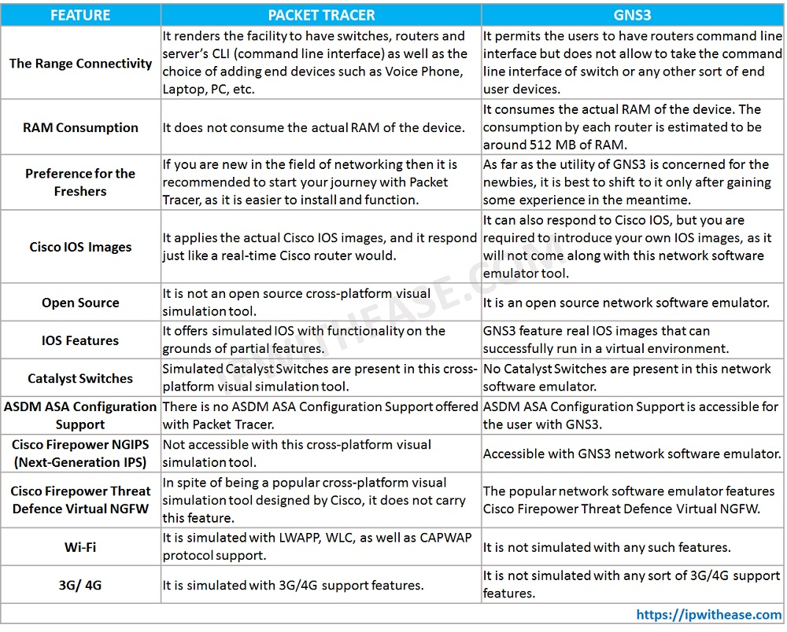

# Figure 2.1

**(source: https://ipwithease.com/gns3-vs-packet-tracer/)**

**Network Simulator of Choice**

Based on the comparison table, there are many limitations and requirements to using Graphical Network Simulator 3. Therefore, Cisco Packet Tracer could be the better choice for this

Project.

# 2.17 Methodology for the project

**Cisco PPDIOO Lifecycle Methodology**

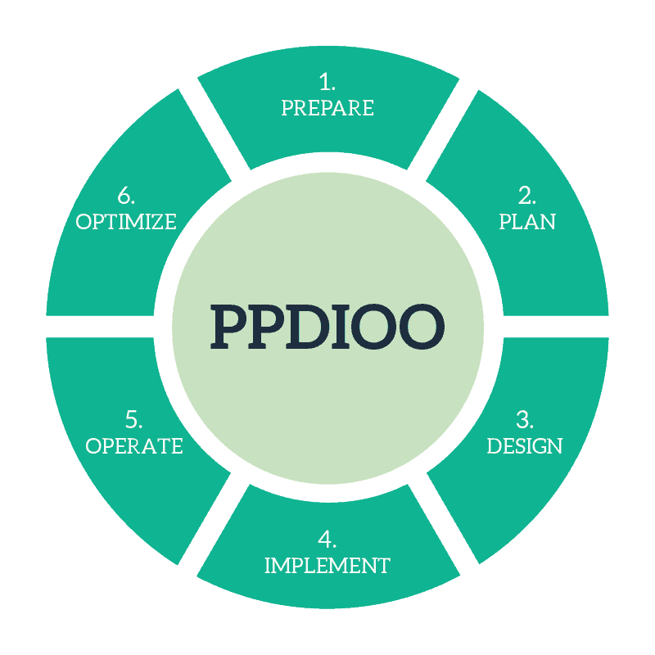**s**

Cisco defines the network life cycle as PPDIOO (Prepare, Plan, Design, Implement, Operate, and Optimize). The key benefit of PPDIOO, like SONA, is that it lowers TCO (total cost of ownership) by allowing you to examine and confirm technological needs early in the process. You may also appropriately prepare for changes in infrastructure and resource requirements. PPDIOO also improves network availability since we utilize a good and reliable network architecture and validate our network operations on our own. It also makes network resources and applications more accessible. One thing to keep in mind is that your network life cycle may not require you to go through all of the phases in the specified sequence. It's quite possible that you'll go through the preparation, planning, design, and implementation phases, and then you'll have to go back to the planning phase to make some modifications, and then to the design phase to incorporate the changes into the design.

Planning and creating a communications network is known as network design. Identifying business and technical needs is the first step in network design, which continues until shortly before the network deployment stage (when you actually do the work to deploy and configure what was designed). Network analysis, IP addressing, hardware selection, and implementation planning are all part of the network design process. Network design is an easy procedure in simple networks, such as those found in most households and small workplaces. The network design process in big corporate networks is frequently complicated and involves a number of parties. (Petryschuk, 2021)

**Prepare**

The preparation phase entails determining the organization's or business's requirements as well as the business's objectives. It also includes the company's board of directors and top management to debate technology strategy, suggest high-level conceptual design, and list all other conceivable infrastructures that may be deployed, as well as identify the technology that can well support the architectures. Aside from that, a business case is needed to justify the proposed architecture and overall network strategy financially.

**Plan**

This part of the planning process includes gathering all relevant data and identifying network requirements, such as where the network will be installed and who will require specific network services, all of which are determined by the network goals. The project plan must allocate the resources required prior to the design and implementation phases, which include the creation of a network security plan and the creation of a project schedule that helps to match the cost, resource parameter, and scope that were already established within the original business requirement. It is also necessary to research the network management software that was utilized to complete the network plan. Configuration management, security management, accounting management, fault management, and performance management are all aspects of the network administration process that must be addressed.

**Design**

In the design phase, data from the preceding two stages is gathered and refined to create a complete network architecture that meets technical requirements and current business needs, as well as standards for availability, dependability, performance, scalability, and security. This stage might potentially serve as a springboard for implementation.

**Implement**

The network, as well as any other new components, will be built based on the design standards in order to integrate devices during the implementation phase. Aside than that, it was primarily about setup and operation. In fact, it enables you to define all of the device setups as well as the associated time. In the implementation phase, it's a good idea to establish and set up a test bed to simulate various aspects of network architecture. Indeed, after the problem or issue has been handled inside the test bed, full-scale implementation may begin. Furthermore, before moving on to the next step, all of the modifications made in this phase must be tested.

**Operate**

The operate phase will entail preserving the network infrastructure's health through day-to-day operations, which will also include lowering costs and maintaining high network availability. It also entails component management, report creation, operating system upgrades, monitoring, and route maintenance. This phase entails doing real testing of the network architecture in order to uncover network-related faults and monitor the operation of various network equipment and devices. This is also the time when the firm is running without making any significant network improvements. During this phase, the organization will devote the bulk of its resources to network administration, which will involve reactive and proactive network monitoring, troubleshooting, performance management, capacity planning and monitoring, and security management. Finally, in the operate phase, performance monitoring, fault identification, and rectification will offer the starting data for the optimize phase.

**Optimize**

The optimal phase is based on proactive network management, which allows for the identification and resolution of issues. It then moves to the whole network, which is based on excellent design. In reality, the optimize phase allowed for changes to the network architecture if a problem arose. It allows you to return to a prior step when addressing an issue. Return to the plan or prepare step to make modifications, then move to the optimize or operate phase to test the network architecture once more. Besides, the current technical and business requirements will be compared to that being used during the network that was initially designed. If there are changes recommended, the phases can start all over again form beginning or previous phase to ensure that the consistency as well as the ongoing good design of the network. Other than that, if there are too many problems encountered or error arise or the outcome and the performance does not meet the expectation, optimize phase may lead to redesign the network in order to state to the point as well as back to the track of what has stated during the beginning of the project.

# CHAPTER 3

# METHODOLOGY AND PROJECT PLAN

# 3.1 Methodology

Cisco PPDIOO lifecycle approach is the technique that I would want to use for Norris Shai Wealth Management and Advisory in this project. Prepare, Plan, Design, Implement, Operate, and Optimize are the six steps of this process (PPDIOO). I chose Cisco PPDIOO lifecycle over other methodologies because it helps to minimize network cost of ownership, enhance network agility, speed up access to services and applications, and boost network availability. Furthermore, it is not required to follow this procedure in order to complete all of the phases. In fact, it permits you to freely return to a prior phase to make modifications.

**Prepare**

In the prepare phase, I have visited and interviewed with top management of Norris Shai Wealth Management and Advisory. During the interview, I have understood about their business requirements and the problems liaises within them, I proposed and demonstrated the most suitable network structure for them based on their organization structure. After the demonstration, they agree the network structure that I have proposed which is the combination of both wired and wireless network as well as my advice to upgrade their internet package.

**Plan**

In the planning phase, I have doing research and collect the information and resources that used to apply to this project. The information and resources during the research are included choosing the right ethernet cables to differentiate between Cat5e and Cat6, comparison between wired and wireless network, comparison between IPv4 and IPv6 for the network design, research about what is DHCP and the importance of DHCP and why it is needed for the network design, clarify what is DNS and compare between Google Public DNS and Cloudflare DNS, discover network security and Demilitarized Zone (DMZ) to explain why it is needed, choosing the right Virtual Private Network (VPN) in which compare between OpenVPN Access Server and SoftEther VPN and explain what is Virtual Local Area Network (VLAN) and the importance of VLAN toward the network design. Besides security for LAN, security for the wireless network is also important. Therefore, I have also discovered what is wireless network and security which making comparison among Wired Equivalent Privacy (WEP), Wi-Fi Protected Access (WPA), Wi-Fi Protected Access 2 (WPA2) and Wi-Fi Protected Access 3 (WPA3). Other than that, I have also research about the protection that offer by router and making comparison between Layer 3 Firewalls (Network Firewalls), Layer 7 Firewalls (Application Firewalls). For the file server, I have compared between Seafile and Windows Server whereas the network simulator I have making compare between Network Simulator 3 and Cisco Packet Tracer.

**Design**

In the design phase, I redefine the business requirements and also decided the components that used to apply into the design. At the same time, Norris Shai Wealth Management and Advisory has decided and already upgrade their network package to Unifi Business 100Mbps. The components that used for the network design would be Cat6 ethernet cable, SoftEther VPN, apply IPv4, Cisco Packet Tracer, DHCP, Layer 7 Firewall (TinyWall), Windows Server 2022 with Active Directory, Wi-Fi Protected Access 2 (WPA2), Google Drive, VLAN and Cloudflare DNS to develop a comprehensive network design that shown in Figure below. After that, I deployed and show up the comprehensive network design toward Norris Shai Wealth Management and Advisory.

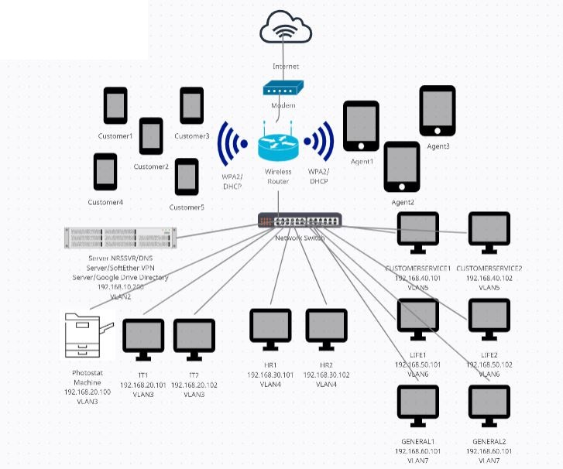

## Figure 3.0 Comprehensive Network Design

**Implement**

In the implement phase, I start to build the network design based on components that has been allocated based on the comprehensive network design as well as the design specification that has been stated in the design phase. In this state, I start to setup the modem and wireless router and allow dedicated agents and customer to join in. Besides, I also allocate static IPv4 and Cloudflare DNS as well as setting up VLAN for every desktop computer and then proceed to install and configure Windows Server 2022 and Active Directory, setting up Google Drive as well as setup SoftEther VPN server and VPN client for the desktop computers to join in. By the way, I’m not going to forget to implement the Layer 7 firewall (TinyWall), enable wireless security (WPA2) to protect the asset of Norris Shai Wealth Management and Advisory against unauthorized access. At the same time, I start to setup a test bed by using Cisco Packet Tracer and start to test all the components in various aspect. This is because I want to observe and trace the problems of each of the components within the Cisco Packet Tracer and resolve it as soon as possible. After that I start to perform full-scale implementation when all of the problems have been resolved and then proceed to the next phase. (Kindly refer Appendix for the implementation and configuration work)

**Operate**

In the operate phase, I have demonstrated the result of the network design toward Norris Shai Wealth Management and Advisory. After I teach all the users, they start to use it and test it whether it fulfil their need or not. At the same time, I start to monitor the network design day by day in order to collect the feedbacks and reviews from the users of Norris Shai Wealth Management and Advisory in the sense of performance, fault, trouble, and security. Based on the user review, I have generated a report based on the feedback that given by the user and find out that most of the users say that the system is acceptable as expected.

**Optimize**

In the optimize phase, I start to optimize the network design by perform modifying and troubleshooting the network design based on the feedbacks and reviews of the user that collected during operate phase in order to meet customer’s expectation. In this state, it will be involved in going back phase to phase to identify and solve the problem of the network design. If there is still too many problems encountered, I have to start all over again to redesign the network. Otherwise, I start to make a conclusion. Based on the conclusion, the user of Norris Shai Wealth Management and Advisory are enjoyed to using the whole new network system as well as the advantage that bring in. For the recommendation and future work, the users are recommended that using of VPN router and Quality of Server (QoS) would be good for idealistic setup in the future.

# 3.2 Final Project Plan

|  |  |  |  |
| --- | --- | --- | --- |
| **TASK** | **START** | **END** | **Duration** |
| Selection Type Of Project | Fri, 23/4/2021 | Thu, 29/4/2021 | 6 |
| Meeting With Supervisor | Fri, 30/4/2021 | Sun, 02/5/2021 | 2 |
| Prepare Phase | Mon, 03/5/2021 | Wed, 26/5/2021 | 23 |
| Interview With Top Management | Mon, 03/5/2021 | Mon, 10/5/2021 | 7 |
| Establish Business Requirement | Mon, 03/5/2021 | Mon, 10/5/2021 | 7 |
| Confirmation Of Project Type | Tue, 11/5/2021 | Wed, 26/5/2021 | 15 |
| Planning Phase | Thu, 27/5/2021 | Thu, 01/7/2021 | 35 |
| Identify Network Requirement | Thu, 27/5/2021 | Thu, 03/6/2021 | 7 |
| Allocate Resources | Fri, 04/6/2021 | Mon, 14/6/2021 | 10 |
| Finalize Network Plan | Tue, 15/6/2021 | Thu, 01/7/2021 | 16 |
| Meeting With Supervisor | Fri, 02/7/2021 | Sun, 04/7/2021 | 2 |
| Submission Of TMA1 | Mon, 05/7/2021 | Tue, 06/7/2021 | 1 |
| Gather and Refine Informations | Wed, 07/7/2021 | Wed, 14/7/2021 | 7 |
| Meeting With Supervisor | Thu, 15/7/2021 | Sat, 17/7/2021 | 2 |
| Design Phase | Sun, 18/7/2021 | Tue, 21/9/2021 | 65 |
| Comprehensive Network Design | Sun, 18/7/2021 | Mon, 30/8/2021 | 43 |
| Checking Of Specifications | Tue, 31/8/2021 | Mon, 20/9/2021 | 20 |
| Implement Phase | Tue, 21/9/2021 | Mon, 15/11/2021 | 55 |
| Setup Test Bed | Tue, 21/9/2021 | Fri, 01/10/2021 | 10 |
| Identify Problem | Sat, 02/10/2021 | Tue, 12/10/2021 | 10 |
| Solve the Problem | Wed, 13/10/2021 | Sun, 31/10/2021 | 18 |
| Full-Scale Implementation | Mon, 01/11/2021 | Tue, 16/11/2021 | 15 |
| Meeting With Supervisor | Wed, 17/11/2021 | Fri, 19/11/2021 | 2 |
| Submission Of TMA2 | Sat, 20/11/2021 | Sun, 21/11/2021 | 1 |
| Meeting With Supervisor | Tue, 30/11/2021 | Thu, 02/12/2021 | 2 |
| Deploy Network Design | Mon, 22/11/2021 | Mon, 29/11/2021 | 7 |
| Operate Phase | Fri, 03/12/2021 | Sat, 22/1/2022 | 50 |
| Performance Monitoring | Fri, 03/12/2021 | Fri, 07/1/2022 | 35 |
| Fault Detection | Fri, 03/12/2021 | Fri, 07/1/2022 | 35 |
| Making Correction | Sat, 08/1/2022 | Sat, 22/1/2022 | 14 |
| Optimize Phase | Sun, 23/1/2022 | Fri, 04/3/2022 | 40 |
| Identify Issue | Sun, 23/1/2022 | Tue, 22/2/2022 | 30 |
| Resolve Issue | Sun, 23/1/2022 | Tue, 22/2/2022 | 30 |
| Gather Result and Generate Final Report | Wed, 23/2/2022 | Sun, 13/3/2022 | 18 |
| Meeting With Supervisor | Mon, 14/3/2022 | Wed, 16/3/2022 | 2 |
| Submission Of TMA3 | Thu, 17/3/2022 | Fri, 18/3/2022 | 1 |
| End Of Project | Sat, 19/3/2022 | Sun, 20/3/2022 | 1 |

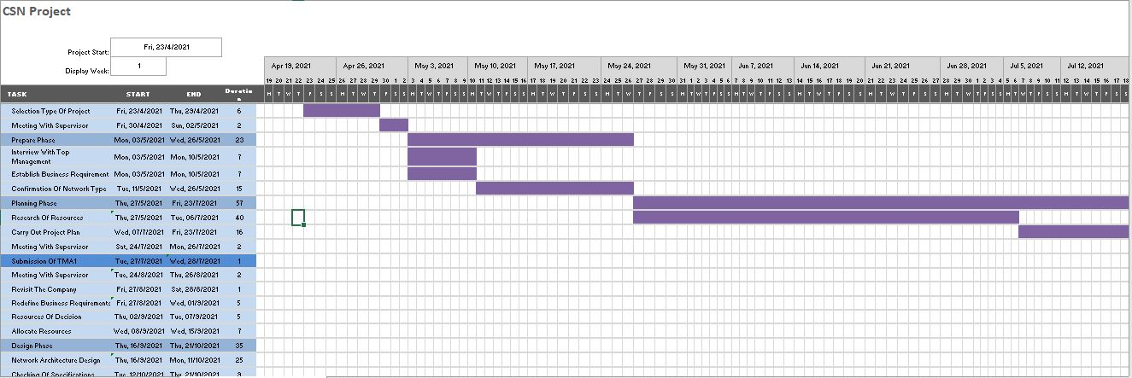

Please refer CSN Project.xlsx for the full version of Gantt Chart

The purpose of the final project plan is to clearly demonstrate each one every task that has been done as well as the duration that required for the entire project.

In order to carry out the final project plan, I meet with my project supervisor Mr. HO HSIAO FOONG @ HO HSIEH HSIUNG to discuss about the type of project that suitable for Norris Shai Wealth Management and Advisory. During the meeting, we list down some of the possible type of project for Norris Shai Wealth Management and Advisory before we going to finalize the choice. In the prepare phase, I organized an interview with top of management of Norris Shai Wealth Management and Advisory. During the interview, we are going to discuss about establish business requirement that we need and the business goals that they want to succeed. After that, I show up all the possible network architecture that previously discuss with project supervisor to them based on their network environment for them to confirm the network type they want. I visit Norris Shai Wealth Management and Advisory and gather all the information and identify network requirements. After that, I allocate the resources and finalize the network plan. In the design phase, I am refining the information that gathered from prepare and planning phases and develop a comprehensive network design and start to perform testing whether the network design is meet the specifications or not before proceeding to implement phase. In the implement phase, I am setting up a test bed to test over the function as well as the performance of each of the additional services and components that has been setup. At the same time, I am also collecting the information and result from the test bed and figure out the potential problem that might be happen and resolve it within the test bed and then perform full-scale implementation and proceed to next phase. In the operate phase, I deploy the network design to Norris Shai Wealth Management and Advisory to use it and test around the network services that provide to them. At the same time, I keep monitoring and maintaining the overall performance of the network design and making correction. In optimize phase, this is the phase that keep identify and resolve the network issue of the entire network design as well as sum up and gathering the result and generate final report and the project will come to an end.

For further detail of prepare phase to optimize phase of the project, kindly refer to 3.1 Methodology.

# 3.3 Development Tools

The development tools that have been used for this project are included:

* **Ethernet Cat6 cable –** Connect to all the desktop computer for the internal staff, photostat machine and server NRSSVR
* **Canon Photostat Machine imageRUNNER ADVANCE iR-ADV C2220 –** Perform printing, copying and scanning the documents
* **Lenovo ThinkCentre Desktop Computer Intel(R) Core(TM) i5-4460 CPU @ 3.20GHz for both Windows 10 Pro and Windows Server 2022 –** Desktop computer that contain Window 10 Pro that used to setup VirtualBox and Window Server 2022
* **Cisco Packet Tracer 7.2 64Bit –** Simulate the new network architecture of Norris Shai Wealth Management and Advisory
* **Tinywall 3.2 –** Protect the data and information that store in Server NRSSVR
* **VirtualBox 6.1 –** Application that used to setup Window Server 2022
* **Window 10 Pro –** Serve as domain user of internal staff that access the data in Server NRSSVR
* **Windows Server 2022 and AD (Active Directory) –** Setup in VirtualBox that serve as file directory for domain user to access as well as the information for dedicated agents and customers
* **Softether-vpnserver_vpnbridge-v4.38-9760-rtm-2021.08.17-windows-x86_x64-intel –** Setup in Server NRSSVR that allow vpn client to connect
* **Softether-vpnclient-v4.38-9760-rtm-2021.08.17-windows-x86_x64-intel –** Setup in domain user’s desktop computer that used to connect the vpn server
* **Google Drive –** To allow dedicated agents and customers to access their information

# CHAPTER 4

# RESULT AND REVIEW

This is the most difficult part because it is where the implementation phase is going to begin that start to configure and develop the network design and then deploy to the company for them to perform testing as well as provides feedback or review after use. The result will divide into two parts which is logical view and physical view. Logical view represents the result of the whole development of the new that well being tested which only see by the network administrator network architecture whereas the physical view is actual result which truly seeing and able to perform testing by the end user and network administrator.

# 4.1 Research and Result Development

In this phase, the discussion will only involve the discussion and analysis base on the testing results after all the things ready enter to the final stage which is optimize. The testing results is focusing on analysis the information into a data that will turn into useful knowledge for further purposes of this project especially adding the new features in the file system. This is important to figure out needs of user in the company and to fulfil business goal in future.

# 4.2 New Network Architecture

**Logical View**



## Figure 4.0 Network Architecture Design of Norris Shai Wealth Management and Advisory

Figure above shows that the outcome of the network structure design for Norris Shai Wealth Management and Advisory which is the combination wired and wireless network. Based on the figure, it clearly shows that is consist of wireless router WRT300N which used to link to the tablet of the agents to perform the new business submission and checking information of the policy as well as connect to the smartphone of the customers to checking their information. Besides, it also connects to a PT-Router which connected to Managed Switch 2950T as wired network to connect the server (NRSSVR) that used as file sharing site, photostat machine as well as the desktop computers for all the departments (IT, HR, CUSTOMERSERVICE, GENERAL, LIFE) by which is separate into different VLAN. In fact, it is for the purpose to segregate into different groups based on the department in order to enhance the internal network security, but they can still communicate to each other. Besides, wireless devices are protected by wireless network security (WPA2). All desktop computers are connected to the server (NRSSVR) which is protected by Layer 7 Firewall (Application Firewall) (TinyWall). Other than that, all the internal staff are connect to server NRSSVR as a domain user in order to access the Shared Folder based on their department which is already set in Active Directory (AD) that used to store their documents for respective departments. Finally, photostat machine is having Department ID for respective department to monitor their usage and also scan folder directory for all the desktop computers.

|  |  |  |
| --- | --- | --- |
| **Department** | **VLAN Group** | **IP Ranges** |
| SERVER | VLAN2 | 192.168.10.x |
| IT | VLAN3 | 192.168.20.x |
| HR | VLAN4 | 192.168.30.x |
| CUSTOMER-SERVICE | VLAN5 | 192.168.40.x |
| LIFE | VLAN6 | 192.168.50.x |
| GENERAL | VLAN7 | 192.168.60.x |

## Table 4.0 VLAN Group

Table above shows that the VLAN and static IP address group for respective departments

|  |  |
| --- | --- |
| Department ID | Department |
| 20 | INFORMATION TECHNOLOGY |
| 30 | HUMAN RESOURCE |
| 40 | CUSTOMER SERVICE |
| 50 | GENERAL |
| 60 | LIFE |

## Table 4.1 Department ID

Table above shows that the Department ID for respective departments

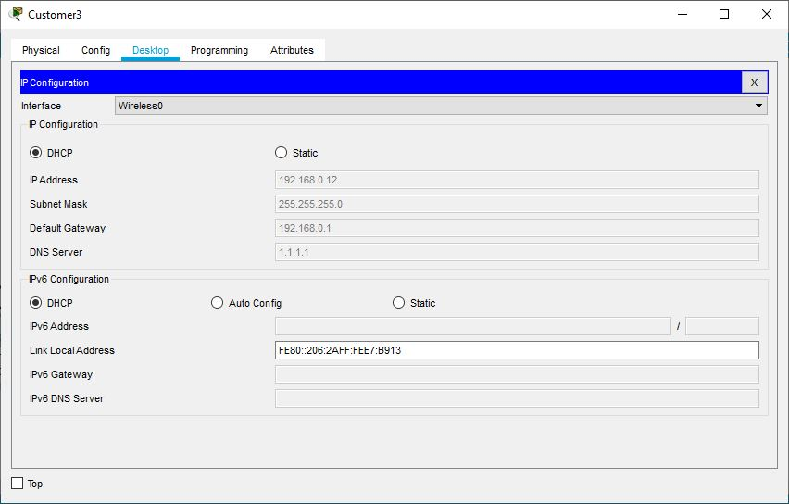

## Figure 4.1 Customer3 Connect to Wireless Network

Figure above shows that Customer3 is able to connect the wireless network, the wireless router is automatically assign DHCP, Subnet Mask, Default Gateway and Cloudflare DNS to the device

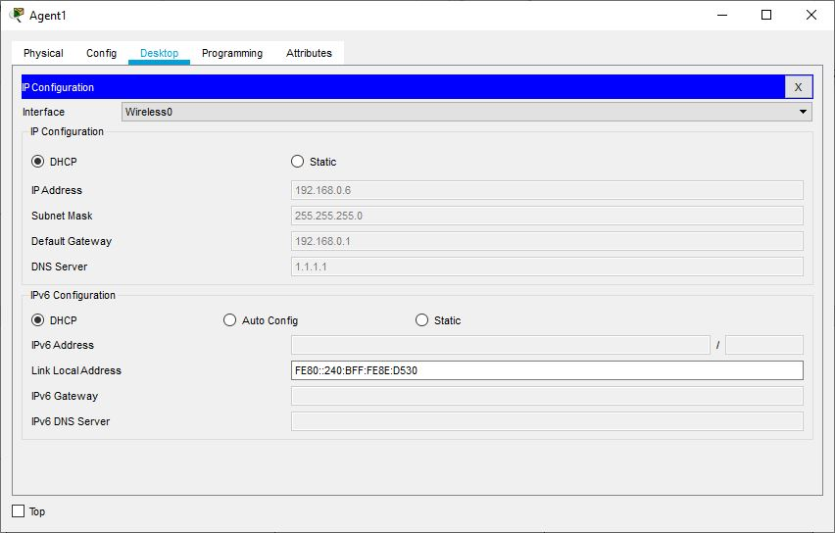

## Figure 4.2 Agent1 Connect to Wireless Network

Figure above shows that Agent1 is able to connect the wireless network, the wireless router is automatically assign DHCP, Subnet Mask, Default Gateway and Cloudflare DNS to the device

GENERAL1 IP : 192.168.60.101 (VLAN7)

NRSSVR IP : 192.168.10.200 (VLAN2)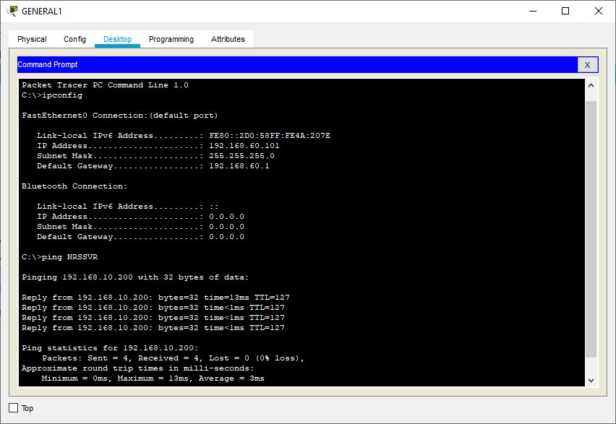

## Figure 4.3 VLAN Ping Test

Figures above shows that GENERAL1 is able to connect to Server NRSSVR

IT1 IP : 192.168.20.101 (VLAN3)

HR1 IP : 192.168.30.101 (VLAN4)

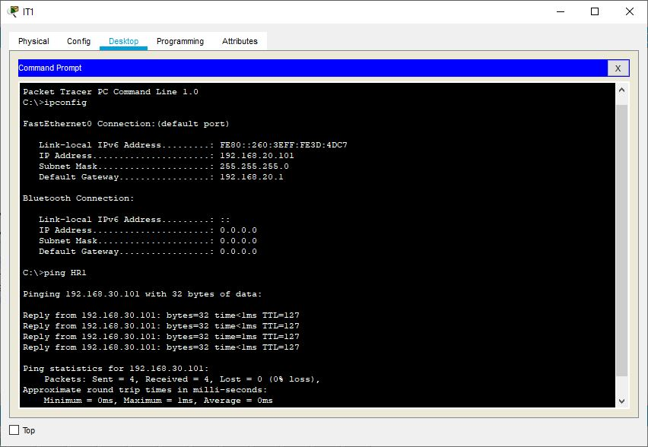

## Figure 4.4 VLAN Ping Test

Figures above shows that IT1 is connect to HR1 each other

LIFE1 IP : 192.168.50.101 (VLAN6)

Photostat Machine IP : 192.168.20.100 (VLAN3)

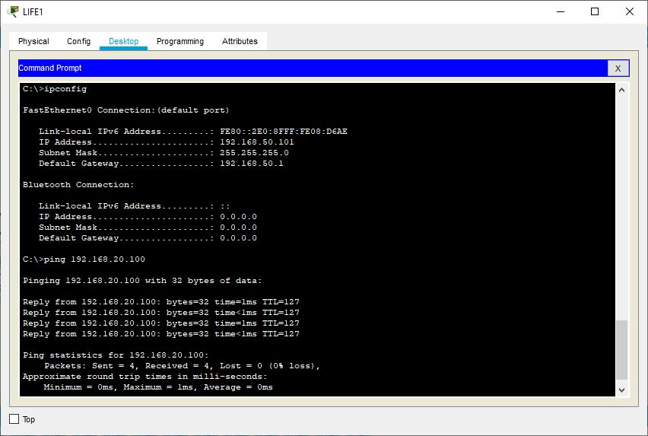

## Figure 4.5 VLAN Ping Test

Figures above shows that LIFE1 connect to the Photostat Machine

CUSTOMERSERVICE2 IP : 192.168.40.102 (VLAN5)

GENERAL2 IP : 192.168.60.102 (VLAN7)

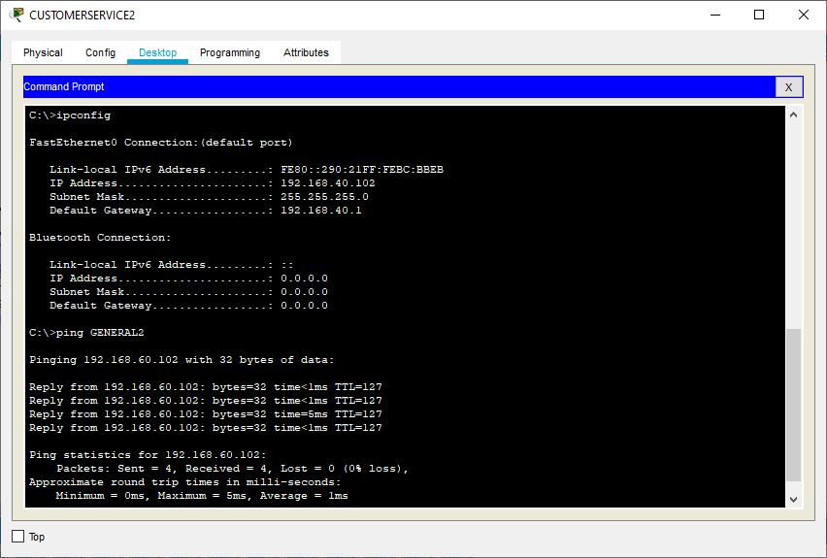

## Figure 4.6 VLAN Ping Test

Figures above shows that CUSTOMERSERVICE2 is connect to GENERAL2 to each other

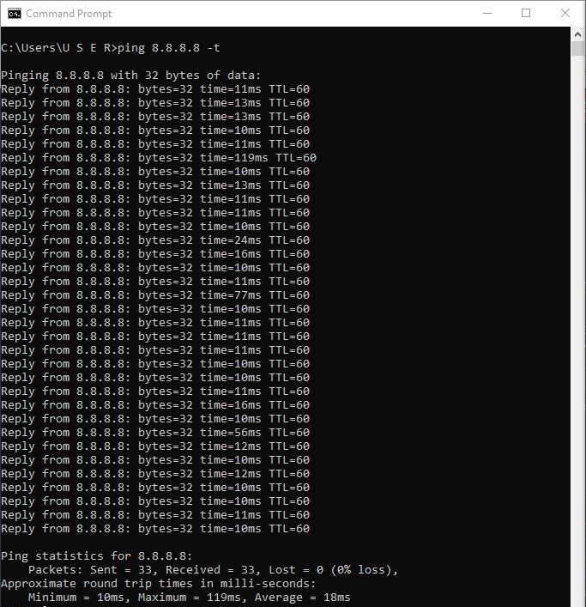

## Figure 4.7 Ping Test Result

Figure above show that the ping test of the network of Unifi Business 100Mbps is connect smoothly without single packet loss

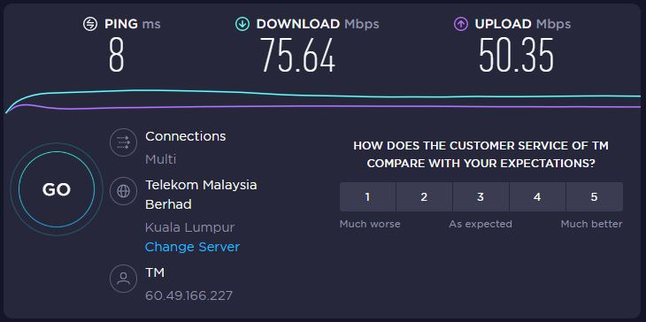

## Figure 4.8 Speed Test

Figures above shows that speed test and find out that the network performance improve dramatically after Norris Shai Wealth Management and Advisory change to Unifi Business 100Mbps.

**Physical View**

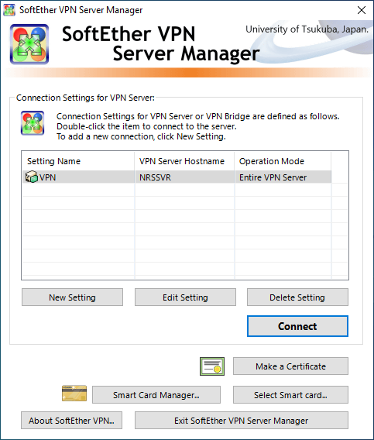

## Figure 4.9 SoftEther VPN Server

Figure above shows that the user interface of SoftEther VPN Server

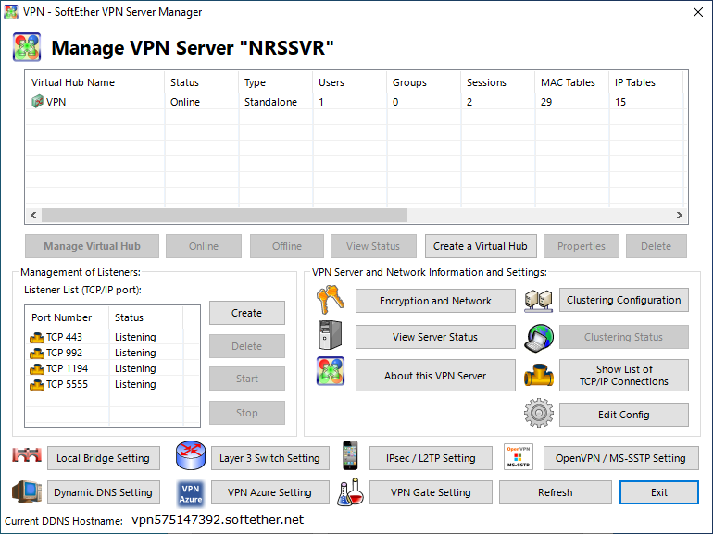

## Figure 4.10 SoftEther VPN Server Connected

Figure above shows that the SoftEther VPN Server is connected

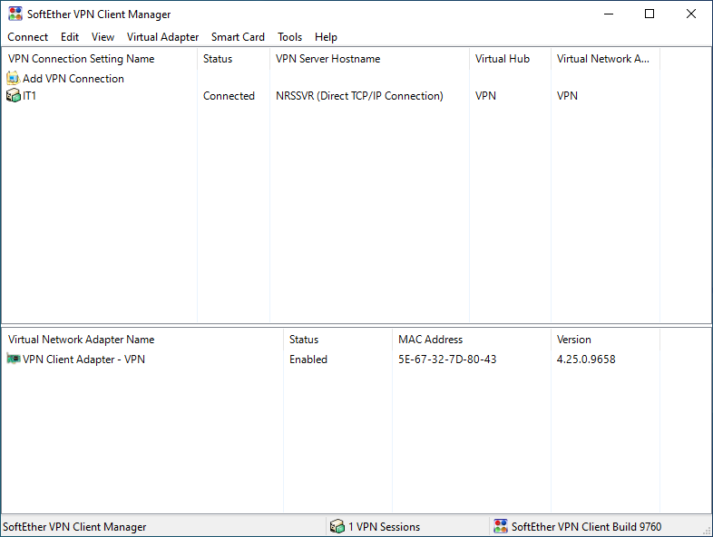

## Figure 4.11 SoftEther VPN Client

Figure above shows that the connection between SoftEther VPN Client and SoftEther VPN Server is established

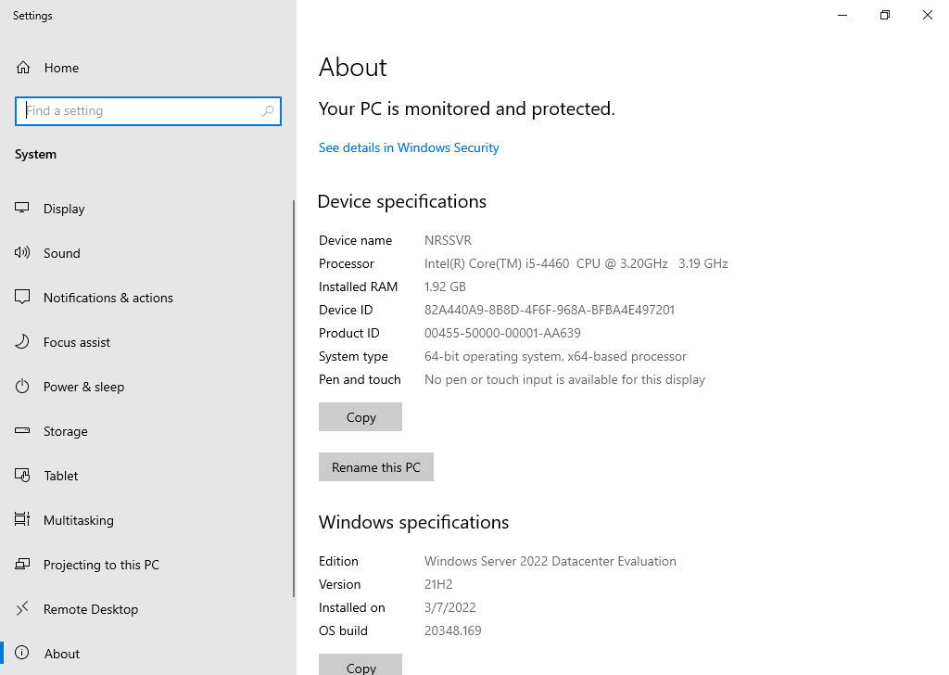

## Figure 4.12 Specification of Server (NRSSVR)

Figure above shows that the specification of Server (NRSSVR)

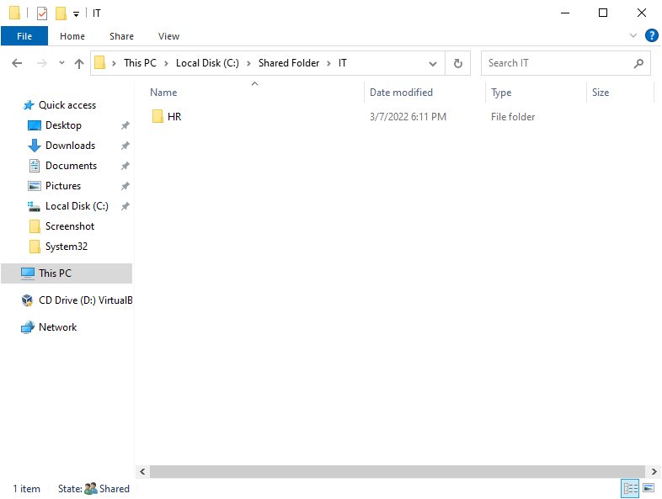

## Figure 4.13 Shared Folder for Each Department

Figure above shows that the shared folder location for each of the department within the Server NRSSVR

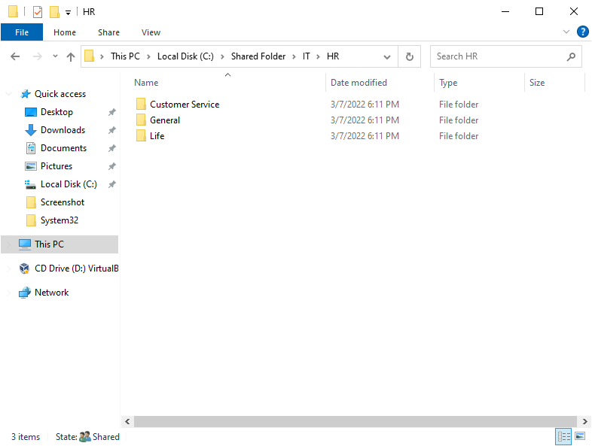

## Figure 4.14 Shared Folder for Each Department

Figure above shows that the shared folder location for each of the department within the Server NRSSVR

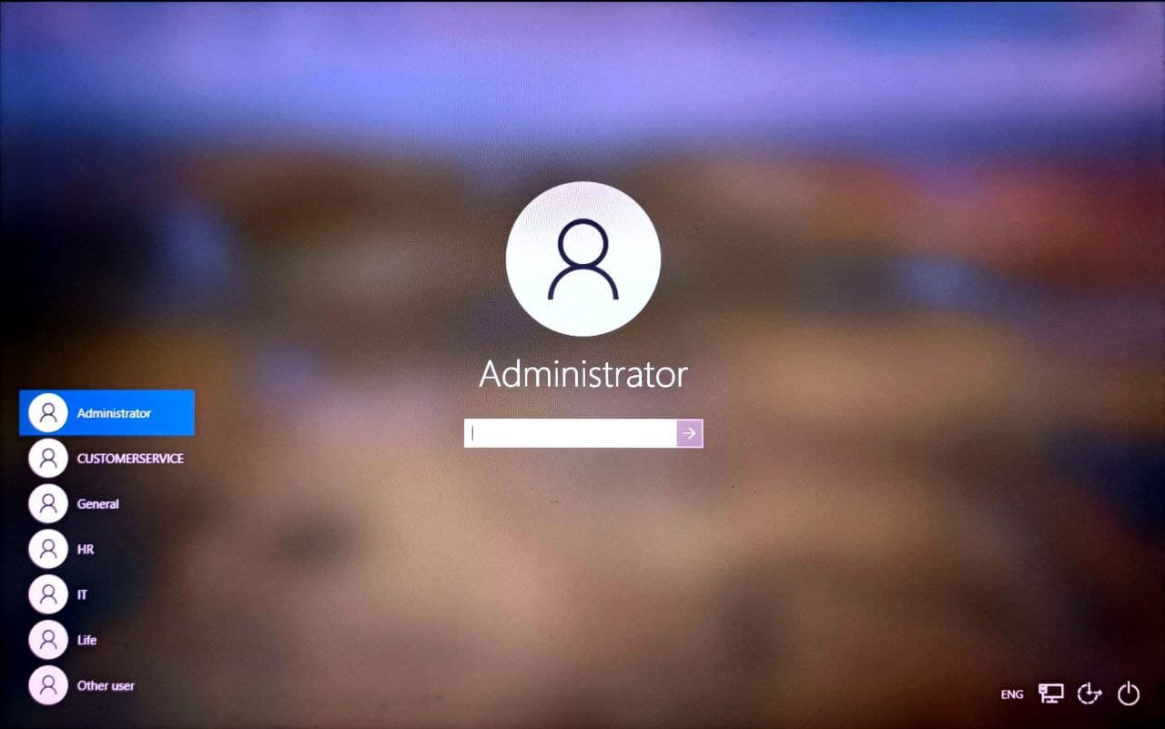

## Figure 4.15 Domain User for Each Department

Figure above shows that the login user interface for the domain user for each of the department

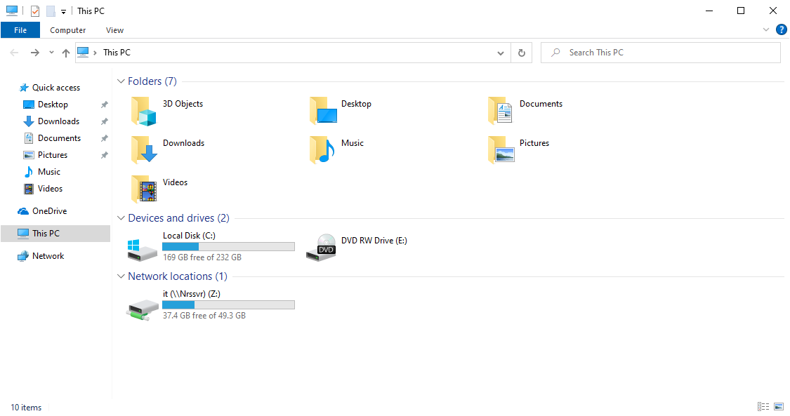

## Figure 4.16 Shared Folder Access for IT Department

Figure above shows that the shared folder access for the domain user of IT department

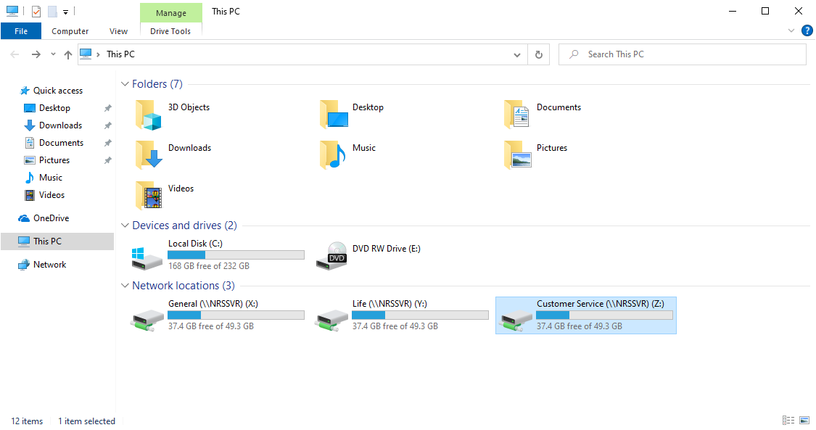

## Figure 4.17 Shared Folder Access for Customer Service Department

Figure above shows that the shared folder access for the domain user of Customer Service department. In fact, Customer Service, Life and General department having the same level of permission access. Therefore, they can use their credential to access Life and General department.

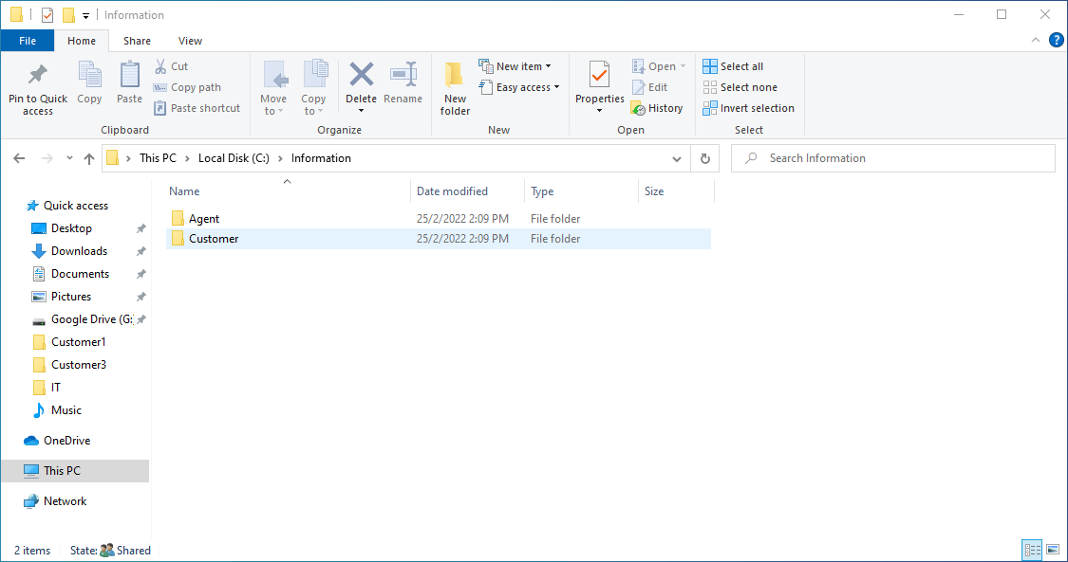

## Figure 4.18 Google Drive Directory for Dedicated Agents & Customers in NRSSVR

Figure above shows that the Google Drive Directory for Dedicated Agents & Customers within Server NRSSVR

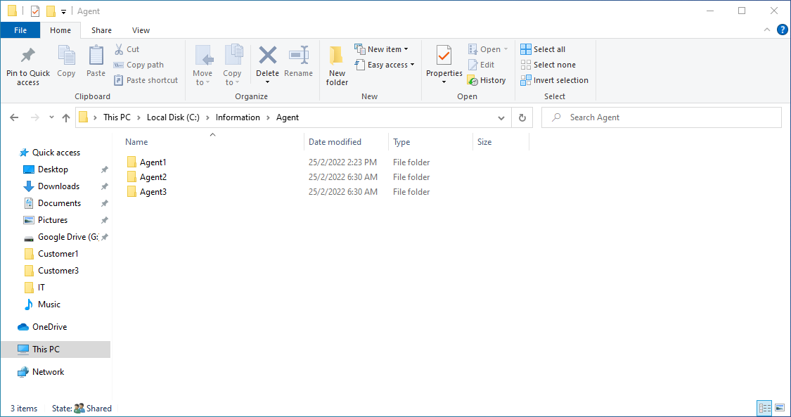

## Figure 4.19 File Server Directory for Dedicated Agents & Customers in NRSSVR

Figure above shows that the Google Drive Directory for Dedicated Agents & Customers within Server NRSSVR

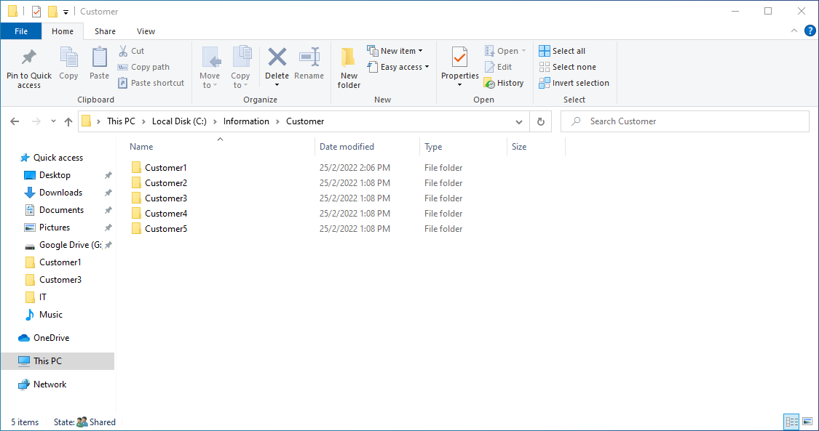

## Figure 4.20 File Server Directory for Dedicated Agents & Customers in NRSSVR

Figure above shows that the Google Drive Directory for Dedicated Agents & Customers within Server NRSSVR

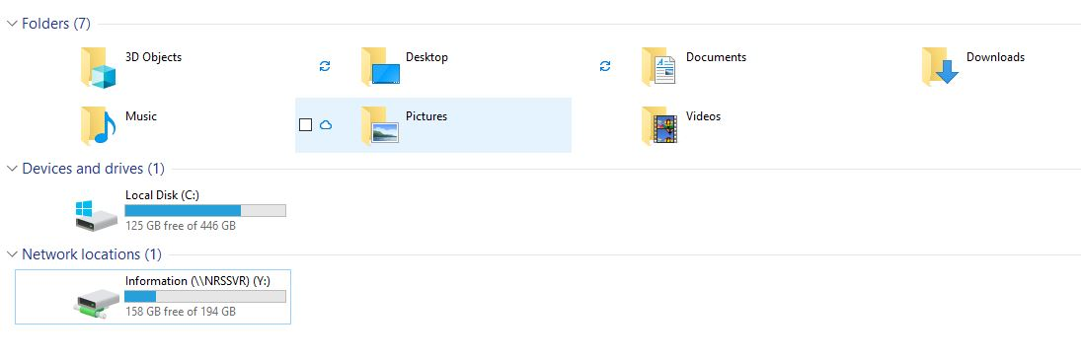

## Figure 4.21 Google Drive Directory Access for Dedicated Agents & Customers for Internal Staff

Figure above shows that the Google Drive Directory Access for Dedicated Agents & Customers for Internal Staff

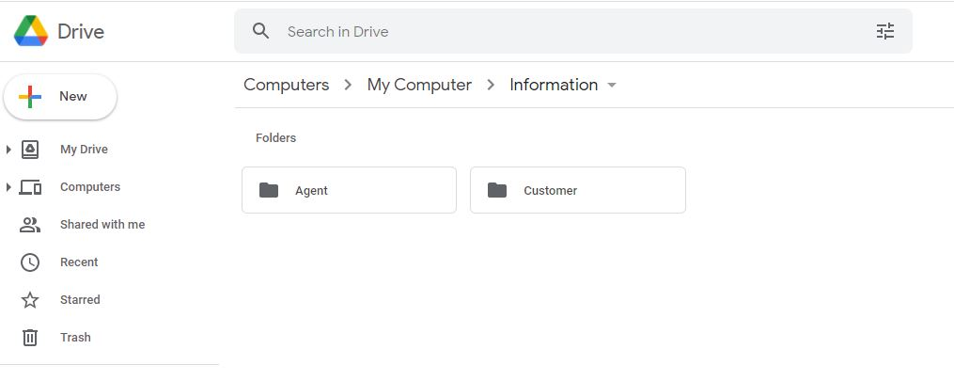

## Figure 4.22 Google Drive Folder for Dedicated Agents & Customers

Figure above shows that the Folder for Dedicated Agents & Customers within Google Drive

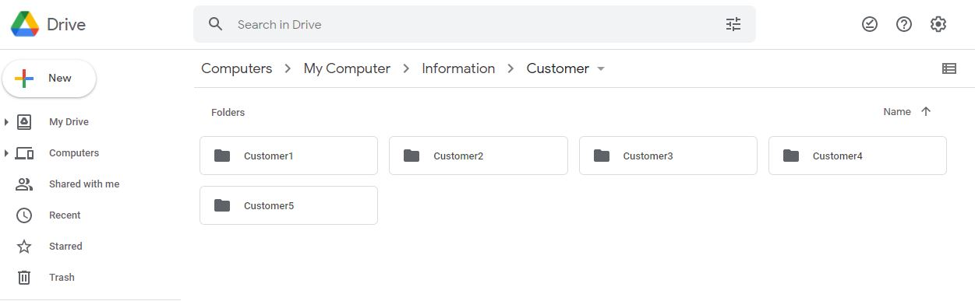

## Figure 4.23 Google Drive Folder for Dedicated Agents & Customers

Figure above shows that the Folder for Dedicated Agents & Customers within Google Drive

Folder for Dedicated Agents & Customers within Google Drive **c**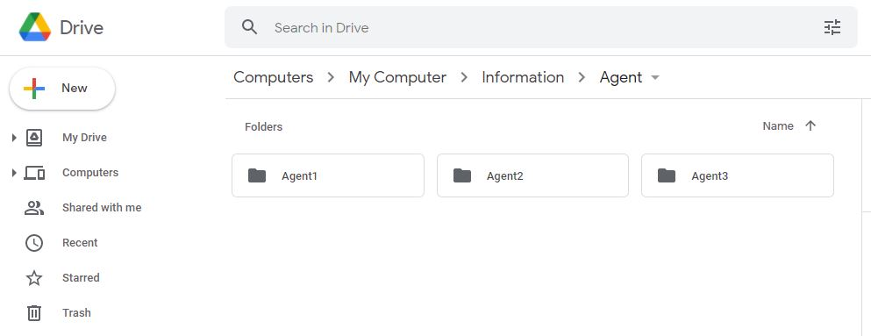

## Figure 4.24 Google Drive Folder for Dedicated Agents & Customers

Figure above shows that the Folder for Dedicated Agents & Customers within Google Drive

i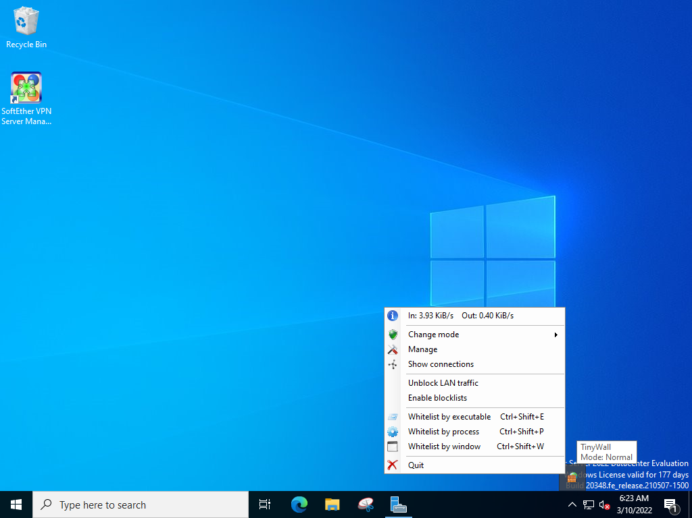

## Figure 4.25 Starting TinyWall

Figure above shows that the service of TinyWall has started

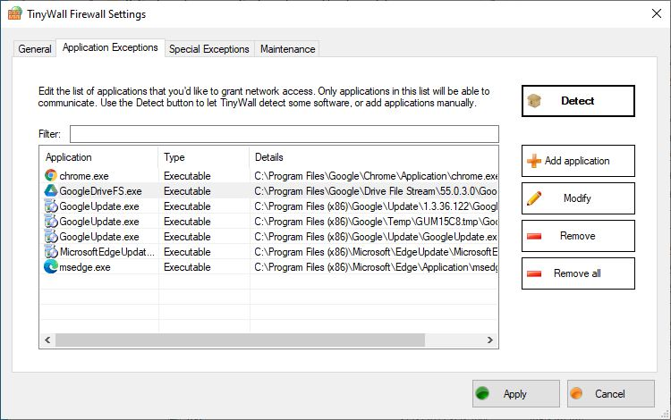

## Figure 4.26 TinyWall Application Exception

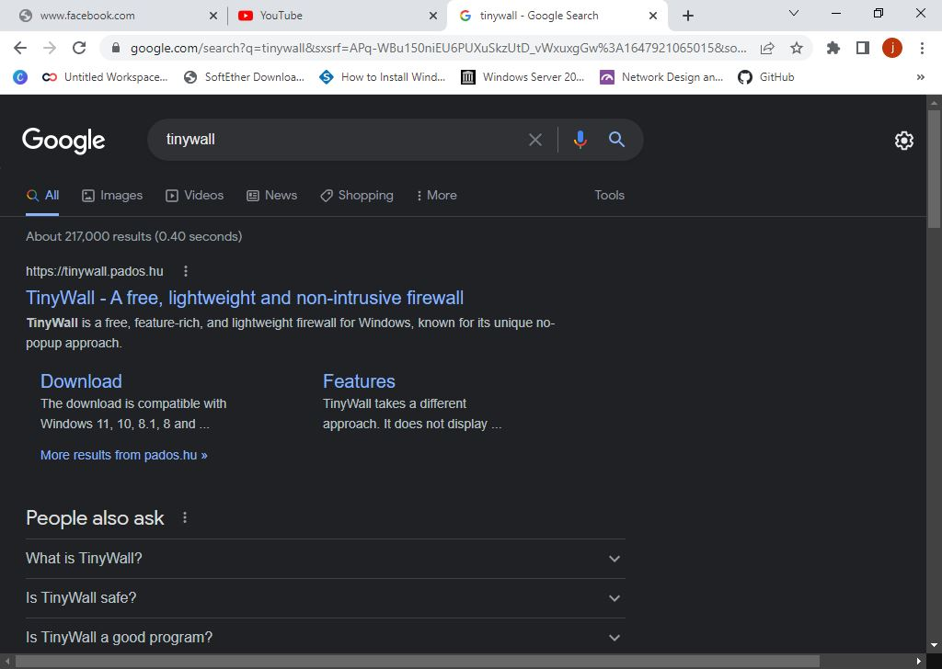

## Figure 4.27 TinyWall Allow Internet Access

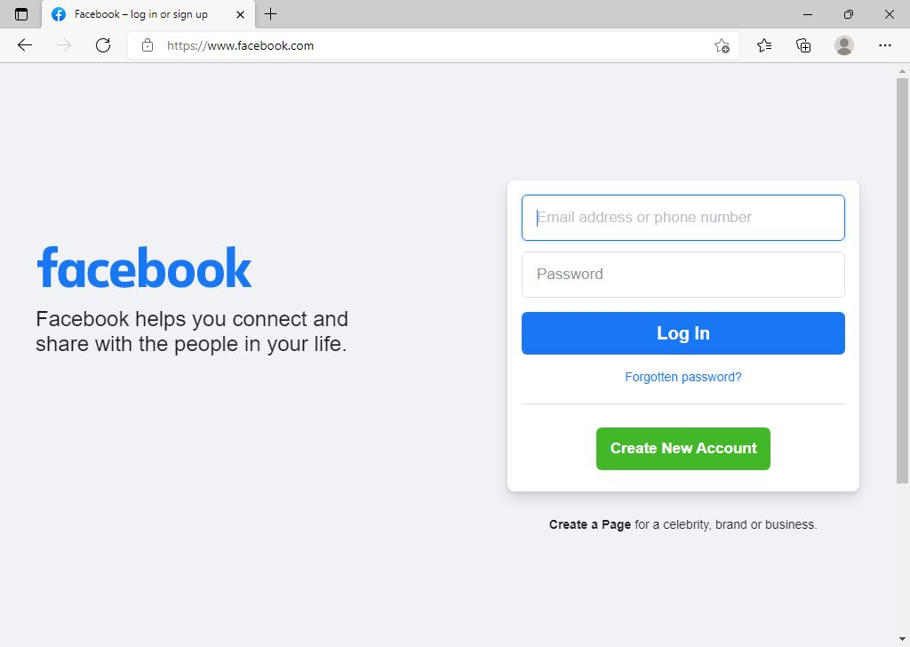

## Figure 4.28 TinyWall Allow Internet Access

Figures above shows that the Server NRSSVR is able to access to the internet when the browser is in the application exception list

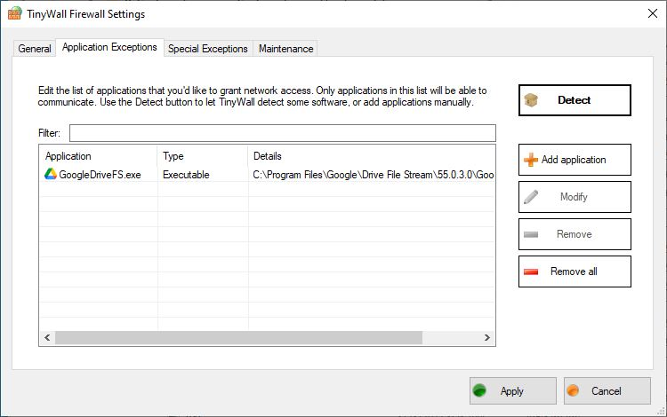

## Figure 4.29 TinyWall Application Exception

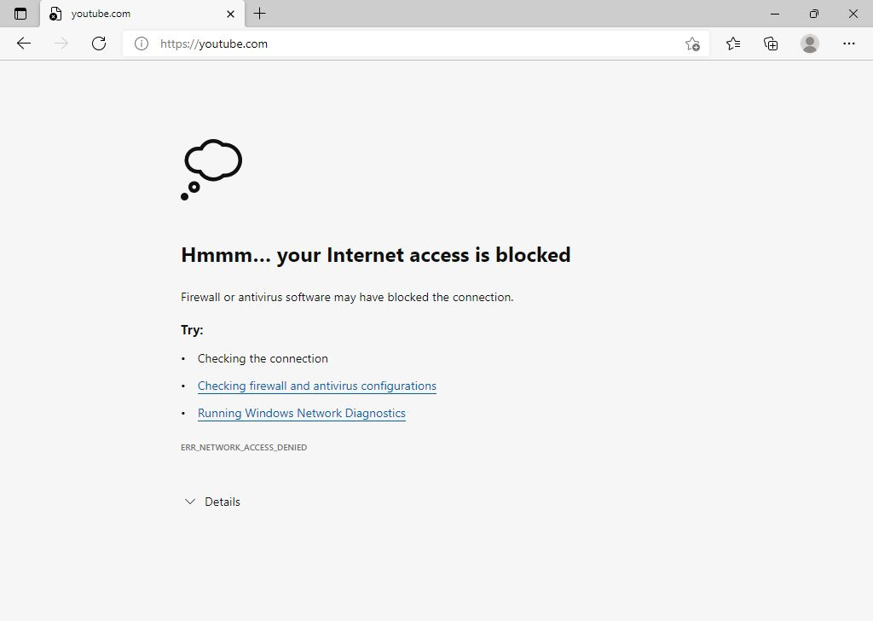

## Figure 4.30 TinyWall Not Allow Internet Access

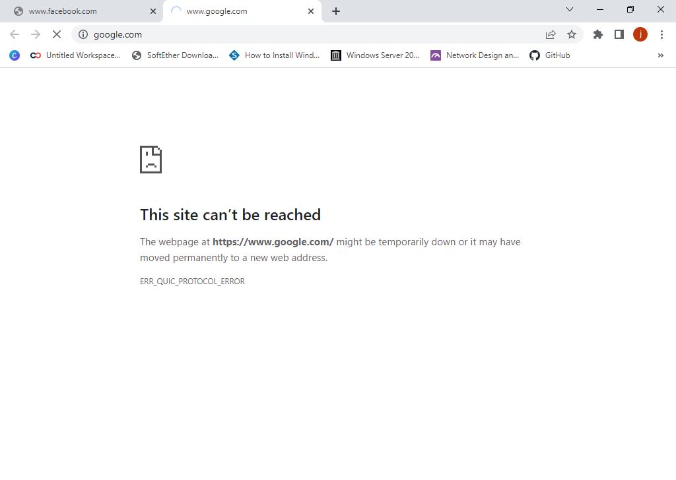

## Figure 4.31 TinyWall Not Allow Internet Access

Figures above shows that the Server NRSSVR is not able to access to the internet when the browser is not in the application exception list

## 4.3 User Testing

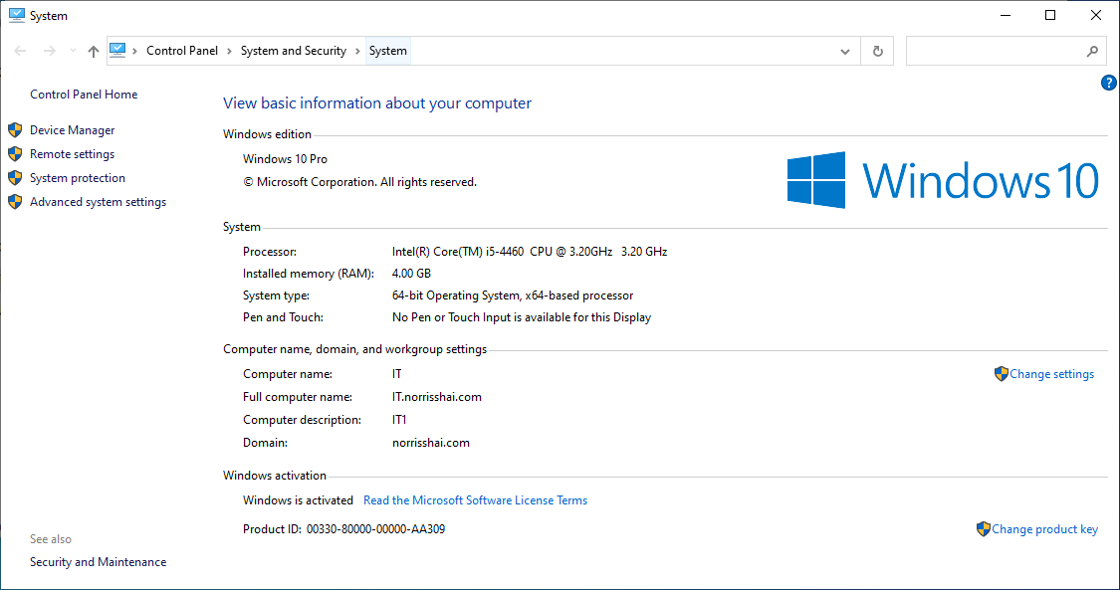

## Figure 4.32 Domain Access of User IT1

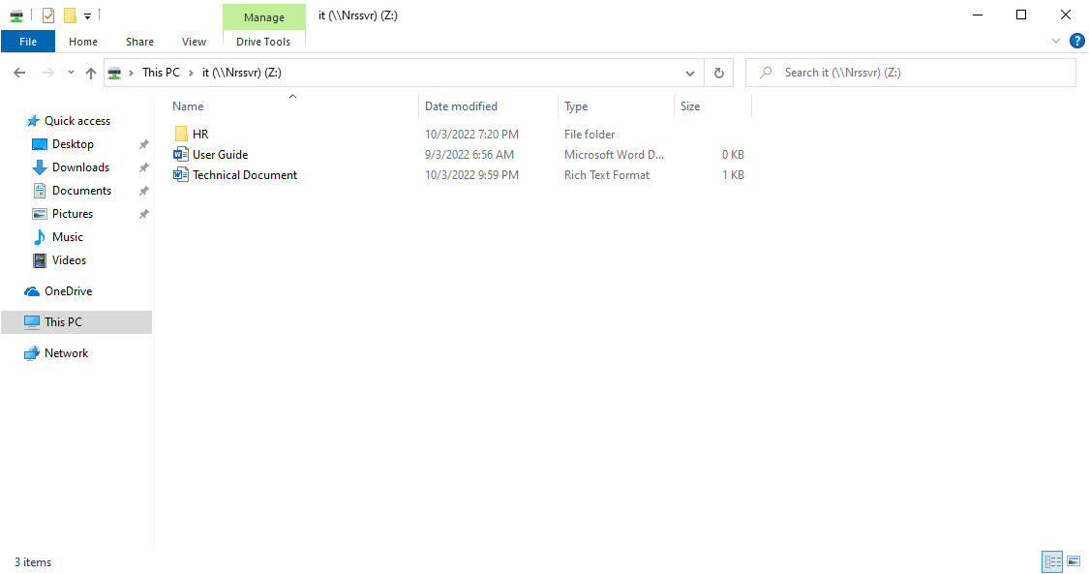

## Figure 4.33 Access of Shared Folder of IT1

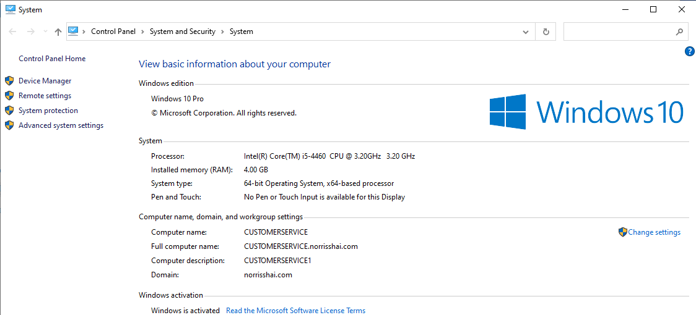

## Figure 4.34 Domain Access of User CUSTOMERSERVICE1

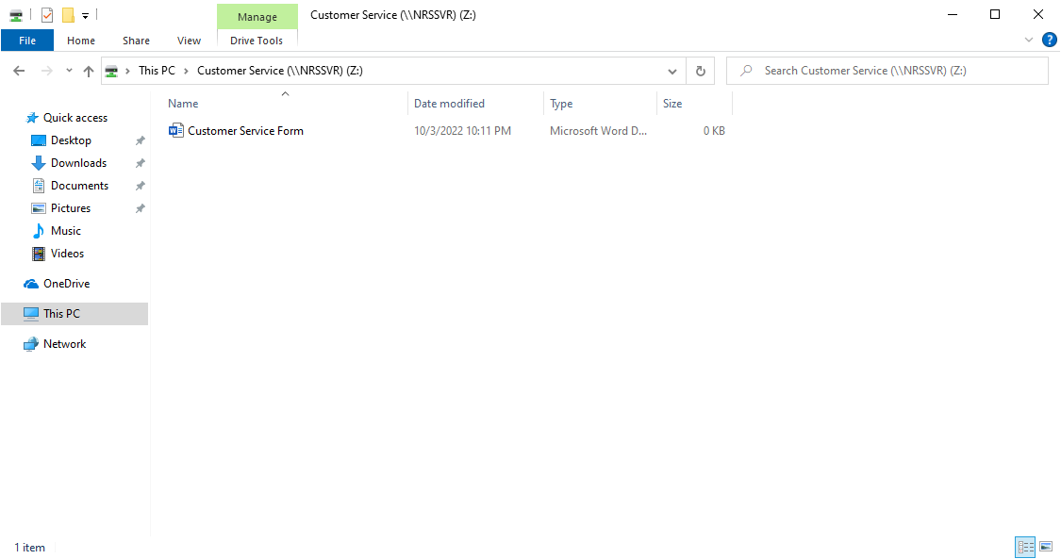

## Figure 4.35 Access of Shared Folder of CUSTOMERSERVICE1

Figures above shows that login of the users successfully login into the domain and able to access the shared folder of their own department.

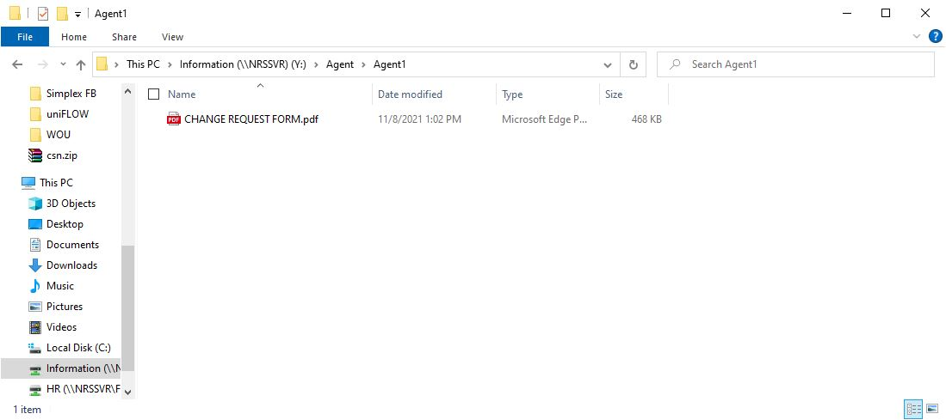

## Figure 4.36 File Sharing to Dedicated Agents

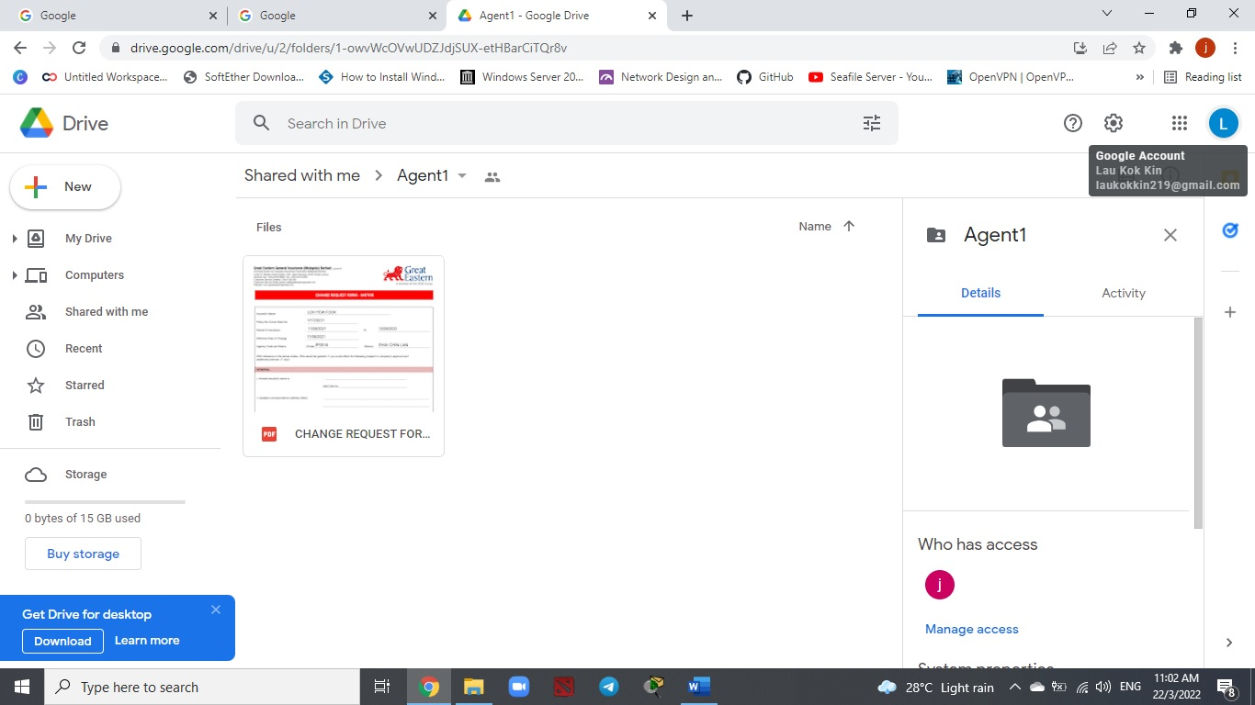

## Figure 4.37 File Sharing to Dedicated Agents

Figure above shows that file sharing to Dedicated Agents is successful

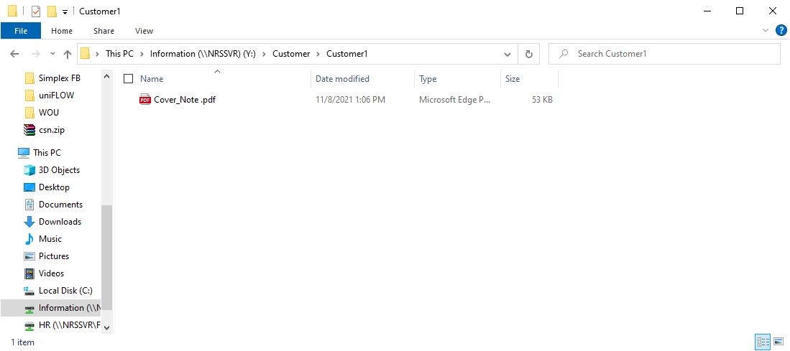

## Figure 4.38 File Sharing to Dedicated Customers

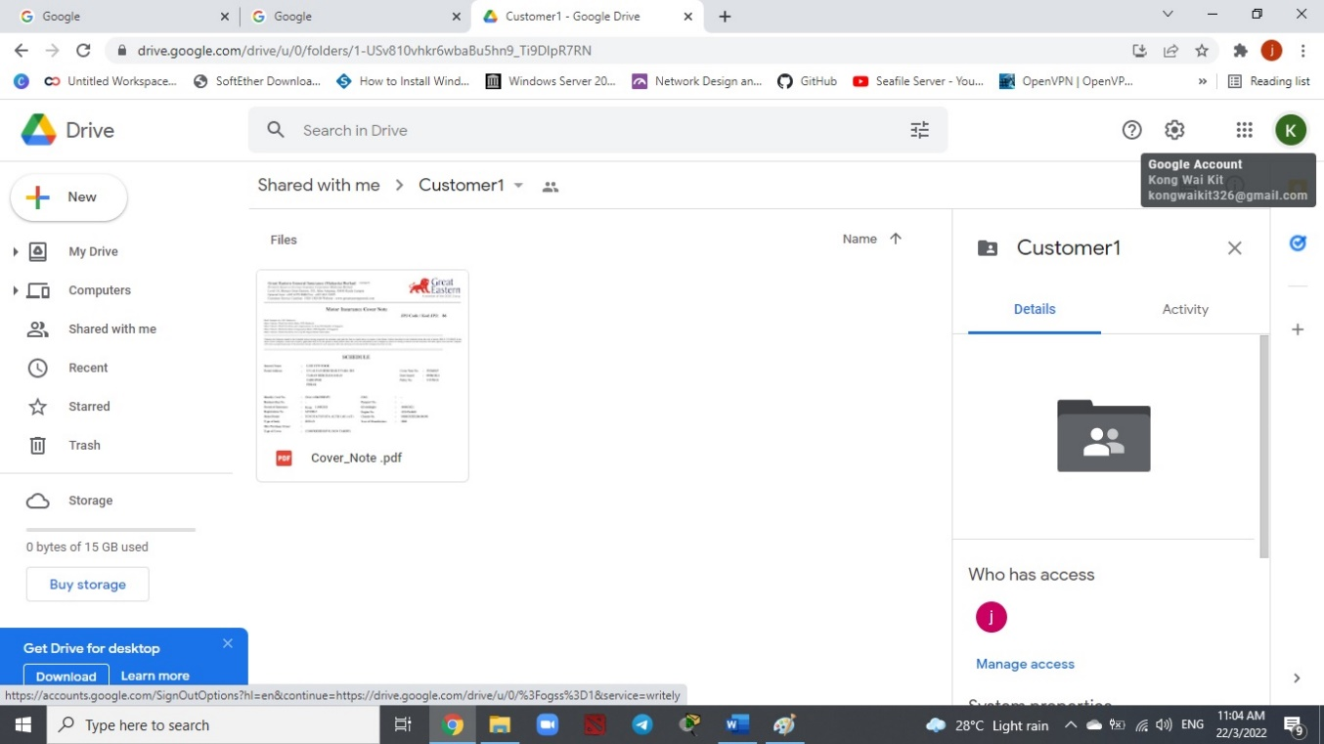

## Figure 4.39 File Sharing to Dedicated Customers

Figure above shows that file sharing to Dedicated Customers is successful



## Figure 4.40 Connection to VPN Server

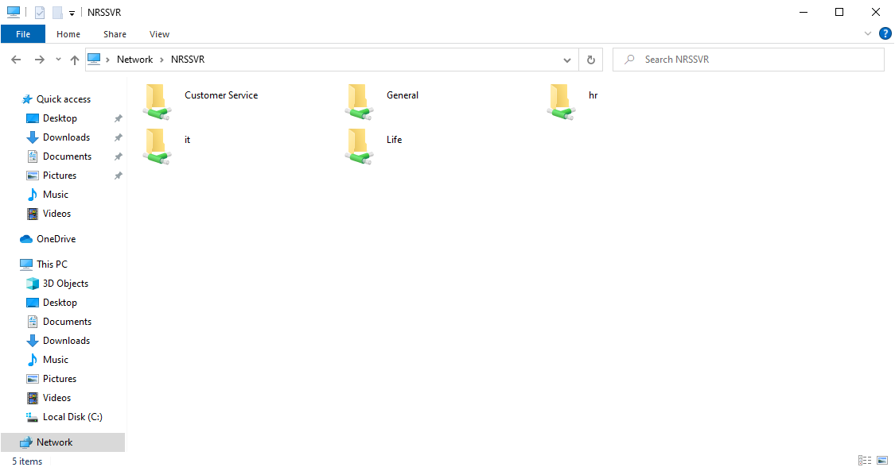

## Figure 4.41 Access Network Folder In NRSSVR

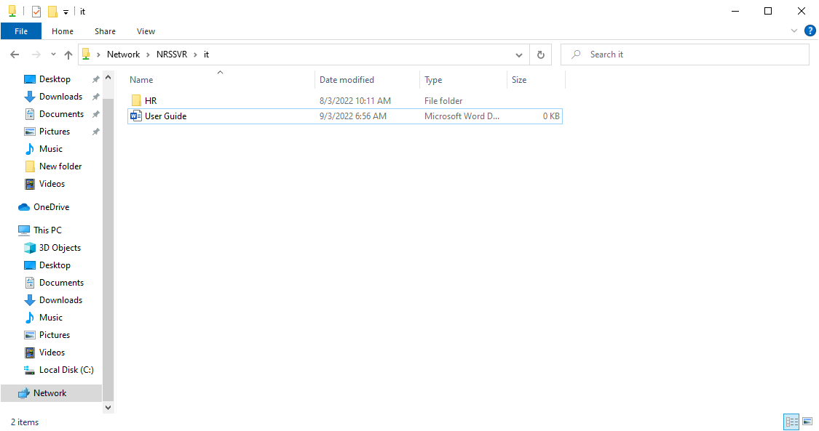

## Figure 4.42 Access the document in the Network Folder

Figures above shows that the connection to VPN Server is successful and able to get through the network folder as well as the document within the server (NRSSVR)

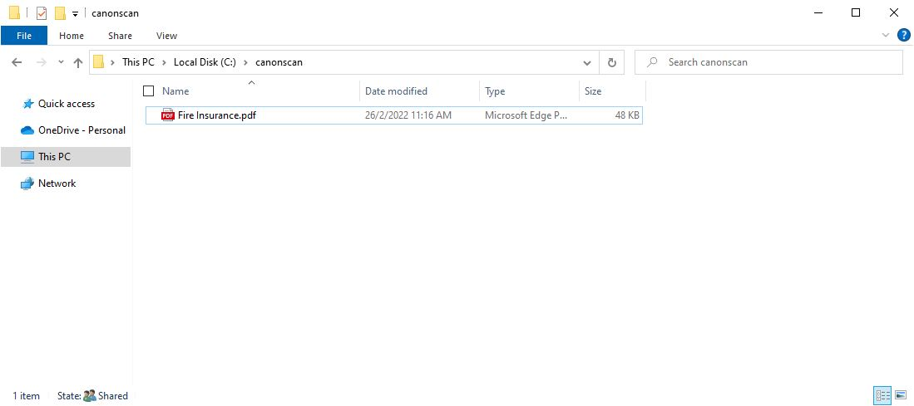

## Figure 4.43 Scanning for GENERAL2

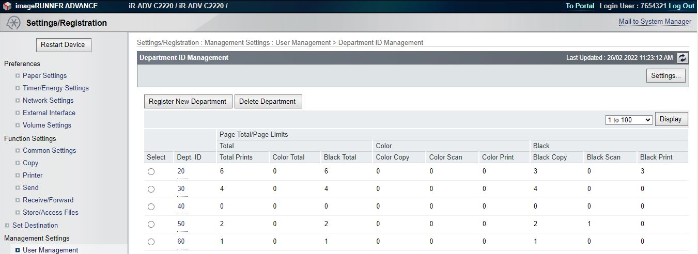

## Figure 4.44 Show Print, Copy and Scan Record

Figures above shows that scanning for the internal staff is successful. In this case, the staff able to store the documents into NRSSVR for future use. Besides, the remote user interface of the photostat machine able to record of the usage for each department which including the total print, copy as well as the scan record for each department respectively.

# 4.4 User Reviews

During the user testing, users such as internal staff, dedicated agents and customers has been randomly pick up to test the whole new architecture network design. Detail of the result is shown at topic above (4.3 User Testing). After the user testing, most of the staff, dedicated agents and customer as well as the boss reviews that the overall performance is good. Just that need some time to familiar with the new system.

# CHAPTER 5

# CONCLUSION AND RECOMMENDATION

# 5.1 Conclusion

The development of the whole new network system of this project has create a great environment for Norris Shai Wealth Management and Advisory in order to fulfil their business needs. In fact, the productivity of the currently state when compared to still using traditional way would be the huge different. By having the whole new system, I believe that the daily task for all the staff of Norris Shai Wealth Management and Advisory can be perform more systematic and more efficient.

# 5.2 Recommendation

There are several recommendations of the customers in order to improve the new network architecture design in the future which stated as follows:

**Using of VPN Router**

It would be better to have a VPN router for the future enhancement of the network for Norris Shai Wealth Management and Advisory not able to afford network switch. In fact, although the SoftEther VPN is good, but a hardware is always a better than software when compared to VPN router. This is because a VPN router able to protect multiple network devices (computers, smartphones and tablets) at once as well as offer a convenience way to encrypt all the devices from one source.

**Quality of Service (QoS)**

For the future enhancement of the network for Norris Shai Wealth Management and Advisory, it is better to apply the use of Quality of Service (QoS). In fact, it helps to optimize the performance of multiple applications within the network. Besides, changing the ways of the data packet route over the internet or other internet to avoid transmission delay and also prioritize the traffic of the organization.

# References

*Bitcatcha*. (2022). Retrieved February 20, 2022, from https://www.bitcatcha.com.my/vpn-reviews/protonvpn/

*Black Box Network Services*. (2021). Retrieved July 6, 2021, from https://www.blackbox.co.uk/gb-gb/page/43869/Resources/Technical-Resources/Black-Box-Explains/Copper-Cable/Category-5e-And-6

Burke, J. (2021). *TechTarget*. Retrieved November 28, 2021, from https://www.techtarget.com/searchnetworking/definition/switch

Caudle, J. (2015, March 31). *DNSimple*. Retrieved July 27, 2021, from https://blog.dnsimple.com/2015/03/why-and-how-to-use-googles-public-dns/

*Check Point*. (2021). Retrieved July 26, 2021, from https://www.checkpoint.com/cyber-hub/network-security/what-is-network-security/

*Check Point*. (2021). Retrieved July 26, 2021, from https://www.checkpoint.com/cyber-hub/network-security/what-is-firewall/

*Cloudflare*. (2021). Retrieved July 27, 2021, from https://www.cloudflare.com/learning/dns/what-is-dns/

*ExaVault*. (2021). Retrieved July 30, 2021, from https://www.exavault.com/docs/filezilla

Fish, C. (2021, Jun 15). *vpnMentor*. Retrieved July 8, 2021, from https://www.vpnmentor.com/blog/best-free-vpns-for-windows/

Fisher, T. (2021, April 25). *Lifewire*. Retrieved July 27, 2021, from https://www.lifewire.com/what-is-a-router-2618162

*Fortinet*. (2021). Retrieved July 26, 2021, from https://www.fortinet.com/resources/cyberglossary/what-is-dmz

Garcia, V. (2013, August 28). *OSTraining*. Retrieved July 30, 2021, from https://www.ostraining.com/blog/webdesign/filezilla-beginner/

*Geekboots*. (2019, July 8). Retrieved November 8, 2021, from https://www.geekboots.com/story/advantages-of-1111-over-8888

*GeeksforGeeks*. (2020, Jun 12). Retrieved July 29, 2021, from https://www.geeksforgeeks.org/what-is-cisco-packet-tracer/

George, S. (2019, February 8). *bobcares*. Retrieved November 8, 2021, from https://bobcares.com/blog/openvpn-pros-and-cons/

Gillis, A. S. (2022). *TechTarget*. Retrieved March 17, 2022, from https://www.techtarget.com/searchnetworking/definition/virtual-private-network

Gupta, P. (2013, March 13). *Softaculous*. Retrieved July 30, 2021, from https://www.softaculous.com/blog/features-that-make-owncloud-a-better-data-management-application/

*IONOS*. (2019, September 18). Retrieved July 10, 2021, from https://www.ionos.com/digitalguide/server/know-how/file-server/

*IPv4.GLOBAL*. (2020). Retrieved March 17, 2022, from https://ipv4.global/blog/everything-you-need-to-know-about-ipv4-vs-ipv6/?keyword=&matchtype=&device=c&adposition=&network=g&gclid=CjwKCAjwlcaRBhBYEiwAK341jTXuiTPdvDNdgzIO1uxeF4izPilIIPllga65gbU9QU3Xb-djQK8TIhoCOSMQAvD_BwE

JOSH. (2021, Jun 28). *All Things Secured*. Retrieved July 12, 2021, from All Things Secured

*Kaspersky*. (2021). Retrieved July 26, 2021, from https://www.kaspersky.com/resource-center/definitions/what-is-an-ip-address

Kerravala, Z. (2018, August 21). *NETWORKWORLD*. Retrieved July 27, 2021, from https://www.networkworld.com/article/3299438/dhcp-defined-and-how-it-works.html

Marshall, A. (2022, January 22). *techradar*. Retrieved February 20, 2022, from https://www.techradar.com/sg/vpn/best-free-vpn

Mazūra, J. (2022, February 3). *cybernews*. Retrieved February 20, 2022, from https://cybernews.com/best-vpn/protonvpn-review/

*Microsoft*. (2022, January 27). Retrieved March 10, 2022, from https://docs.microsoft.com/en-us/windows/win32/srvnodes/windows-server

Mike Lorenzen, M. V. (2018, Jun 20). *Linkedin*. Retrieved July 9, 2021, from https://www.linkedin.com/pulse/importance-using-vlans-segment-network-traffic-mike

Mitchell, B. (2021, September 8). *Lifewire*. Retrieved February 21, 2022, from https://www.lifewire.com/network-file-sharing-in-microsoft-windows-818219

Mocan, T. (2019, February 1). *CACTUSVPN*. Retrieved November 8, 2021, from https://www.cactusvpn.com/beginners-guide-to-vpn/what-is-openvpn/#advantages-disadvantages

Morello, J. (2018, October 3). *securityboulevard*. Retrieved July 26, 2021, from https://securityboulevard.com/2018/10/know-your-firewall-layer-3-vs-layer-7/

N, D. (2020, October 29). *Power Admin*. Retrieved February 21, 2022, from https://www.poweradmin.com/blog/what-are-the-pros-and-cons-of-file-sharing/

*NS1*. (2021). Retrieved July 27, 2021, from https://ns1.com/resources/what-is-dns

*OpenVPN*. (2021). Retrieved July 7, 2021, from https://openvpn.net/3-reasons-your-business-needs-a-vpn/

*OpenVPN*. (2021). Retrieved July 12, 2021, from https://openvpn.net/for/a-new-approach-to-remote-access/

*openvpn*. (2022). Retrieved March 17, 2022, from https://openvpn.net/faq/what-is-openvpn-access-server/

*openvpn*. (2022). Retrieved March 17, 2022, from https://openvpn.net/for/remote-access/

Parson, A. (2021). *CHRON*. Retrieved July 10, 2021, from smallbusiness: https://smallbusiness.chron.com/router-firewall-vs-software-firewall-62131.html

*pcquest*. (2001, July 7). Retrieved July 26, 2021, from https://www.pcquest.com/a-firewall-linux-ipchains/

Petryschuk, S. (2021, Apil 7). *Auvik*. Retrieved from https://www.auvik.com/franklyit/blog/network-design-best-practices/

*PLCGurus.NET*. (2021). Retrieved July 7, 2021, from https://www.plcgurus.net/choosing-the-best-vpn/

*ProPrivacy*. (2021). Retrieved July 30, 2021, from https://proprivacy.com/cloud/review/seafile

Raphaely, E. (2021). *SECUREW2*. Retrieved July 26, 2021, from https://www.securew2.com/blog/complete-guide-wi-fi-security

Roman, A. (2021, May 25). *Vlad talks tech!* Retrieved March 10, 2022, from https://vladtalks.tech/vpn/what-is-softether-vpn

*SolarWinds*. (2021). Retrieved July 26, 2021, from https://www.solarwinds.com/ip-address-manager/use-cases/ip-address-plan

STEGNER, B. (2021, May 12). *makeuseof*. Retrieved March 10, 2022, from https://www.makeuseof.com/tag/windows-server-different-windows/

Strickland, D. (2021). *phoenixNAP*. Retrieved July 26, 2021, from https://phoenixnap.com/blog/types-of-network-security

*Summit 360*. (2021). Retrieved July 9, 2021, from https://www.summit360.com/2017/08/30/vlans-types-benefits/

*techinn*. (2021). Retrieved November 28, 2021, from https://www.techinn.com/en/d-link-12-port-indus-smart-manage-switch/137940434/p?utm_source=google_products&utm_medium=merchant&id_producte=12377853&country=my&gclid=Cj0KCQiA7oyNBhDiARIsADtGRZZxcQTIdV84f8Z93EHCr6I_m8gw172UP64Q4VcYjTHeNAD_6bZ8FGkaAoDqEALw_w

*techopedia*. (2012, April 16). Retrieved March 10, 2022, from https://www.techopedia.com/definition/359/windows-server

*tp-link*. (2021). Retrieved November 28, 2021, from https://www.tp-link.com/lk/service-provider/managed-switch/tl-sg5412f/

*TRENDNET*. (2021). Retrieved November 28, 2021, from https://www.trendnet.com/products/features/default?featureid=56

Tucakov, D. (2020, January 28). *phoenixnap*. Retrieved July 26, 2021, from https://phoenixnap.com/kb/iptables-tutorial-linux-firewall

*vpnMentor*. (2021). Retrieved July 12, 2021, from https://www.vpnmentor.com/blog/what-is-openvpn-is-it-safe-enough-to-use/?keyword=&geo=1010227&device=&cq_src=google_ads&cq_cmp=13033858757&cq_term=&cq_plac=&cq_net=g&cq_plt=gp&gclid=Cj0KCQjw0K-HBhDDARIsAFJ6UGg08BvNxNbO-cA1b6ETsWOQpRiHQirc8SJldgRA_-h1R82av

WatElectronics. (2021, February 17). *WatElectronics*. Retrieved July 27, 2021, from https://www.watelectronics.com/what-is-network-simulation-various-simulators-tools/

*Whitehats*. (2015). Retrieved July 10, 2021, from https://whitehatsme.com/benefits-using-file-server-businesses#

William, M. (2021, July 19). *TechRadar*. Retrieved July 27, 2021, from https://www.techradar.com/sg/news/best-dns-server

Williams, L. (2022, January 11). *Guru99*. Retrieved March 17, 2022, from https://www.guru99.com/difference-ipv4-vs-ipv6.html

Wong, M. (2017, October 20). *Medium*. Retrieved July 29, 2021, from https://medium.com/@mikowong405/wireless-network-vs-wired-network-which-one-to-choose-55b48ff47c3c

*Your IT Department*. (2022). Retrieved February 22, 2022, from https://www.your-itdepartment.co.uk/knowledge-bank/the-real-advantages-of-a-virtual-lan-vlan/

# Appendix

**Configure Wireless Router**

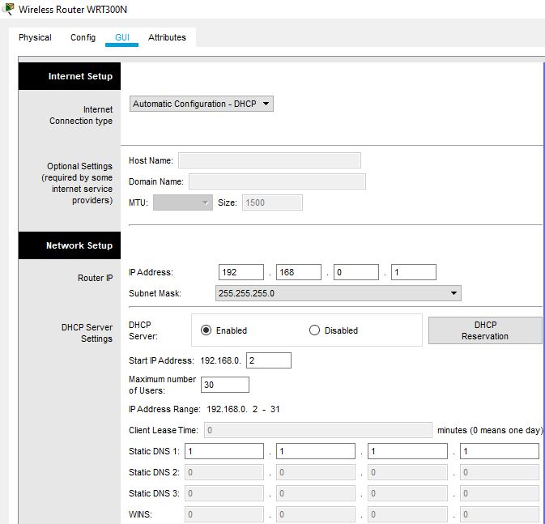

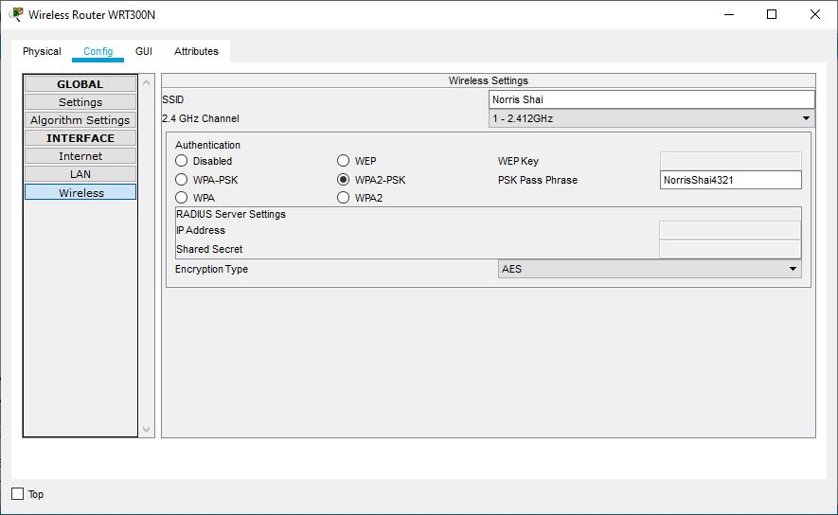

**Configure Switch**

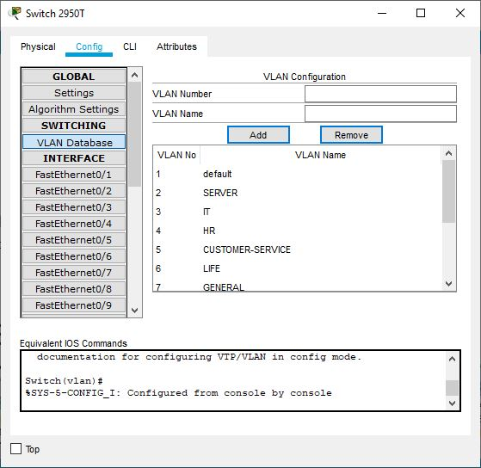

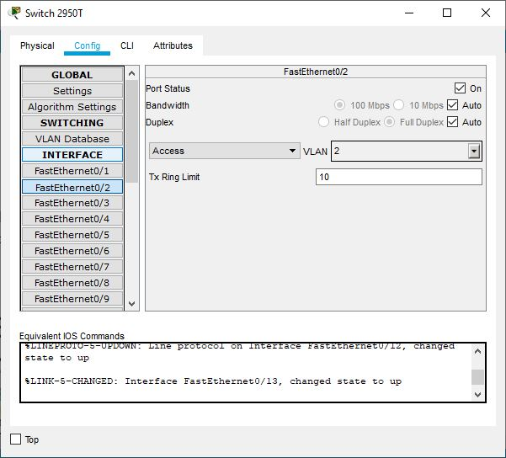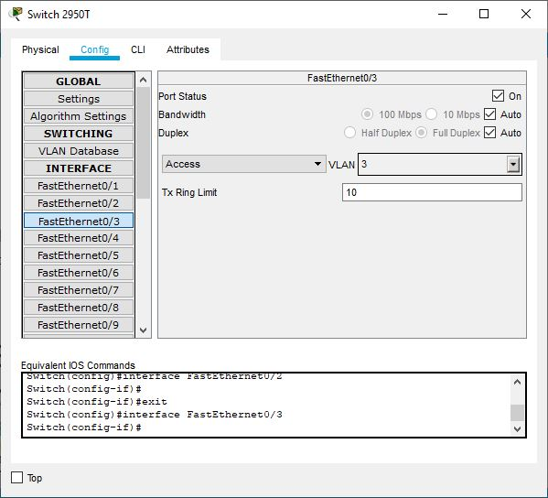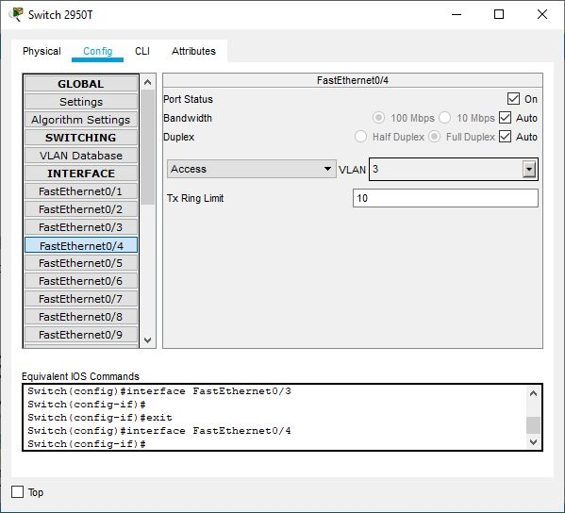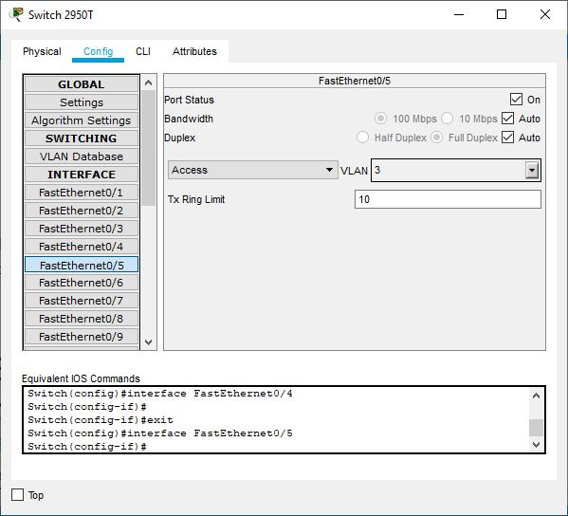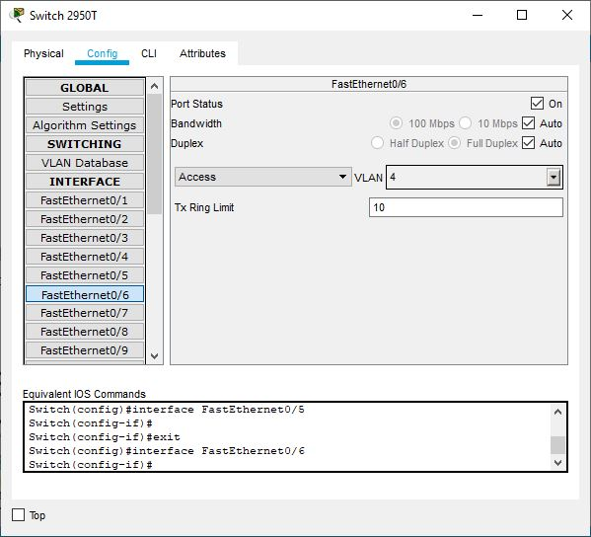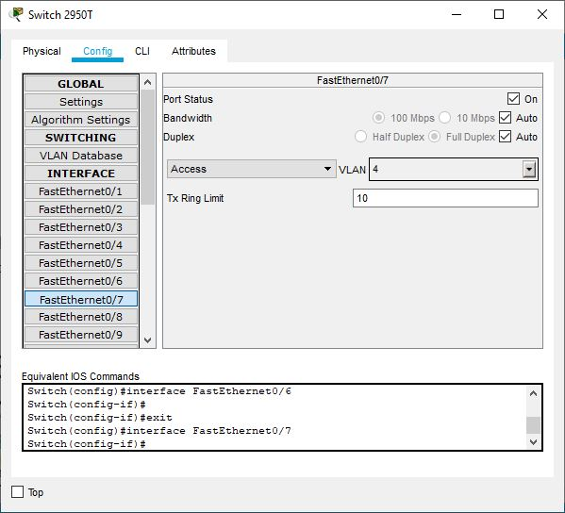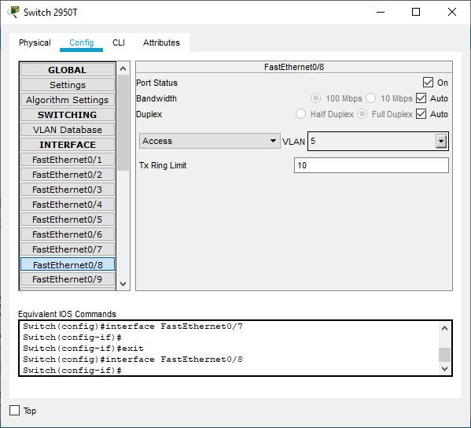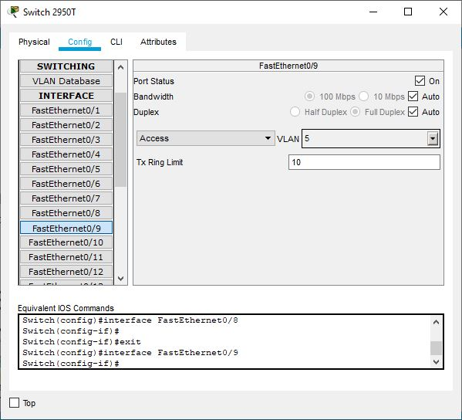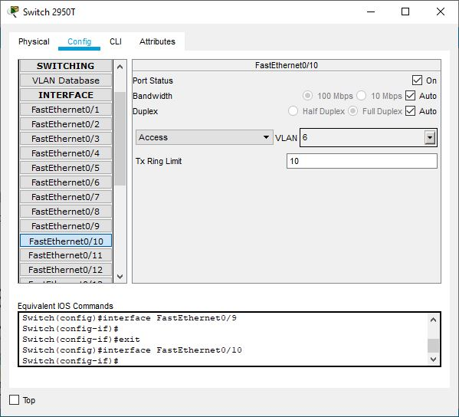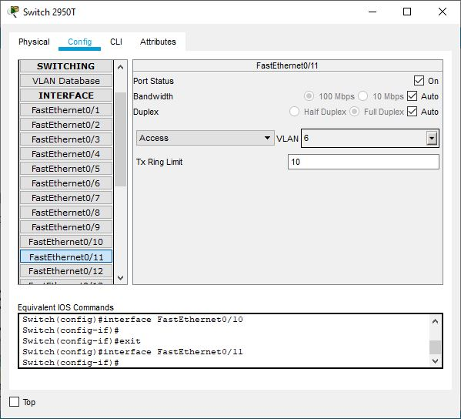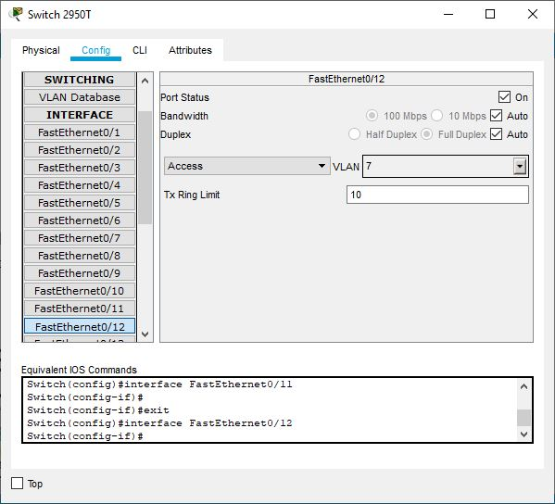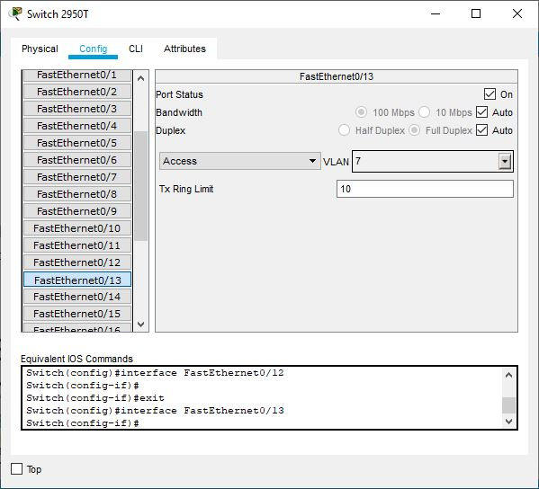

**Configure Internal Network Device**

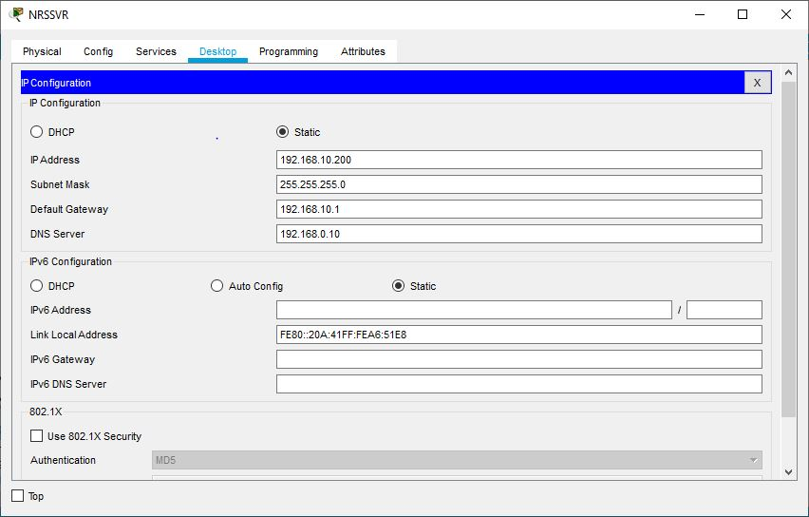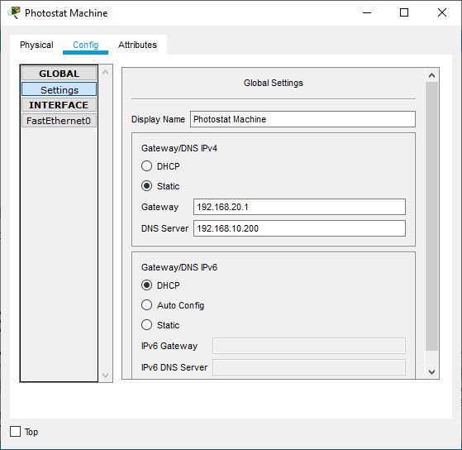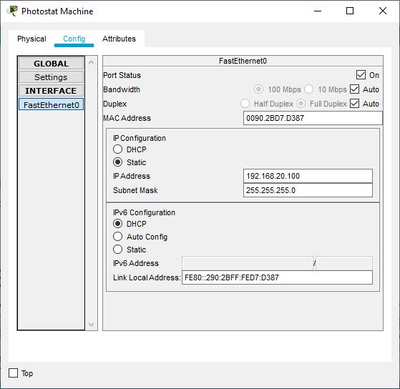

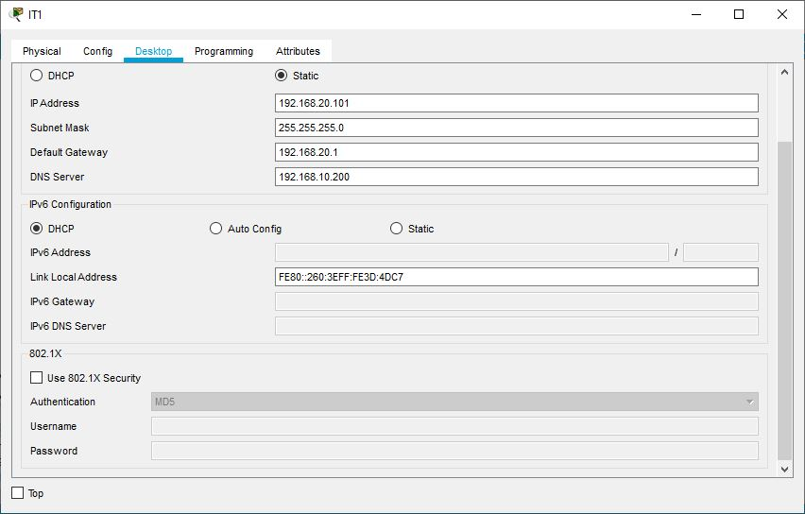

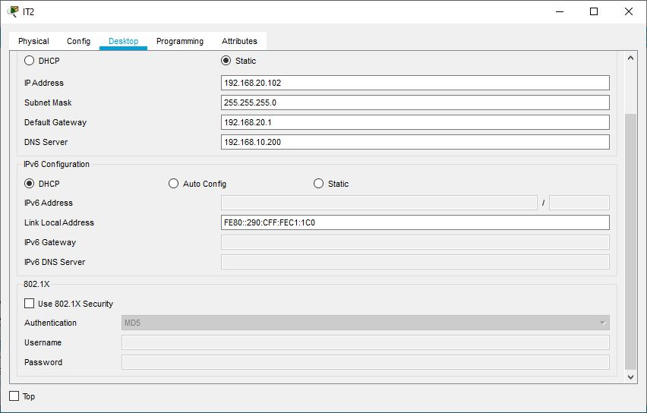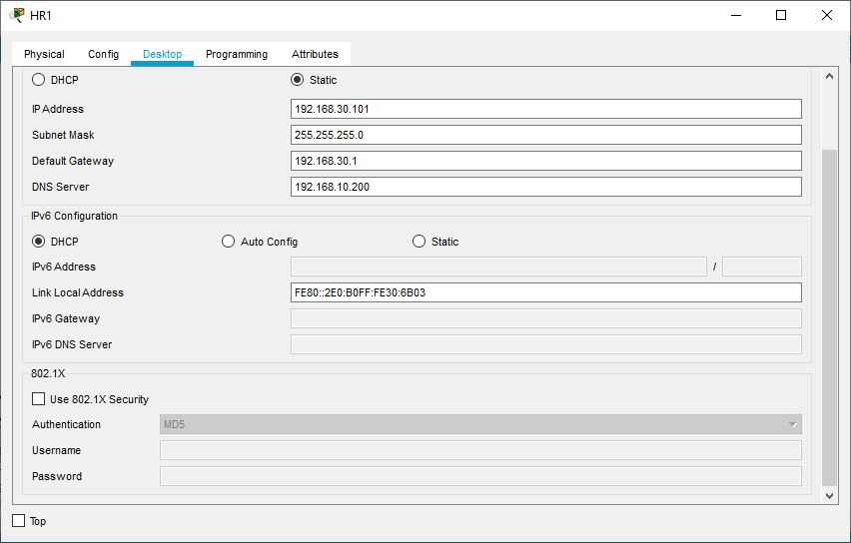

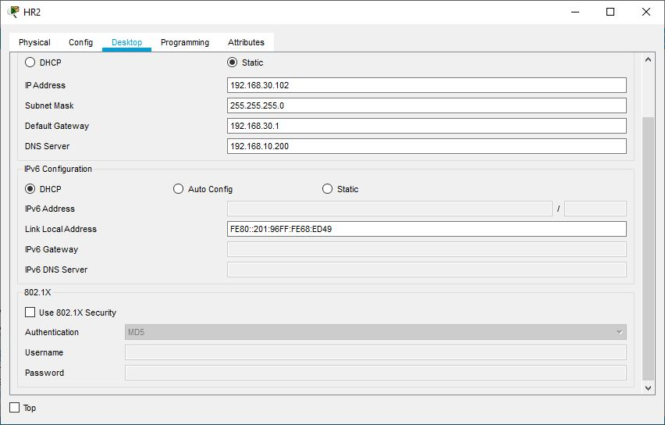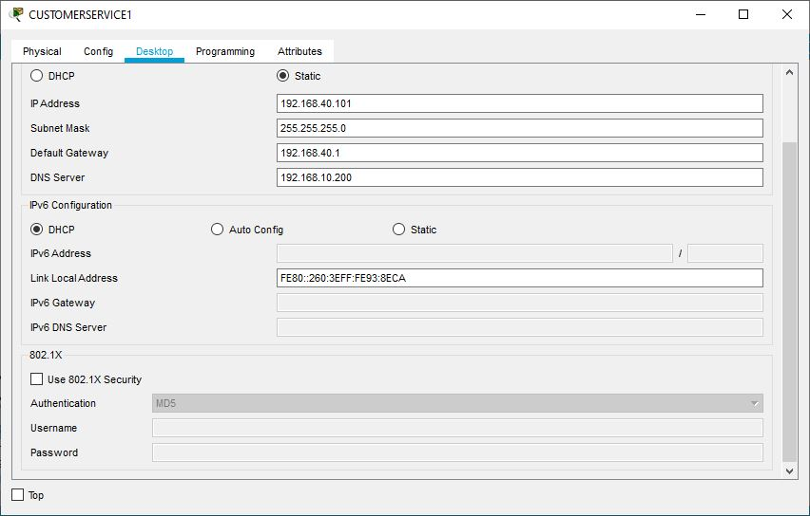

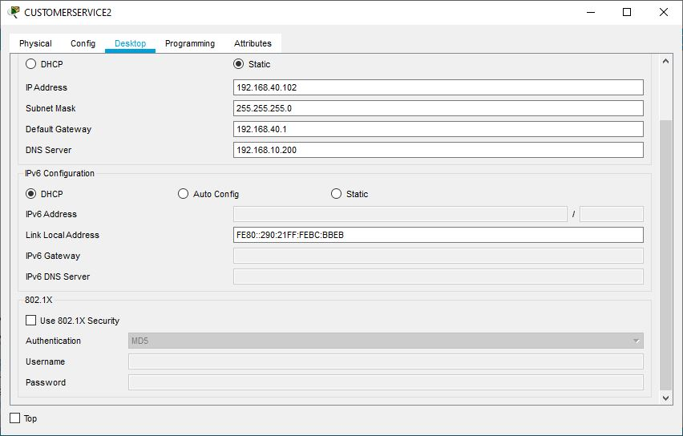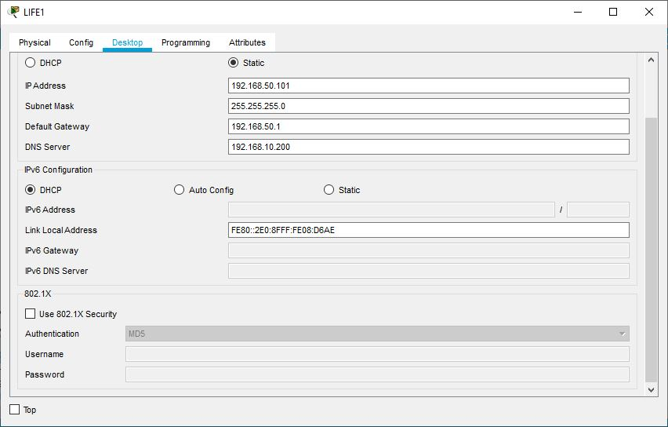

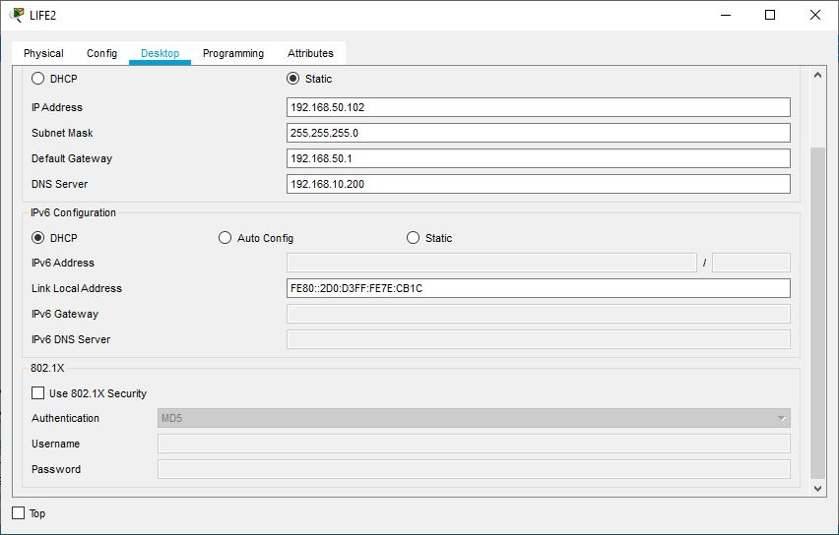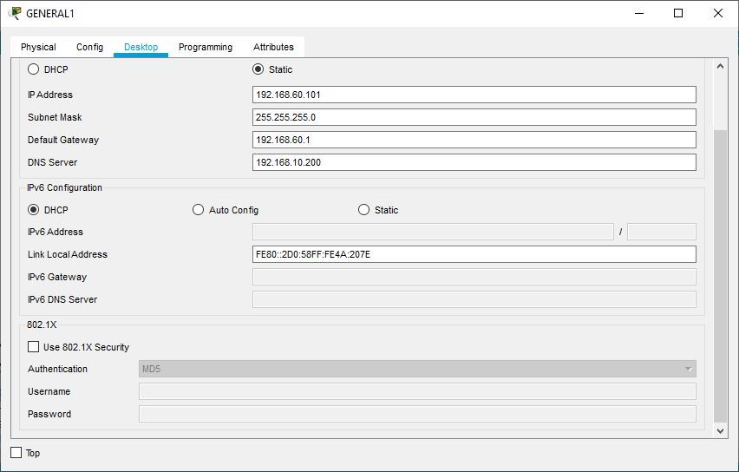

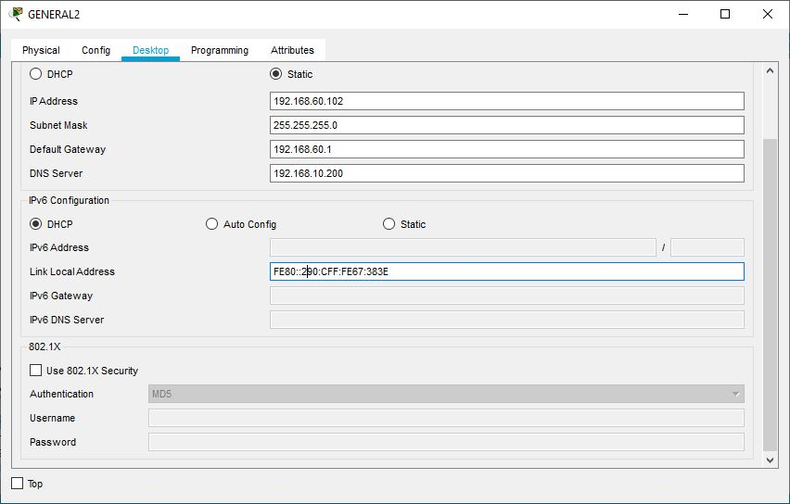

**VLAN Routing Configuration**

Router#en

Router#config terminal

Router(config)#int fa0/0.10

Router(config-subif)#encapsulation dot1q 2

Router(config-subif)#ip address 192.168.10.1 255.255.255.0

Router(config-subif)#int fa0/0.20

Router(config-subif)#encapsulation dot1q 3

Router(config-subif)#ip address 192.168.20.1 255.255.255.0

Router(config-subif)#int fa0/0.30

Router(config-subif)#encapsulation dot1q 4

Router(config-subif)#ip address 192.168.30.1 255.255.255.0

Router(config-subif)#int fa0/0.40

Router(config-subif)#encapsulation dot1q 5

Router(config-subif)#ip address 192.168.40.1 255.255.255.0

Router(config-subif)#int fa0/0.50

Router(config-subif)#encapsulation dot1q 6

Router(config-subif)#ip address 192.168.50.1 255.255.255.0

Router(config-subif)#int fa0/0.60

Router(config-subif)#encapsulation dot1q 7

Router(config-subif)#ip address 192.168.60.1 255.255.255.0

**Configure Active Directory (AD) and DNS Server**

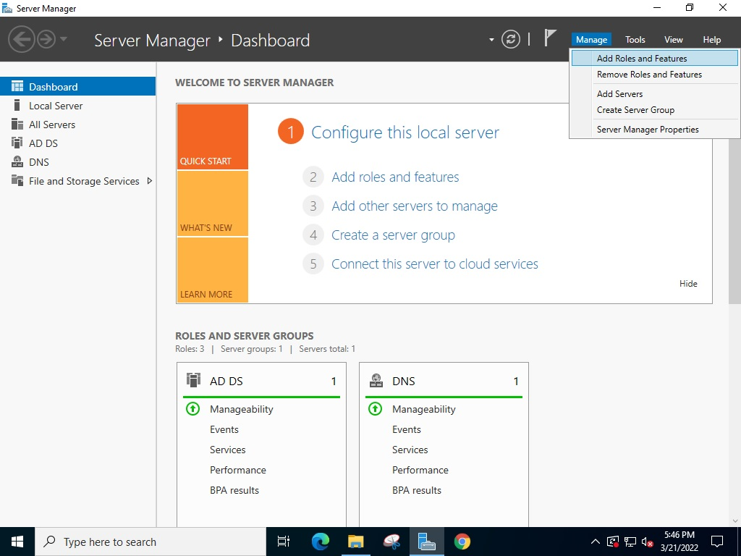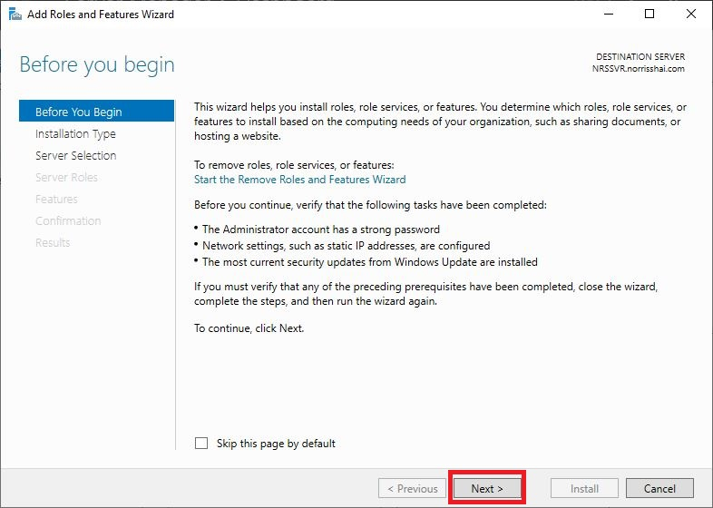

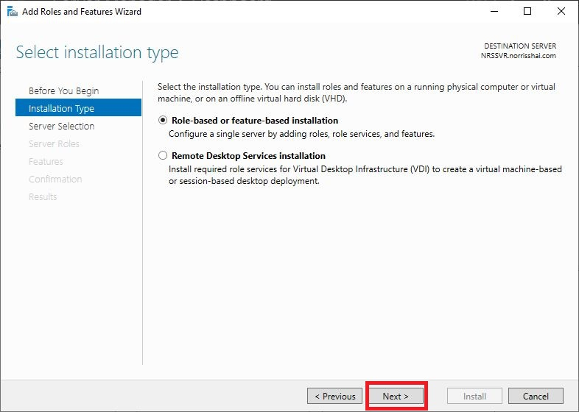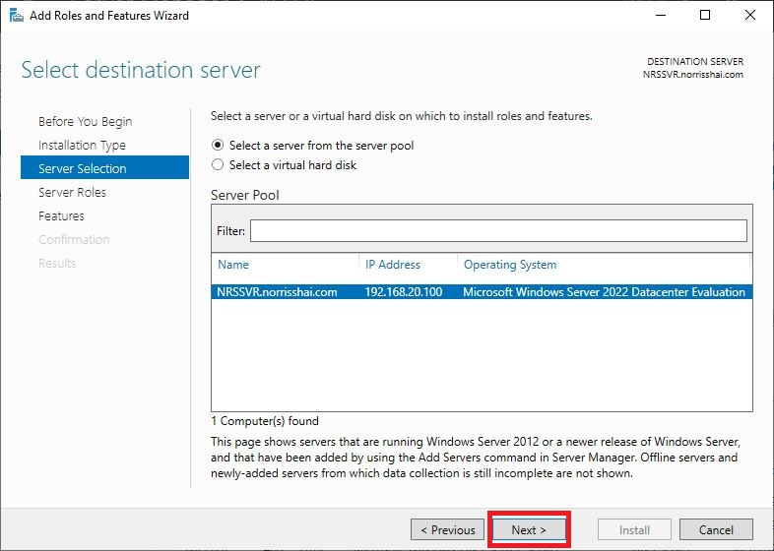

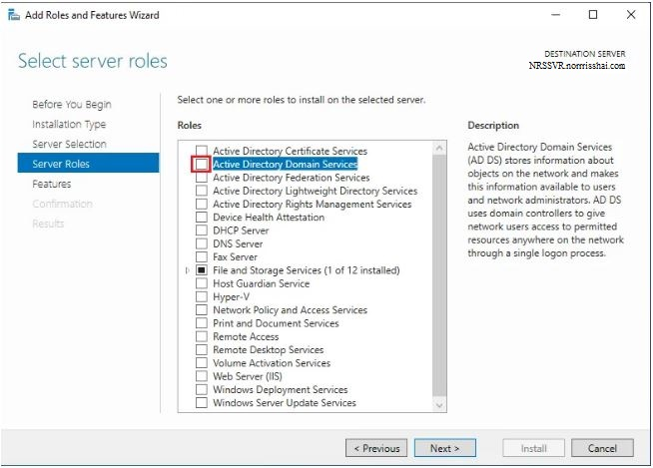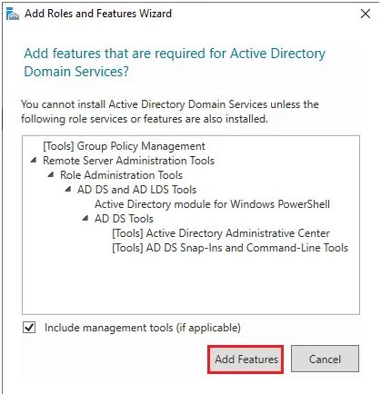

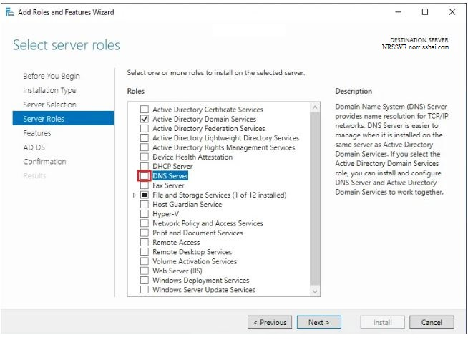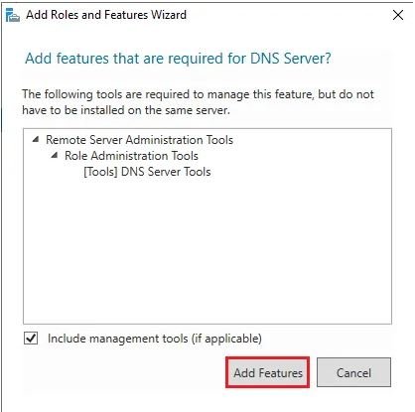

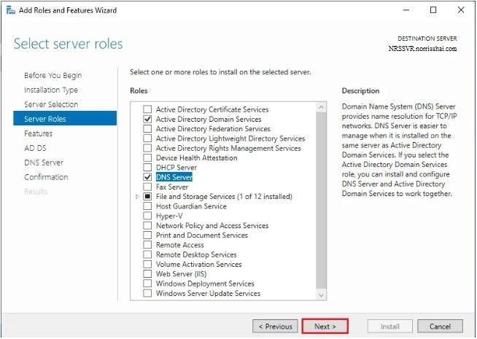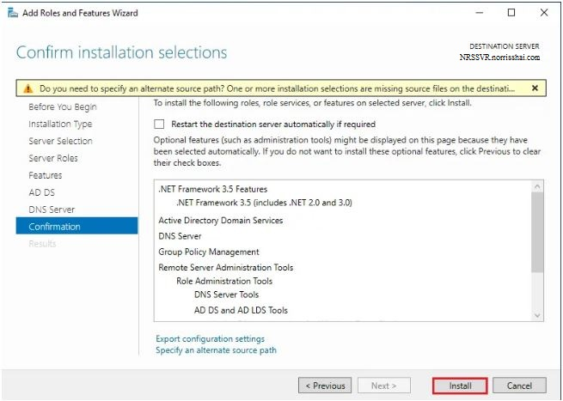

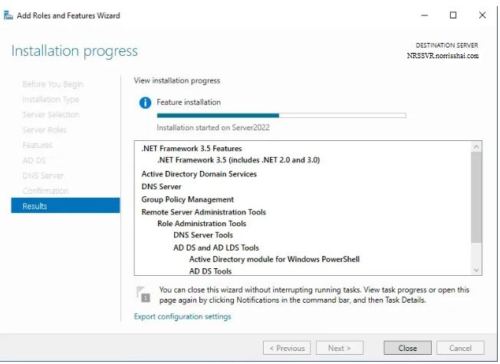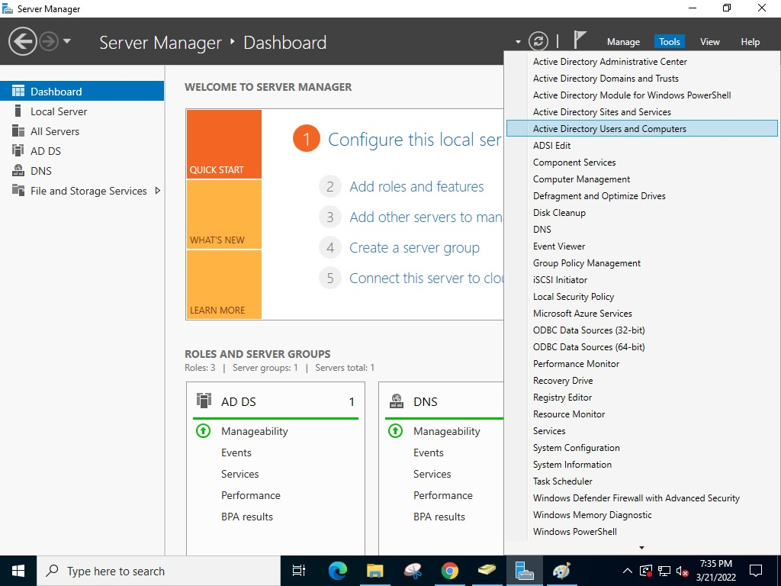

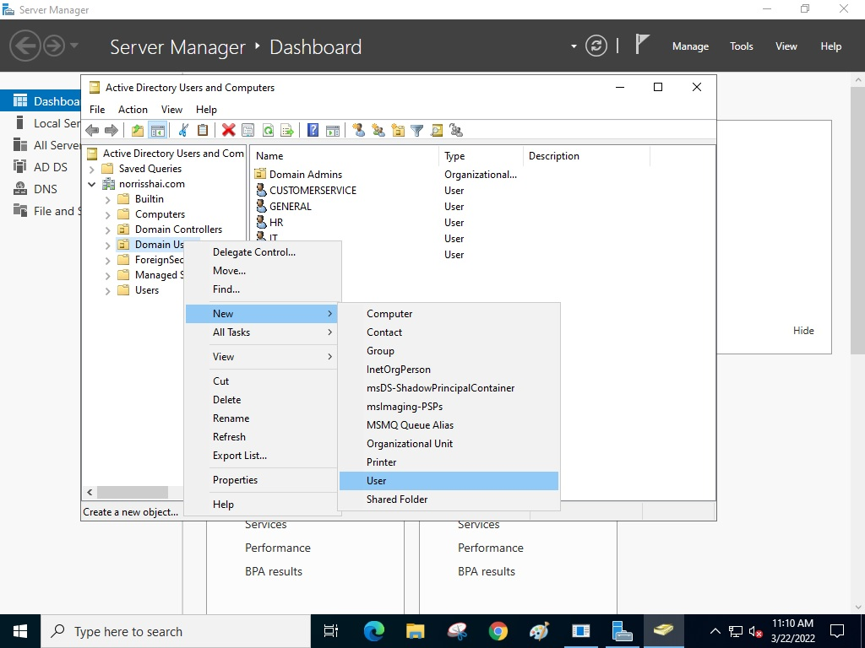

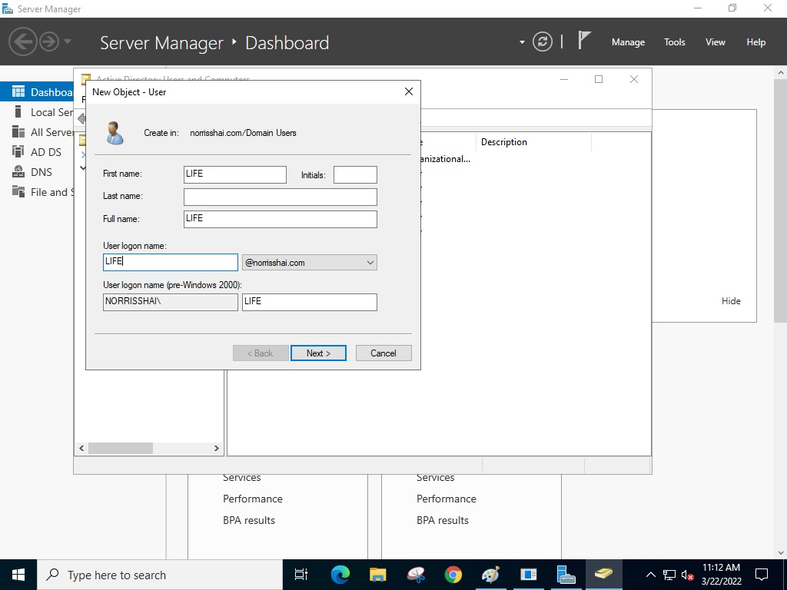

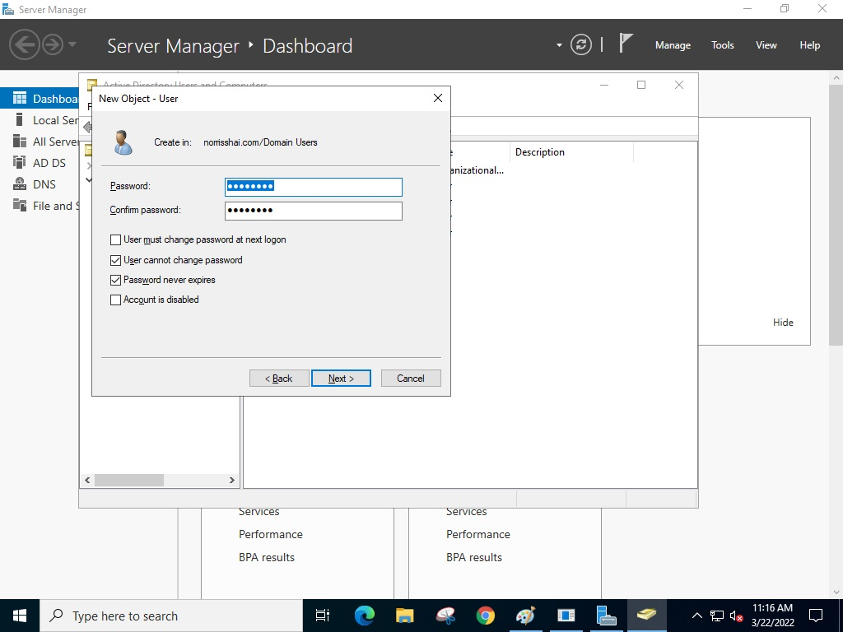

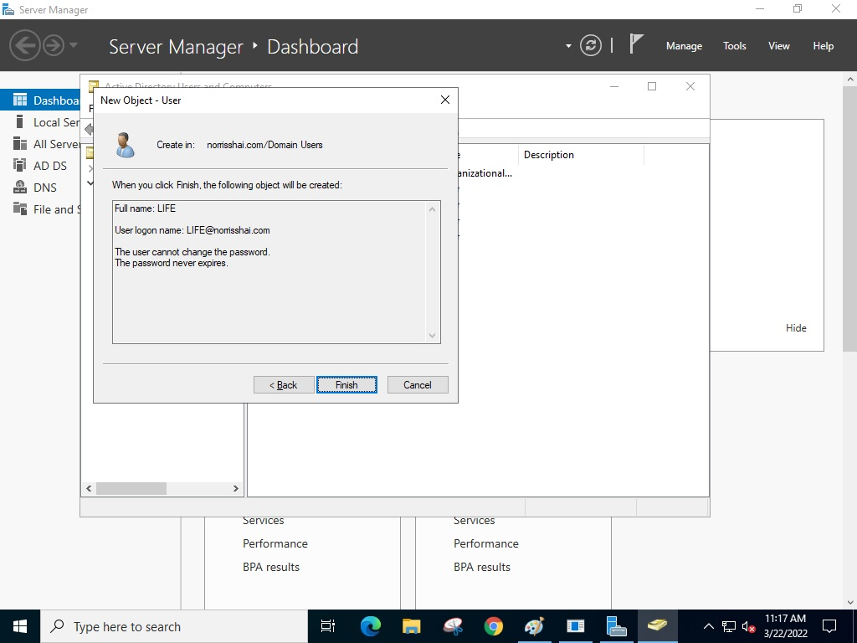

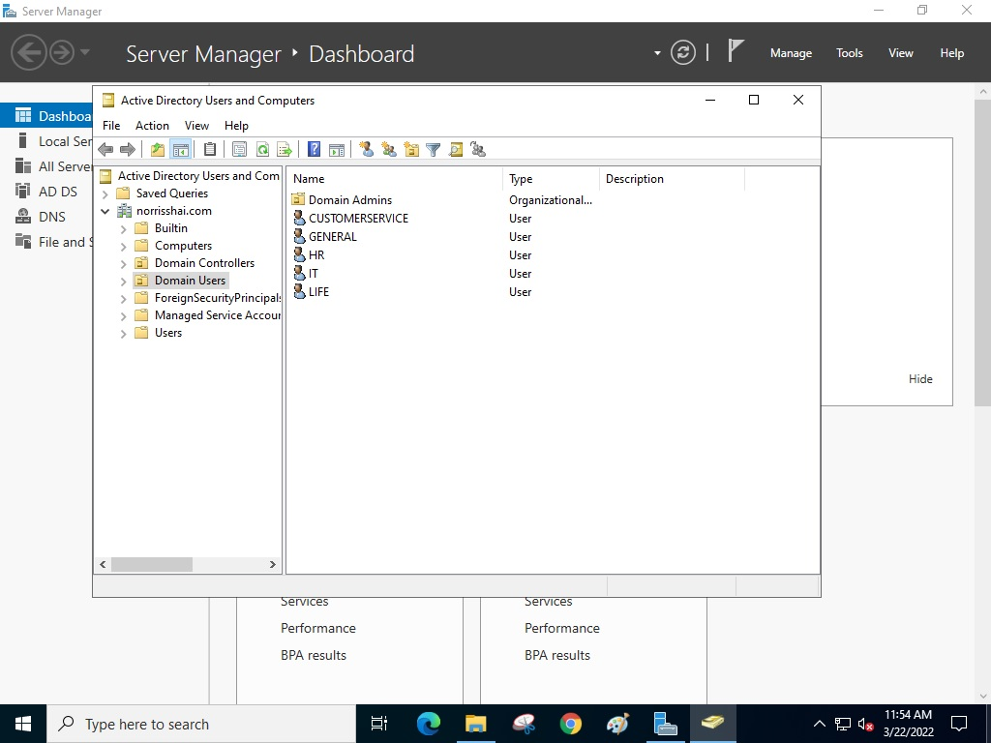

**Assign Folder Permission**

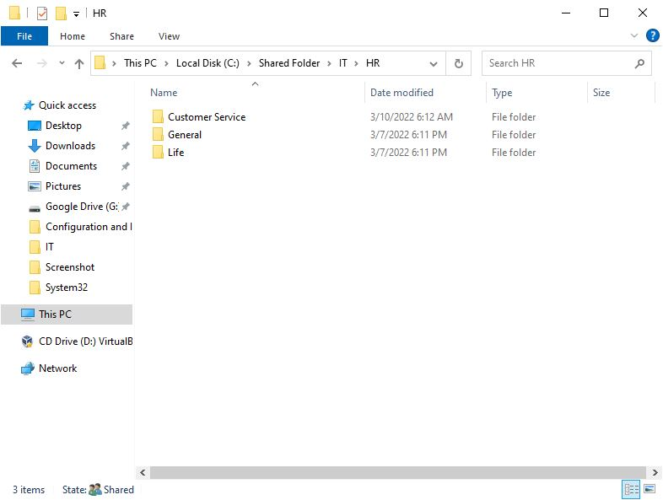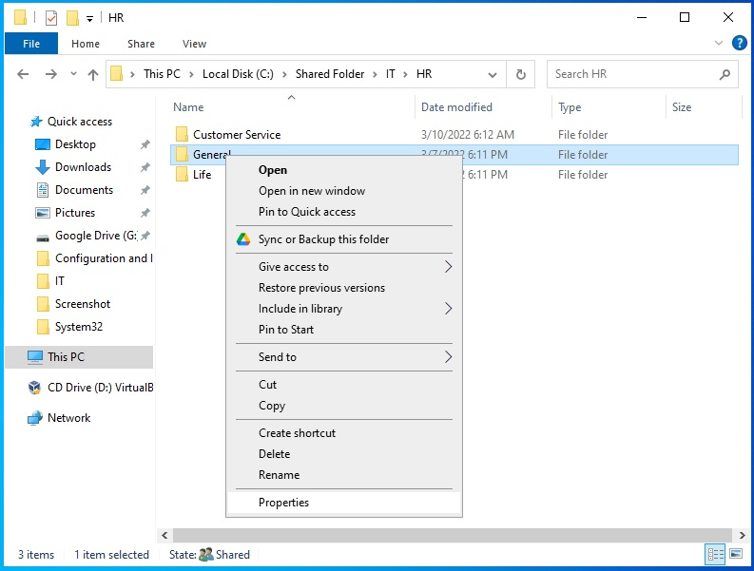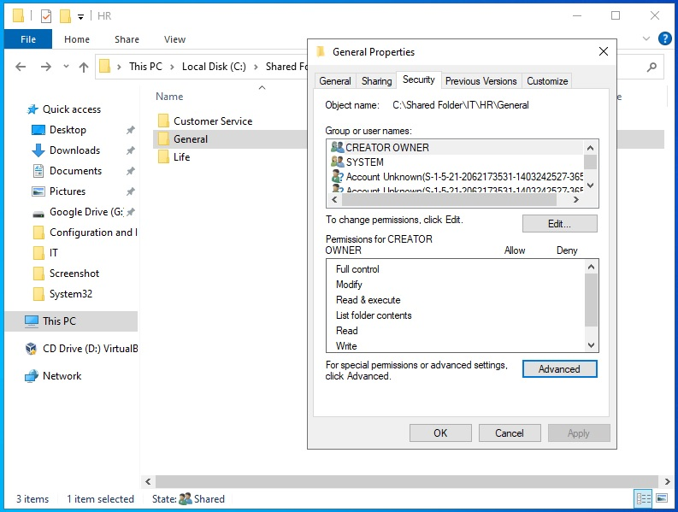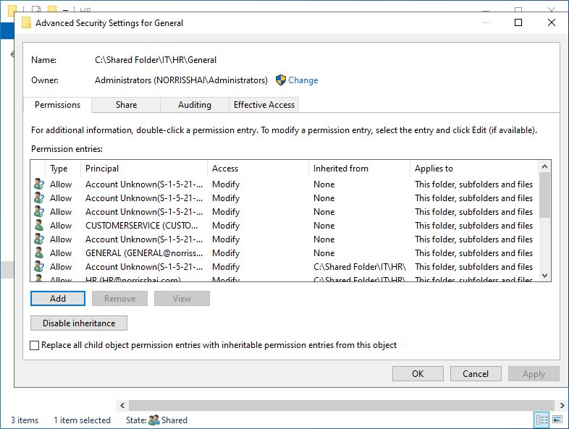

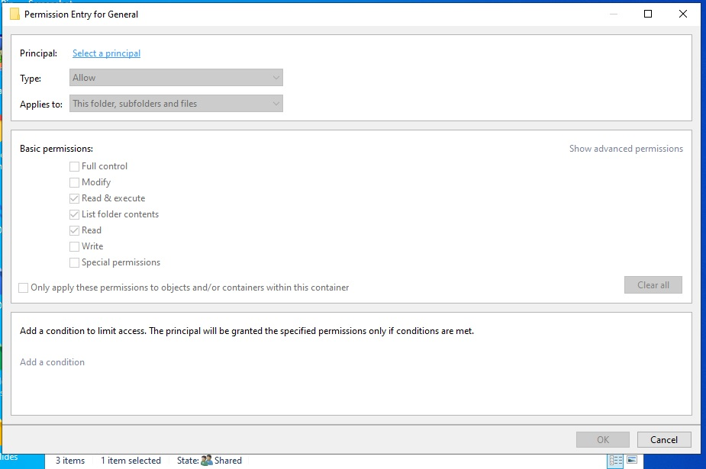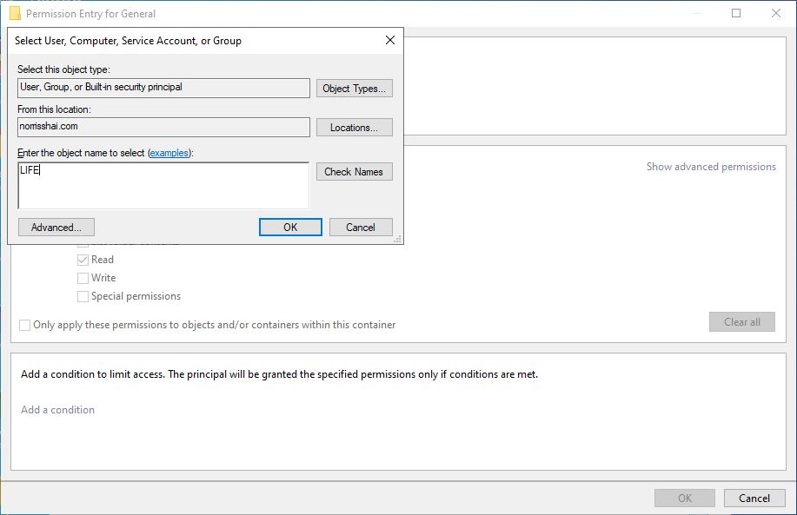

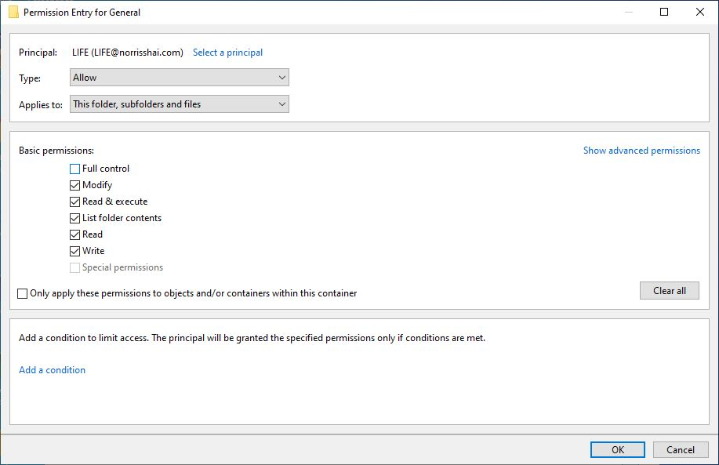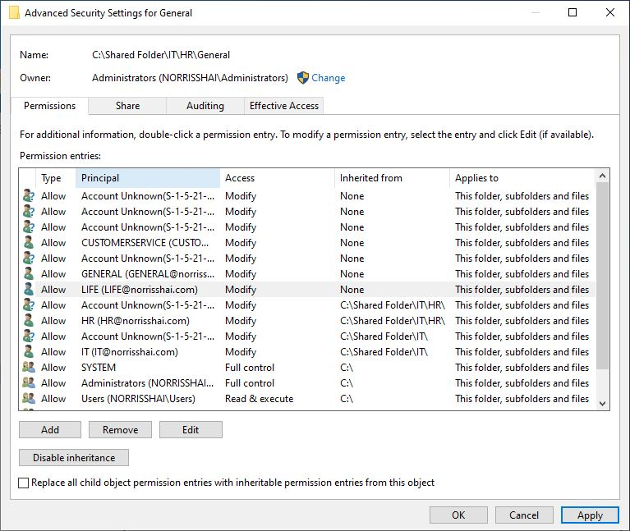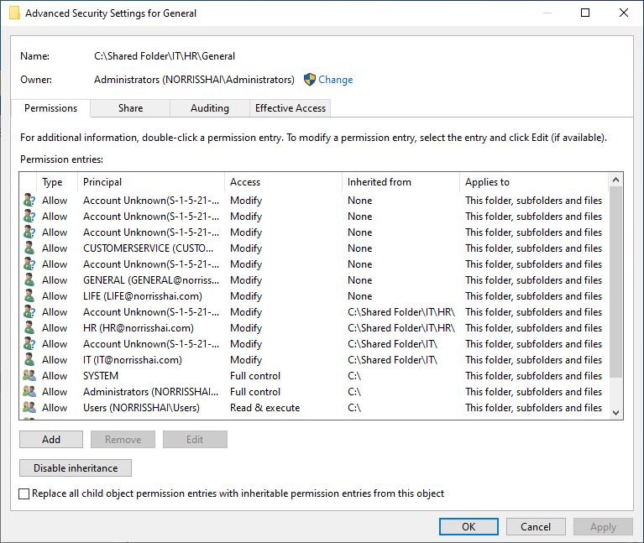

**Configure SoftEther VPN**

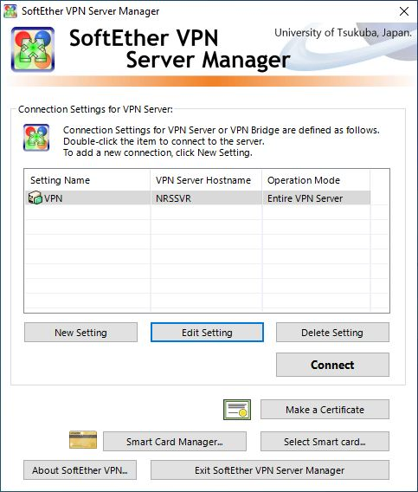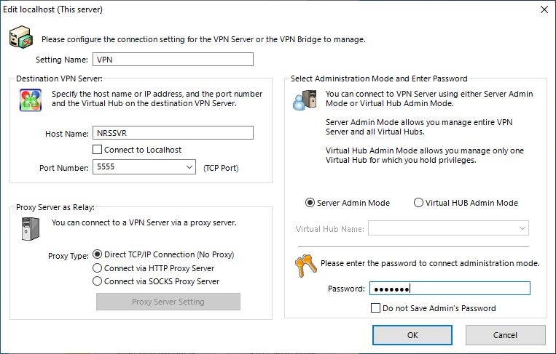

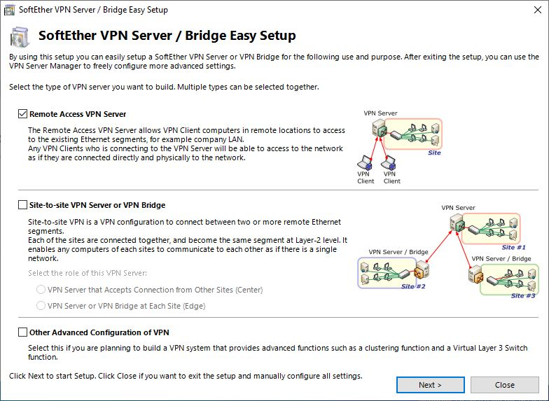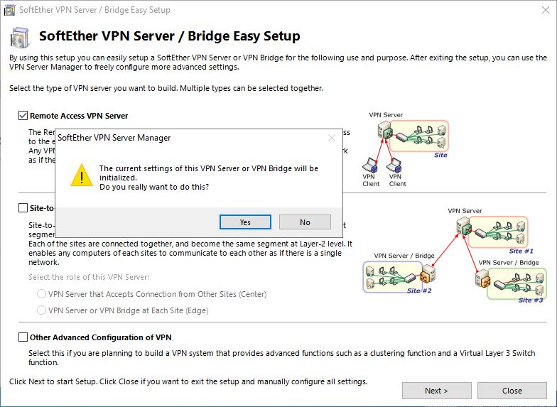

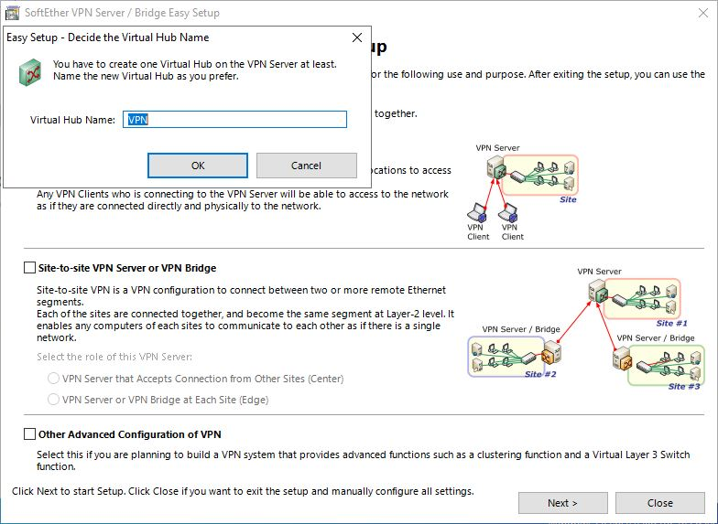

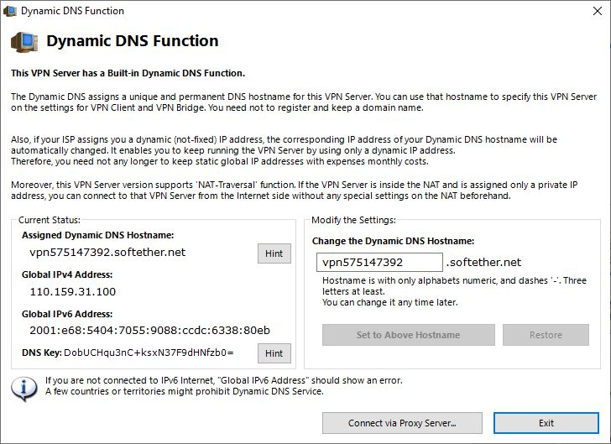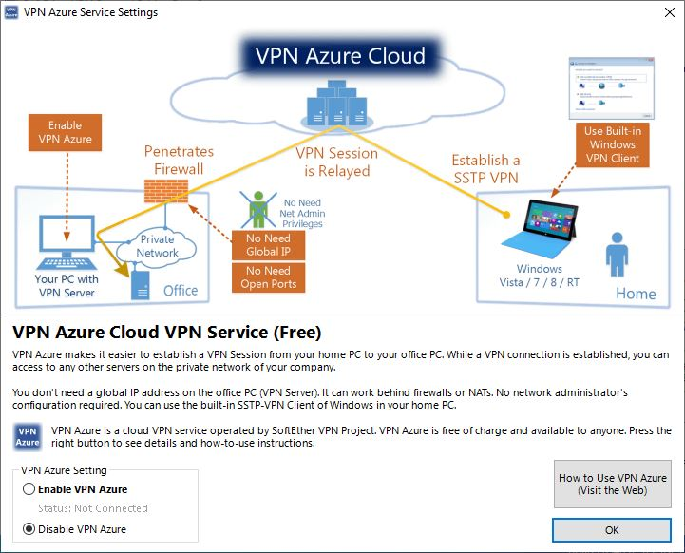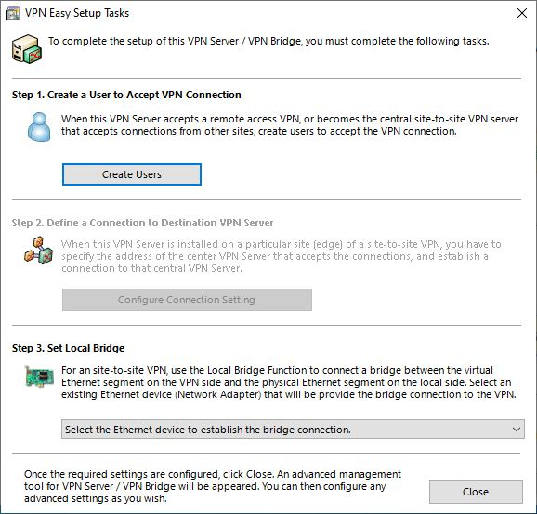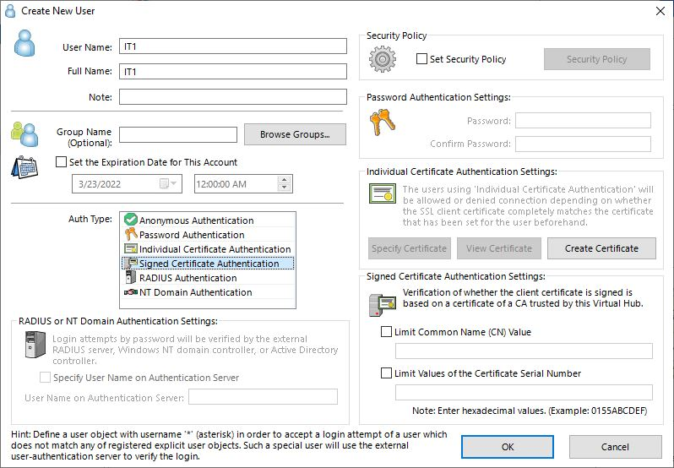

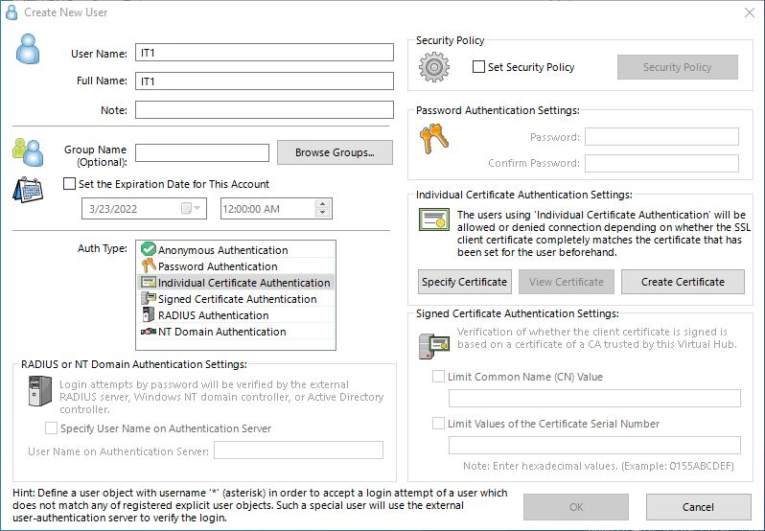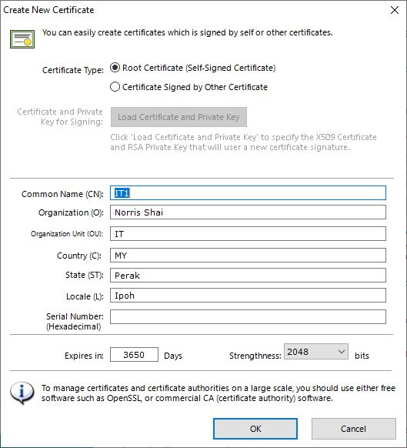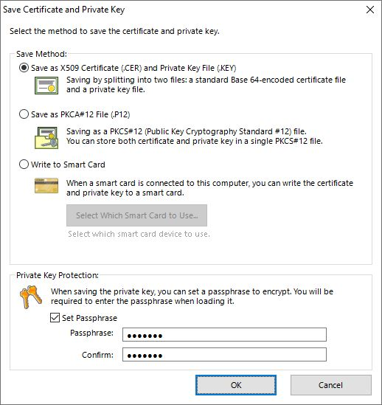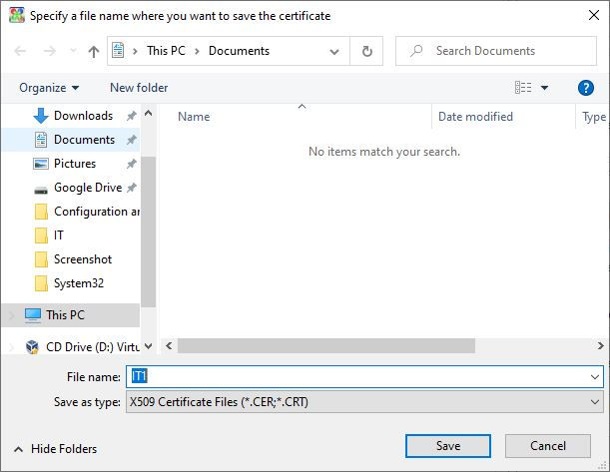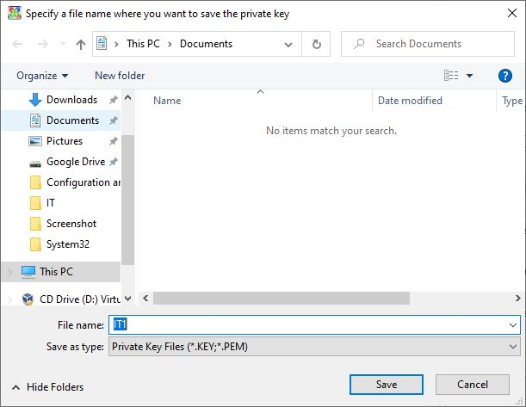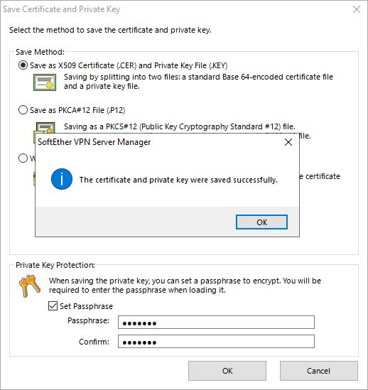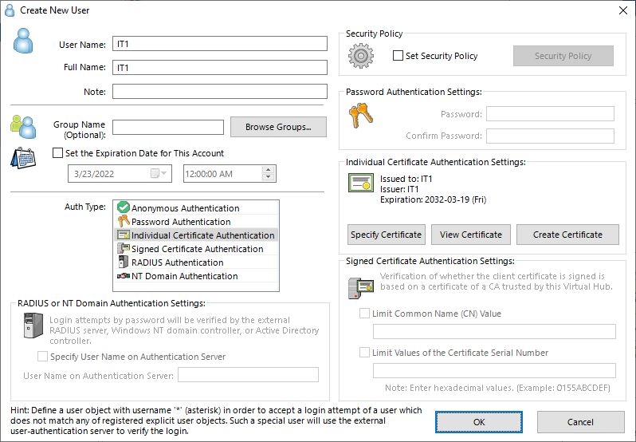

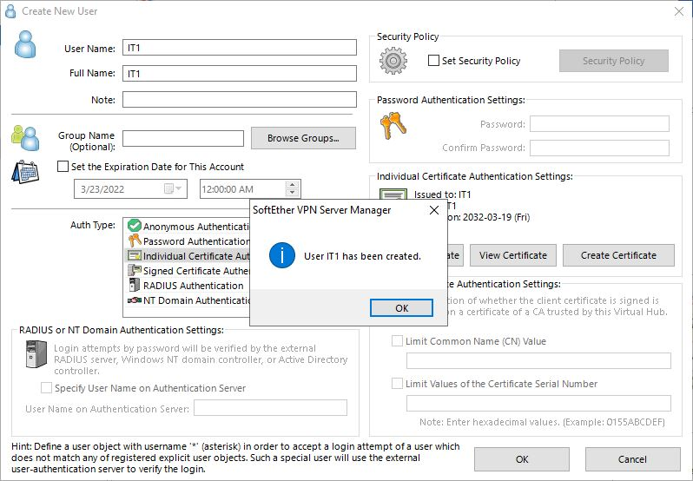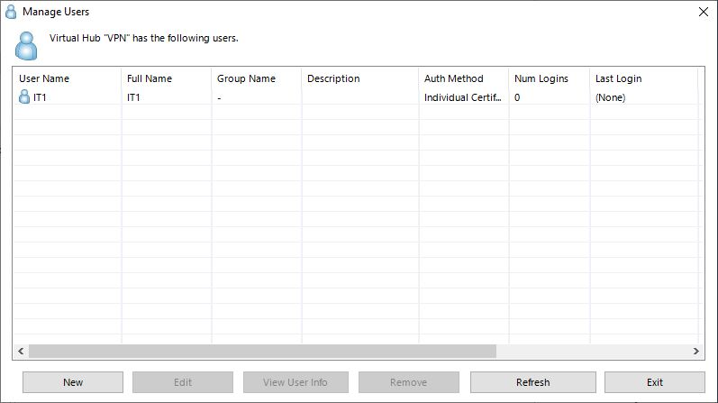

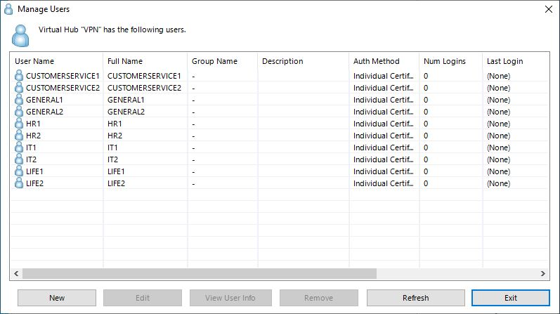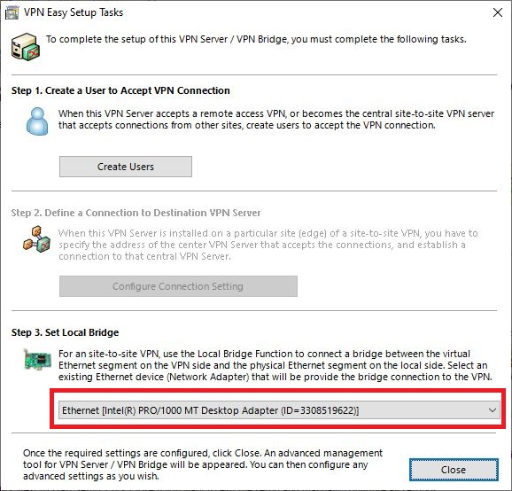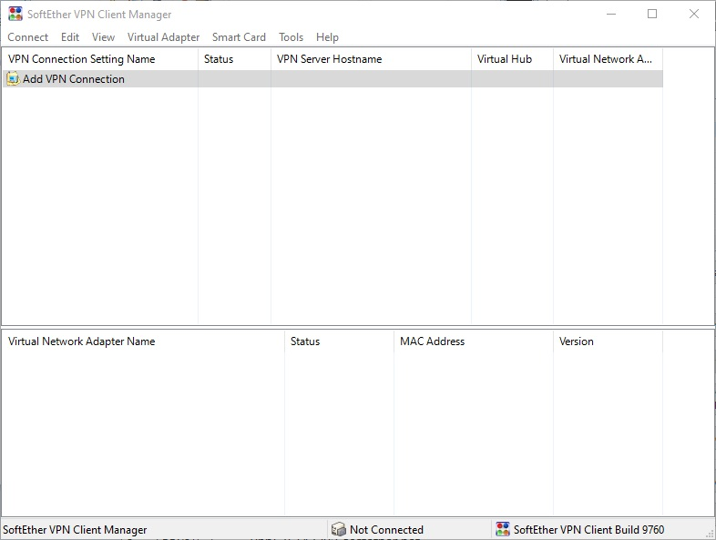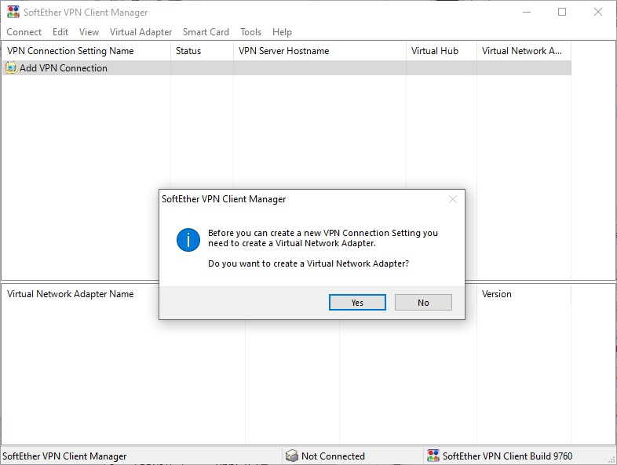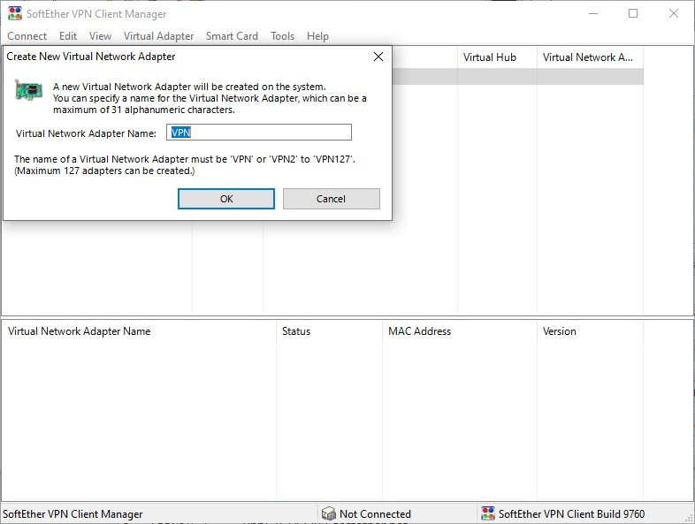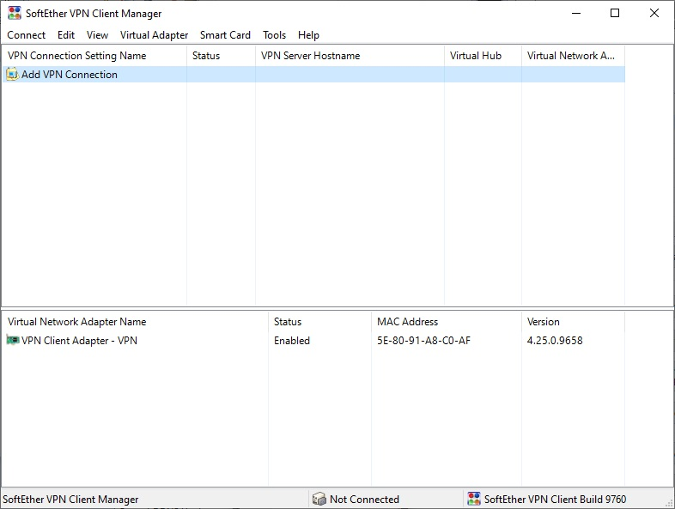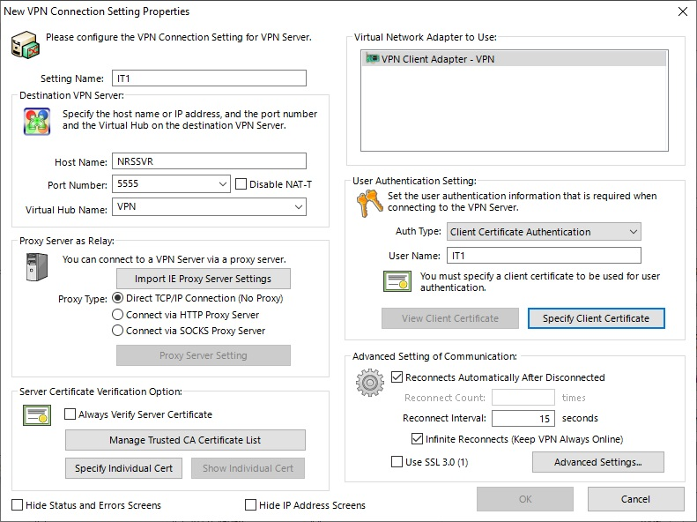

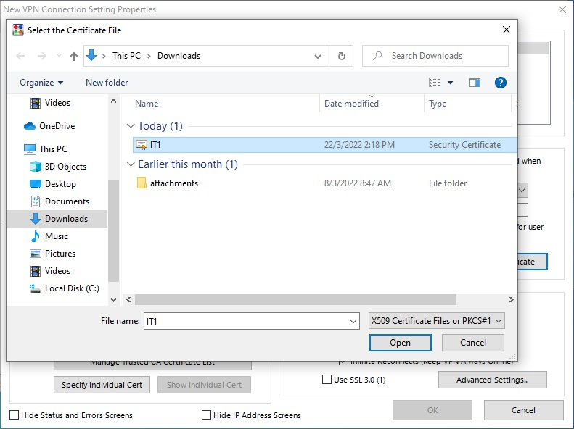

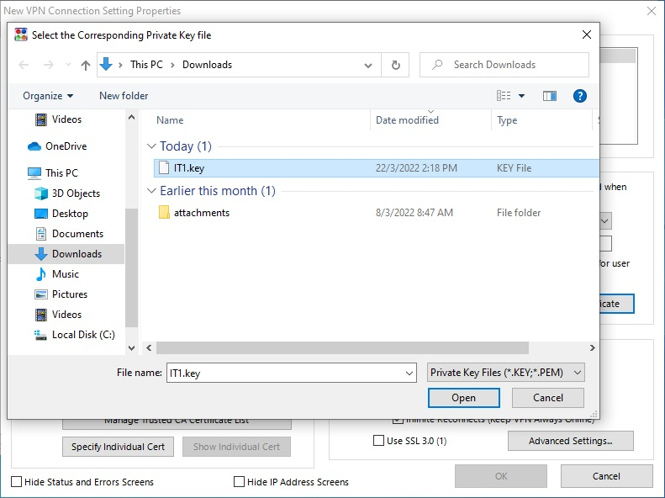

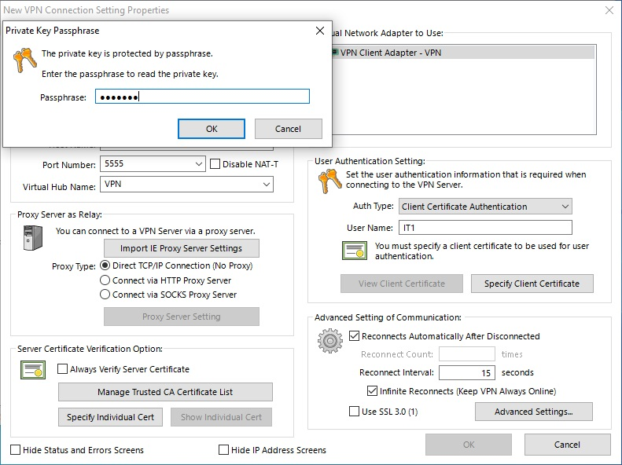

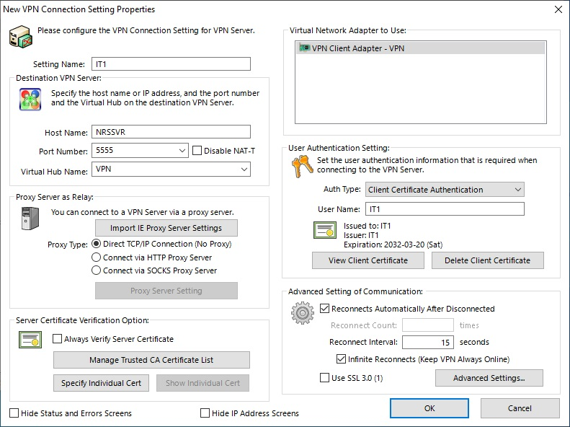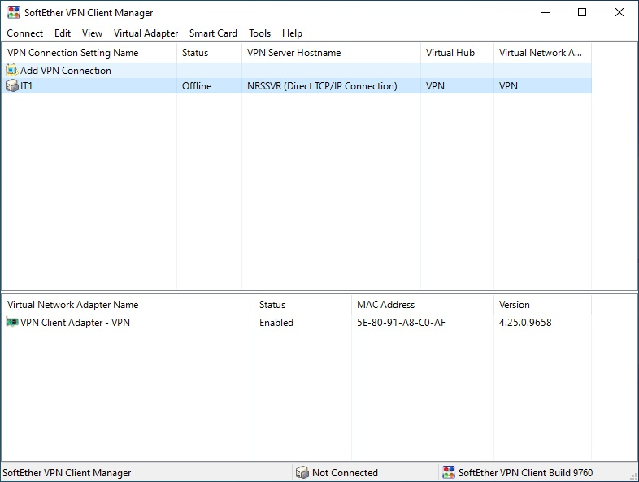

**Setup Google Drive**

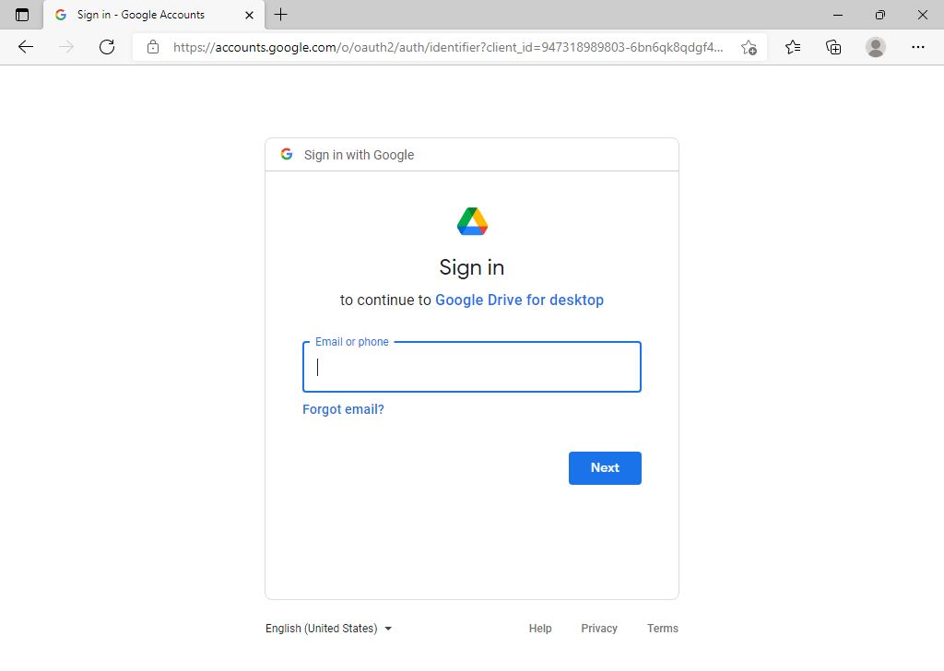

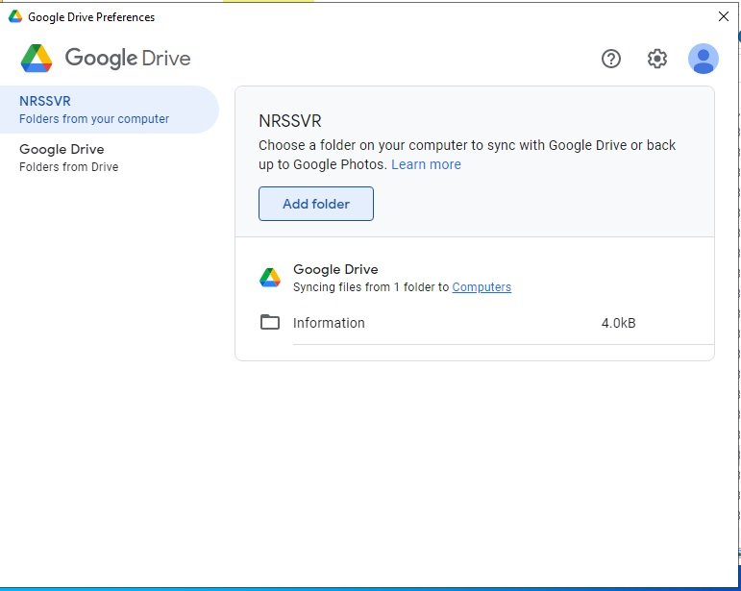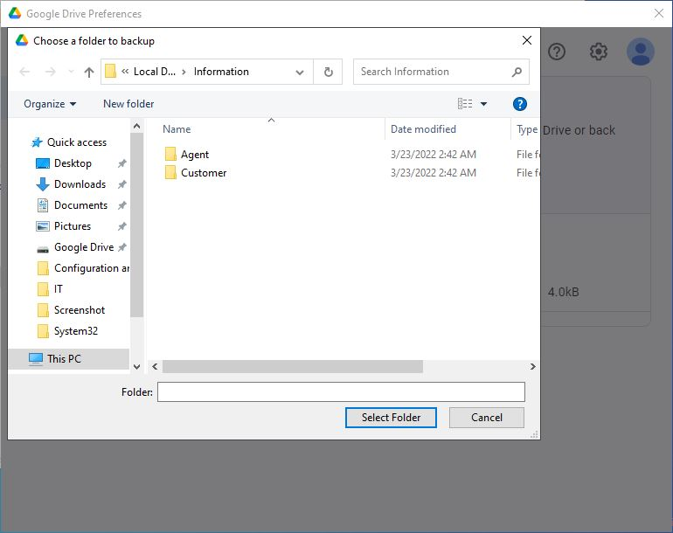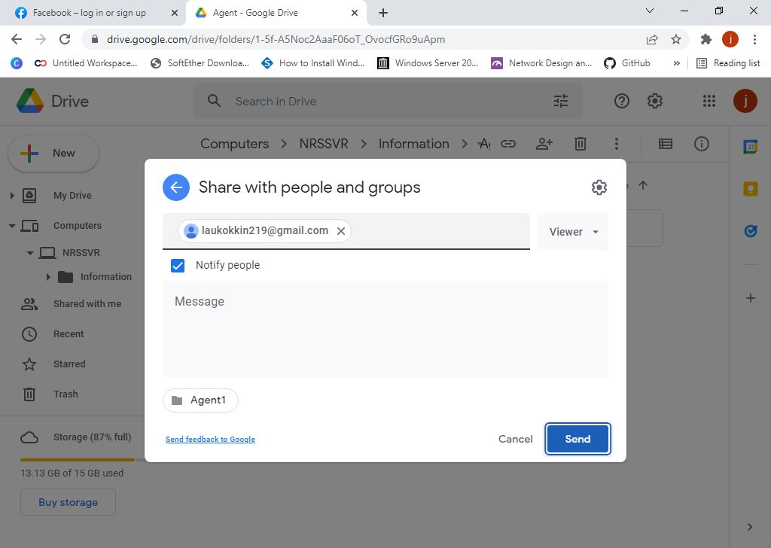

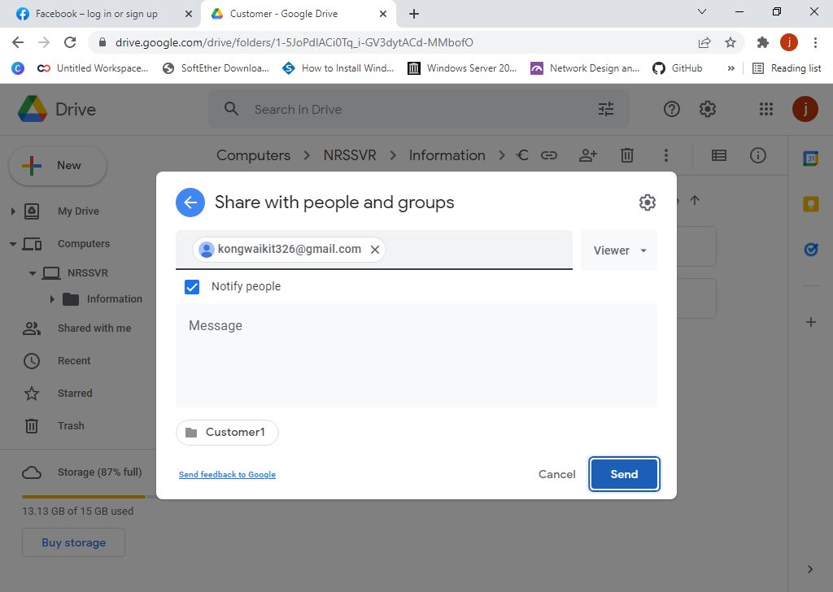

**Setup TinyWall**

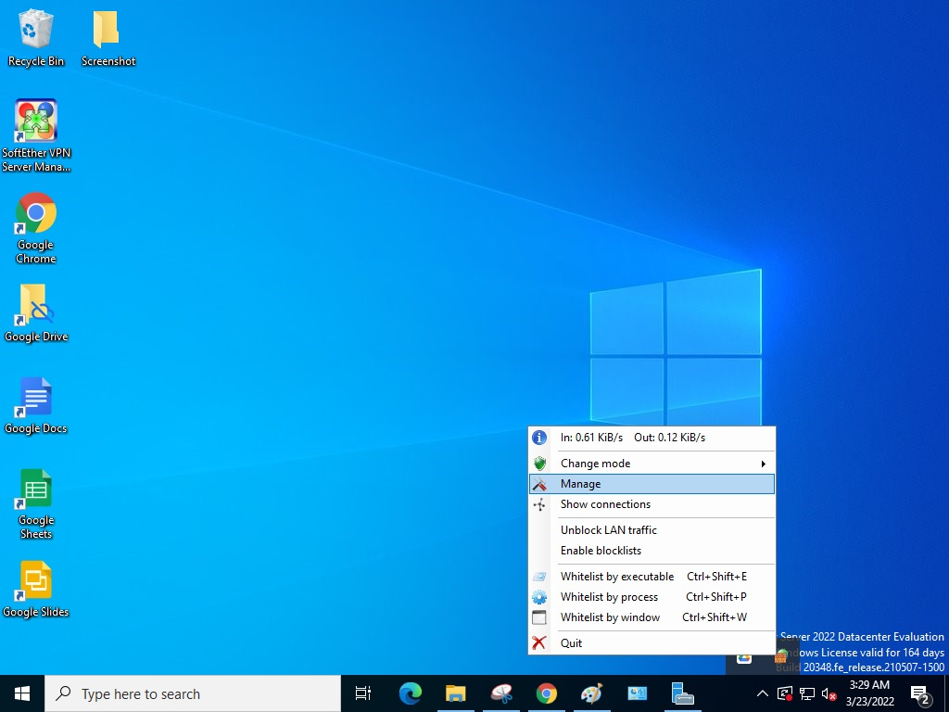

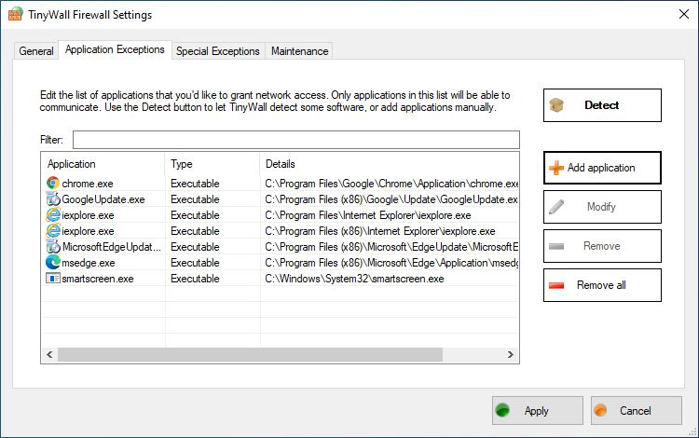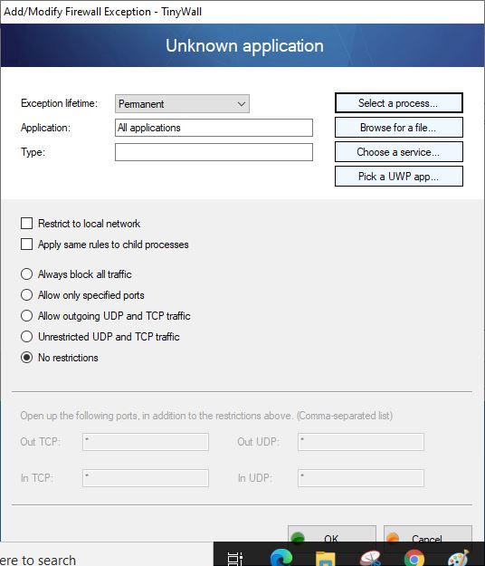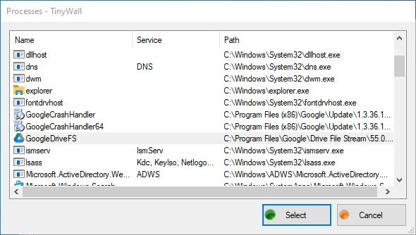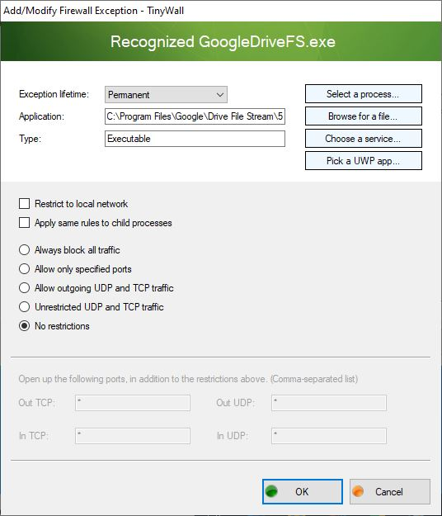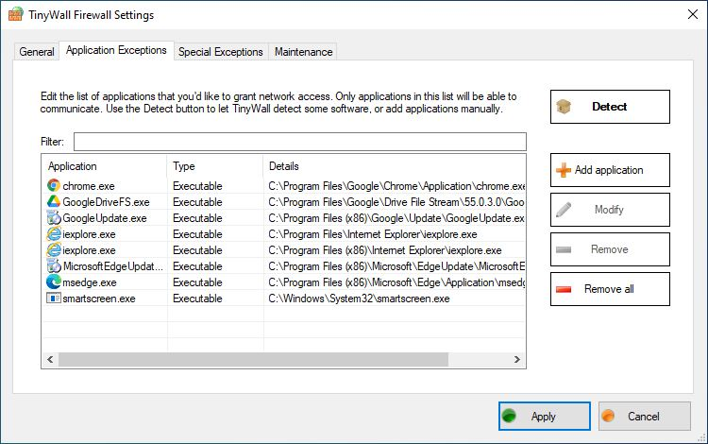

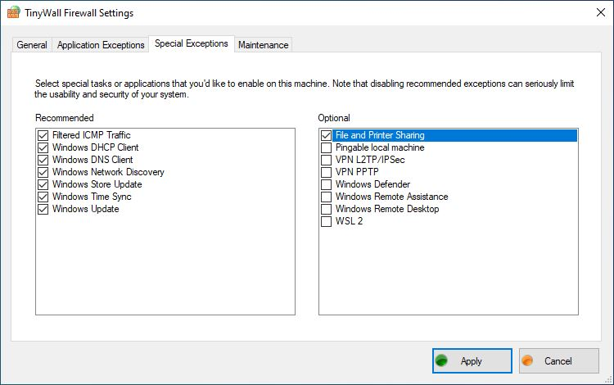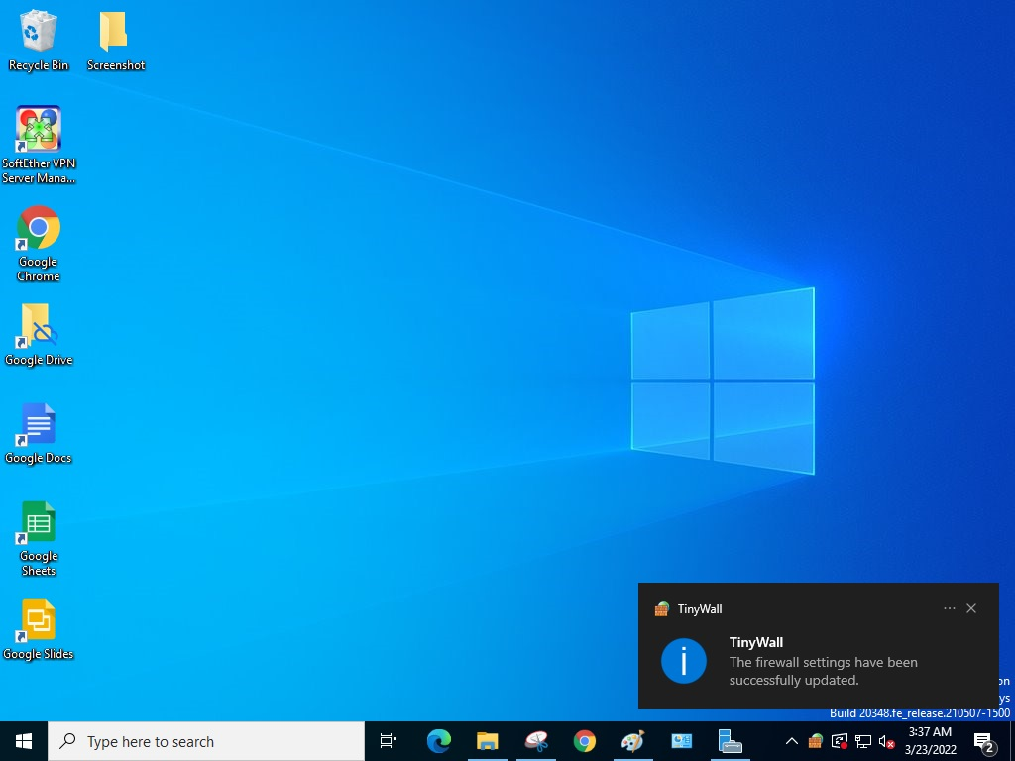

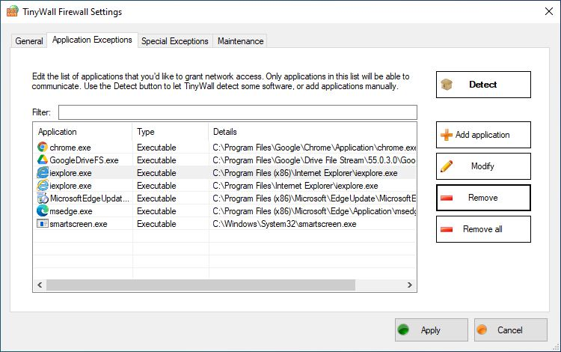

**Configure Photostat Machine**

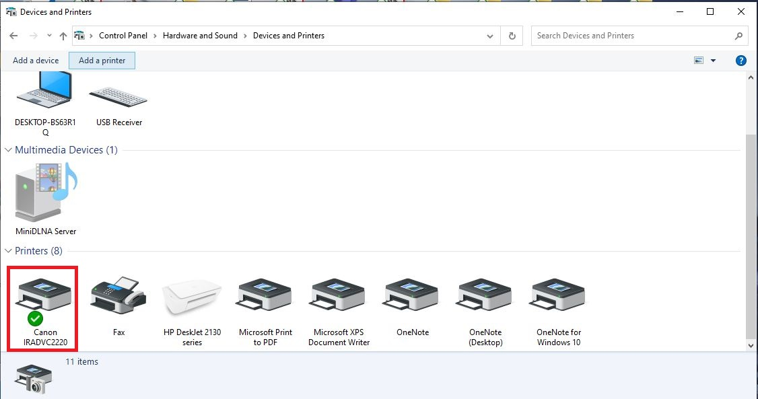

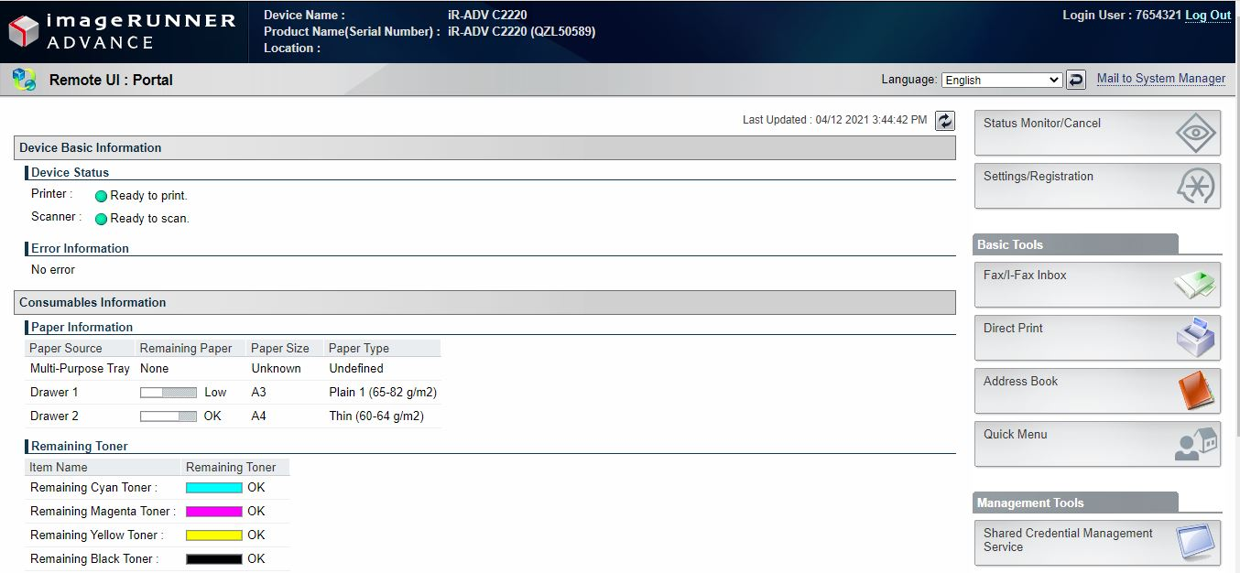

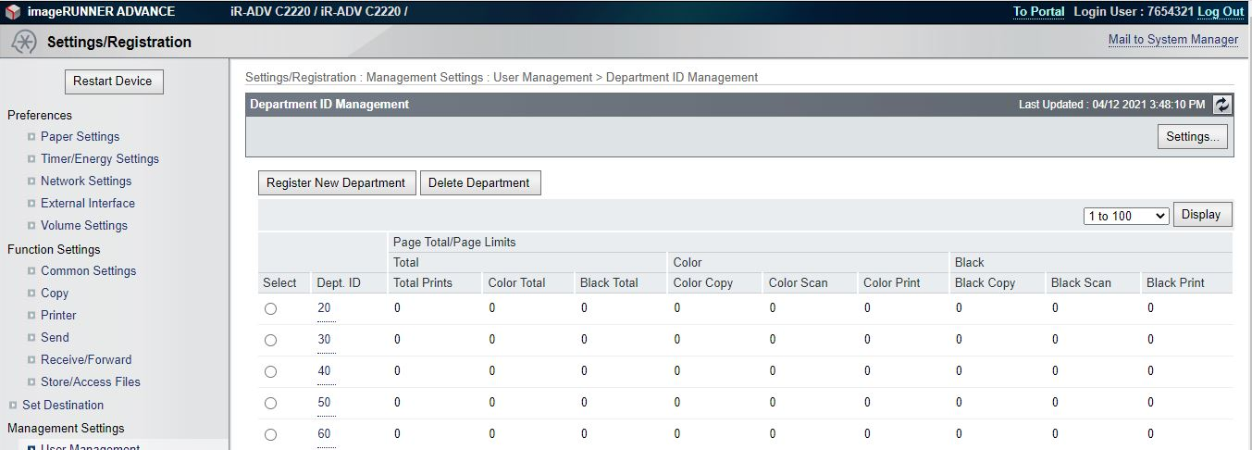

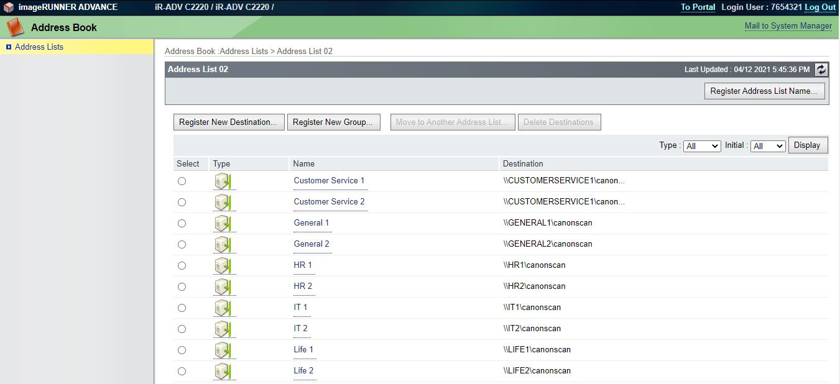

|  |  |
| --- | --- |
| Department ID | Department |
| 20 | INFORMATION TECHNOLOGY |
| 30 | HUMAN RESOURCE |
| 40 | CUSTOMER SERVICE |
| 50 | GENERAL |
| 60 | LIFE |

# Youtube Presentation Link

https://youtu.be/EqkjcwGrCw8

# Github File Link

https://github.com/Joeg22/5P-CSN2-Y_051160090_TMA3.git